Year 2– English Homework

To help you understand what we have been learning this week I would like you to complete the following sentences into your homework book.

Practice the spellings given as there will be a spelling test on Friday.

Remember homework is due in on WEDNESDAY 23rd
Year 2 Homework
We would like you to have a go at spelling these words, try to write it out four times, correct yourself if you make a mistake, practice makes perfect!
Example Word:
Square Square Square Square
Spelling words | X1 | X2 | X3 | X4
super
power
flew
light
speed
This week, we have introduced our new word of the week, please practice spelling out the word a few times and writing down the definition.
Word of the week – Tempestuous
Meaning: Very windy and stormy.
Can you write five sentences in your books persuading me to eat the honey in the jar.

Example: The honey in the jar is terrific, it tastes incredible with fresh toast in the morning.

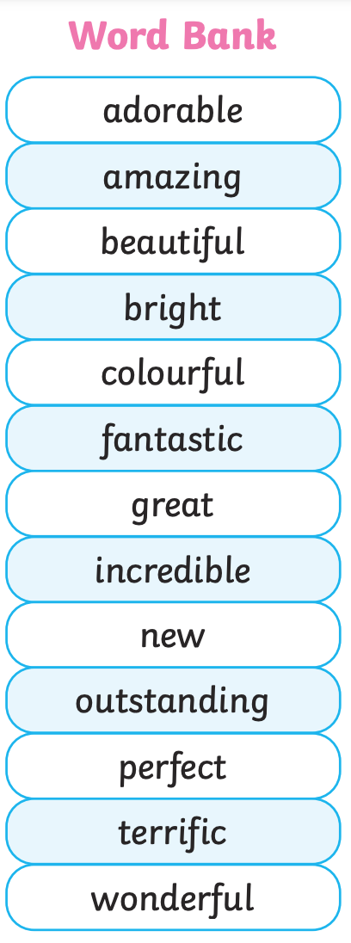

1.______________________________________________________________
2. ______________________________________________________________
3. ______________________________________________________________
4. ______________________________________________________________
5. ______________________________________________________________

