Friday 16th September 2022
Homework is due in no later than THURDAY 22nd September 2022
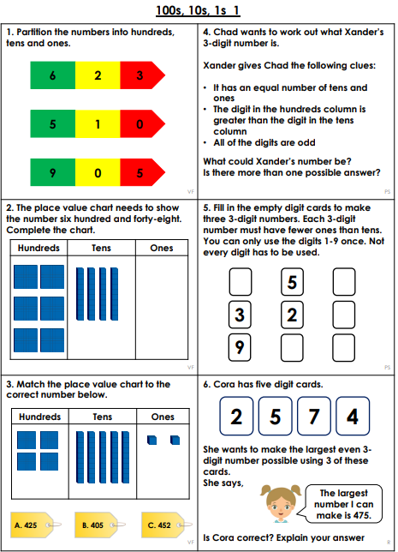

Friday 16th September 2022
Homework is due in no later than THURDAY 22nd September 2022
