Science project for KS1 Year 1 and 2
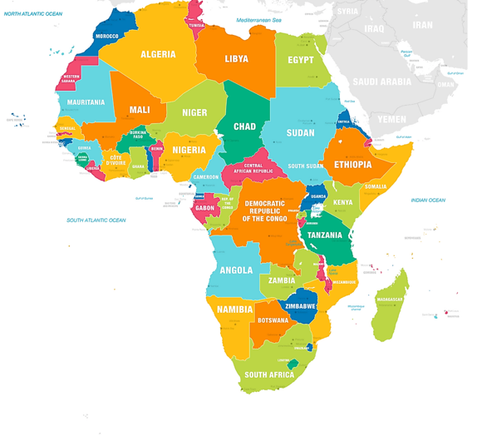

Next term KS1 will be learning about Africa. For half term holiday we are setting year 1 and 2 children a project where they must create a poster of a country in Africa. Africa has 54 countries, and they can choose from any! They will have to include information of the country, the capital city of the country, their flag and names of historical people from that country! Can’t wait to read it! Have a lovely holiday! Enjoy!

