Year 2 Homework

We would like you to have a go at spelling these words, try to write it out four times, correct yourself if you make a mistake, practice make perfect!
Example:
Word:
Square
Square
Square
Square

Spelling words | X1 | X2 | X3 | X4
behind
climb
sugar
because
improve
Once you have completed these words, please practice spelling out the word of the week.
Our word of the week is blustery (of weather) characterised by strong winds
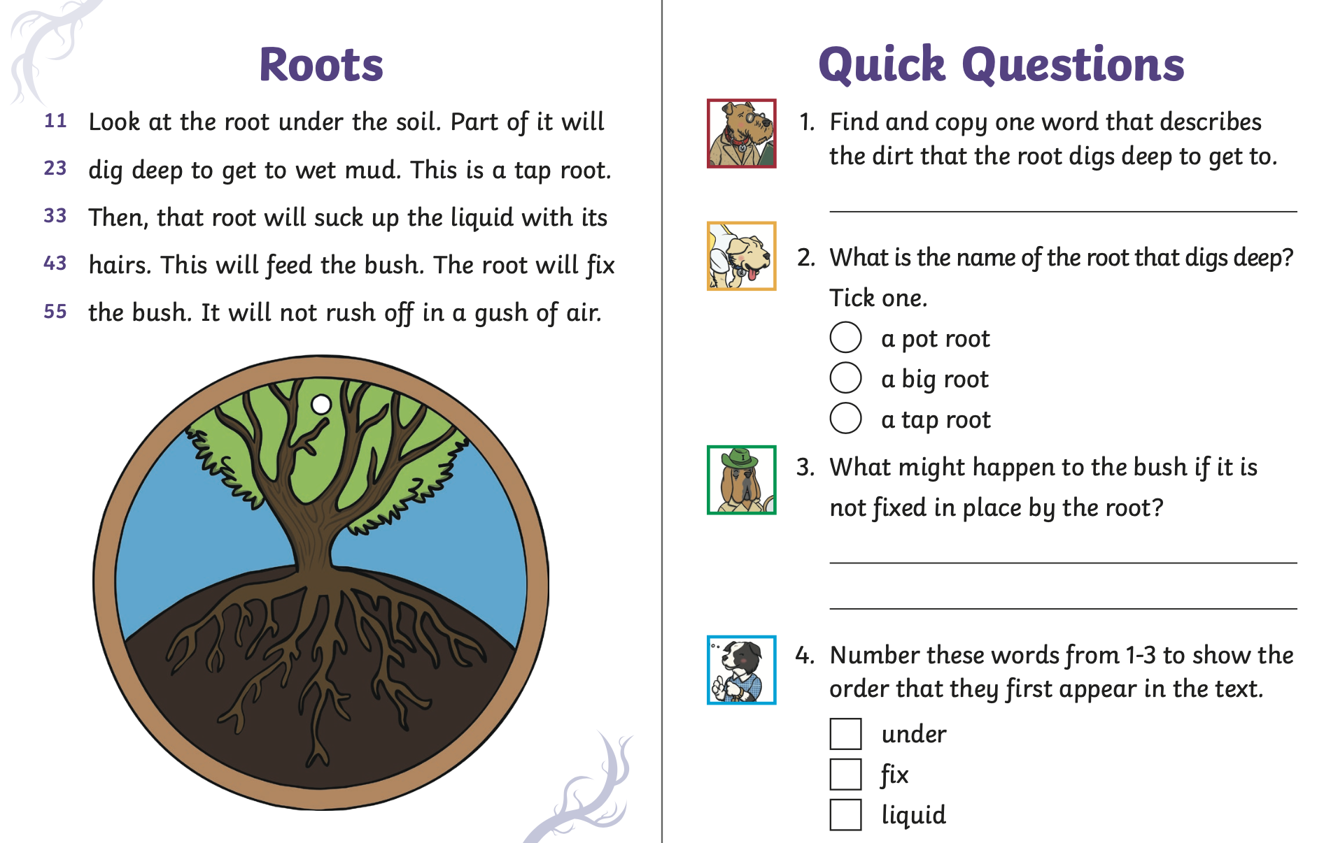
Phase 2 – Phase 3
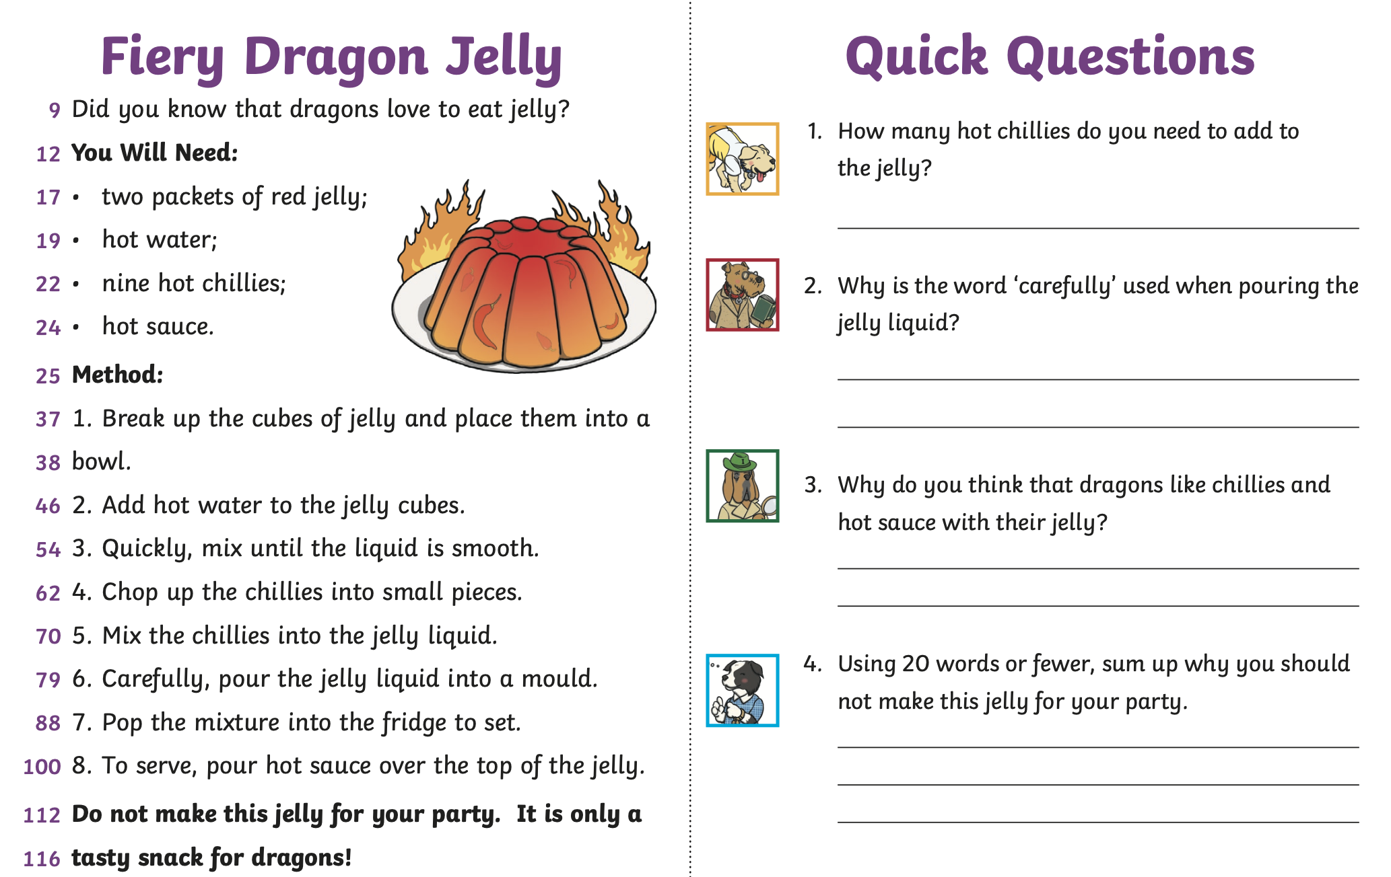
Phase 4+

Ramadan Journal
As the Blessed Month of Ramadan is starting very soon it is important, we keep ourselves busy with worshipping Allah and doing good deeds insha’Allah. There are many good deeds that you can do from cleaning your room and helping your family to donate money to charity and feeding a poor family. For your half-term homework, you will be writing a Ramadan Journal and discussing what you did and what you learned about Allah and our beloved prophet Muhammad (PBUH) this month.

