Homework – Science Week
Next week is science week.

For homework this week you will need to make a poster about the seasons.
There is some information you will need to have on your poster.

How many seasons are there?
What season are we in now?
What months are the different seasons in?
What is the weather like in each season?

Make your poster as colourful as possible and make sure you have the above facts on it. Be creative. There are some ideas shown below. The best poster will win a prize!

Good luck and have fun!
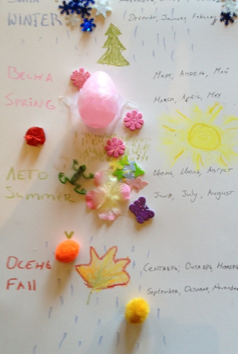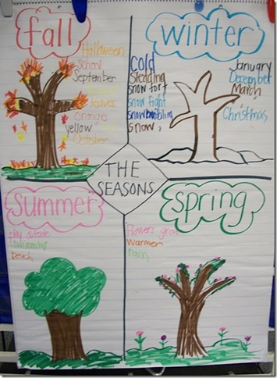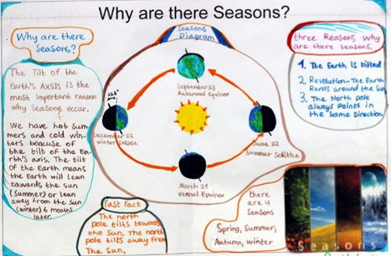
Also have a look at the links below on making boats. We will trying to make our own boats next week.

https://www.youtube.com/watch?v=HpUSim0SA1o

https://www.youtube.com/watch?v=Ndox1NrYsGw

