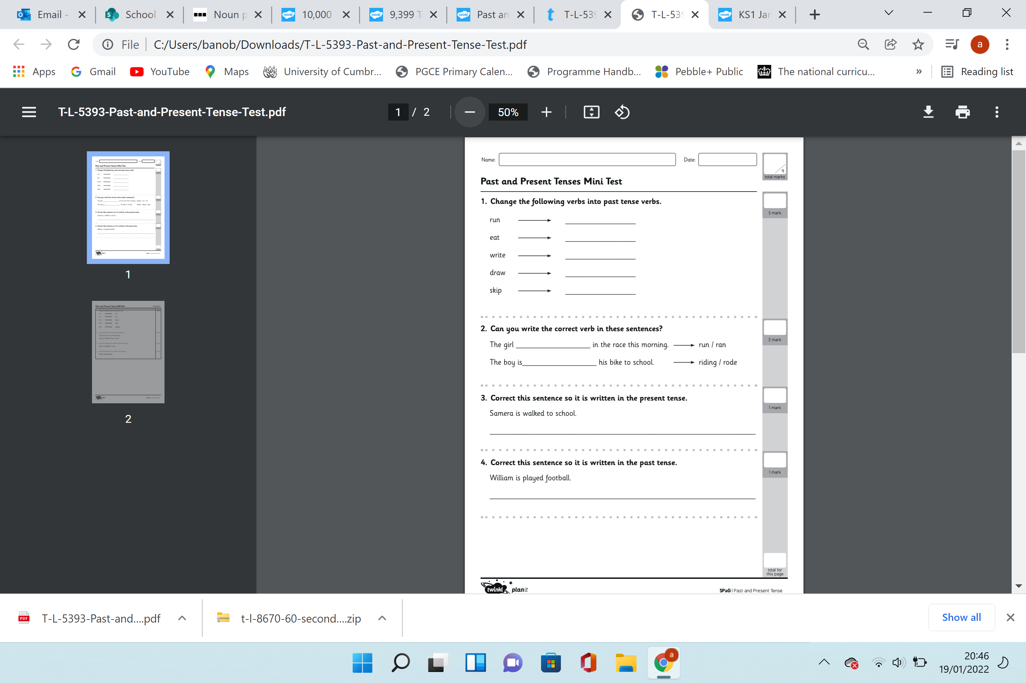

Year 2 - We have looked at past and present tense this week. Complete the following questions.

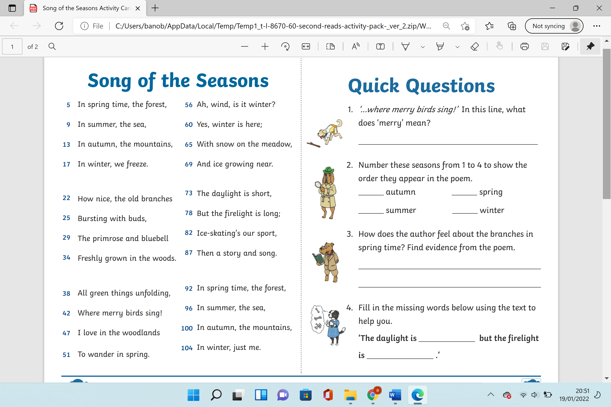

Year 2 – We have been learning about the different season. Read this short poem and answer the questions.