Buttercup Primary School
Personal, Social and Health Education
Policy including EYFS

Compiled by: Zahina Faruque Reviewed by: Rena Begum
Reviewed on: 15th July 2021 Date of next view: 15th July 2022

At Buttercup Primary School, Personal, Social and Health Education (PSHE) and Citizenship enables our children to become healthy, independent and responsible members of society. Our pupils are encouraged to develop their sense of self-worth by playing a positive role in contributing to school life and the wider community. They learn how society is organised and governed and experience the process of democracy in school through the school council. We provide opportunities for them to learn about rights and responsibilities and appreciate what it means to be a positive member of a diverse society.

Aims

- To develop pupils’ self-esteem and a sense of personal responsibility.
- To promote self-respect, respect for others and celebrate diversity.
- To equip pupils to live safe, healthy lives.
- To encourage pupils to contribute to school life and be an active, responsible member of the wider community.
- To foster positive attitudes towards the principles of sustainable development and global citizenship.
- To prepare pupils for the challenges, choices and responsibilities of work and adult life.
- To work with other schools to share good practice in order to improve this policy

Teaching and Learning

Preventative Curriculum

At Buttercup, we ensure that all pupils are treated with respect and, in turn, are respectful of others. The school has devised its own schemes of work to provide a preventative curriculum using the PSHE Association audit tool to plan for PSHE lessons and the tarbiyah document for Islamic studies. . Safeguarding and Relationship education has also been incorporated within the schemes of work and has been interwoven within the core and foundation subjects to provide relevant and statutory teaching that will enable children to gain knowledge so that they are able to manage themselves and understand risks. Assemblies and Circle times provide beneficial opportunities for the children at Buttercup to develop personally, socially and emotionally. It is fair to say that PSHE in Buttercup Primary School is taught across the board and is embedded within the school life. Health and happiness of our pupils is of paramount importance.

We have shaped our current PSHE program to make it relevant to the children and the local community e.g., dealing with the economic deprivation and domestic violence. Teachers have the flexibility to deliver PSHE cross-curricular within the school community life and curriculum. We also have weekly PSHE lessons where teachers have to follow the scheme of work devised by the senior leaders. ( See Appendix 1)

The Education for Social Responsibility (ESR) scheme of work compliments the PSHE curriculum. This gives children the skills they need to look after the planet and its people. ESR is a primary citizenship and environmentalism curriculum for Ks1 and 2. It prepares children for the future with experiences that will give them the skills to care for the world they will inherit.

The subject leader continuously monitors and evaluates the PSHE curriculum to ensure that high standards are delivered and all areas are covered.

Buttercup Primary School PSHE framework is available to support them in this significant aspect of education.

Monitoring and Evaluation

PSHE assessments are informal, continuous and ongoing and is tracked throughout the school curriculum. They identify the needs of individual and groups of pupils. These assessments happen incidentally during classroom activities, community and national news that take place and informs the planning of future activities. It is compulsory in the school for children to experience watching Newsround everyday so that they are aware of local and national and international news.

Equality Impact Assessment

Under the Equality Act 2010 we have a duty not to discriminate against people on the basis of their age, disability, gender, gender identity, pregnancy or maternity, race, religion or belief and sexual orientation.

This policy has been equality impact assessed and we believe that it is in line with the Equality Act 2010 as it is fair, it does not priorities or disadvantage any pupil and it helps to promote equality at this school.

Monitoring the Effectiveness of the Policy

When the need arises the effectiveness of this policy will be reviewed by the coordinator, the Headteacher and the necessary recommendations for improvement will be made to the Proprietor. The subject leader will work on the PSHE Association audit tool to ensure that topics that are relevant and must be taught in the school are being met. This will be reviewed annually.

Linked Policies

This policy must be read in conjuncture with the following linked policies

- Health & Safety  - Mental health | - Foundation  - Anti Bullying  - Cyber Bullying | - SMSC policy  - Behavior Policy  - Digital Resilience Policy | - Child Protection  - Relationship Policy

Appendix:
Sexual violence and sexual harrassment:
The Department for Education published the new ‘Keeping Children Safe in Education’ For 01st September 2021. Part five: Child on child sexual violence and sexual harassment will be adhered to in monitoring any sexual violence behaviour offline/online.

https://assets.publishing.service.gov.uk/government/uploads/system/uploads/attachment_data/file/999239/SVSH_2021.pdf

Initial Equality Impact Assessment

Policy Title | The aim(s) of this policy | Existing policy () | New/Proposed Policy () | Updated Policy ()
PSHE | To outline the aims, content, and delivery of the curriculum for PE which is used throughout the whole school.

This policy affects or is likely to affect the following members of the school community () |  |  |  | Pupils |  |  |  | School Personnel |  |  |  |  |  | Parents/carers |  |  |  |  | Proprietor |  |  | School Volunteers |  |  |  |  |  | School Visitors |  |  |  |  | Wider School Community
Question |  | Equality Groups |  |  |  |  |  |  |  |  |  |  |  |  |  |  |  |  |  |  |  |  |  |  |  |  |  |  |  |  |  |  |  |  | Conclusion
Does or could this policy have a negative impact on any of the following? |  | Age |  |  |  | Disability |  |  |  | Gender |  |  |  |  | Gender identity |  |  | Pregnancy or maternity |  |  |  |  | Race |  |  |  | Religion or belief |  |  |  | Sexual orientation |  |  |  | Undertake a full EIA if the answer is ‘yes’ or ‘not sure’
 |  | Y | N |  | NS | Y | N |  | NS | Y |  | N | NS |  | Y | N | NS | Y |  | N | NS |  | Y | N |  | NS | Y |  | N | NS | Y | N |  | NS | Yes | No
Does or could this policy help promote equality for any of the following? |  | Age |  |  |  | Disability |  |  |  | Gender |  |  |  |  | Gender identity |  |  | Pregnancy or maternity |  |  |  |  | Race |  |  |  | Religion or belief |  |  |  | Sexual orientation |  |  |  | Undertake a full EIA if the answer is ‘no’ or ‘not sure’
 |  | Y | N |  | NS | Y | N |  | NS | Y |  | N | NS |  | Y | N | NS | Y |  | N | NS |  | Y | N |  | NS | Y |  | N | NS | Y | N |  | NS | Yes | No
Does data collected from the equality groups have a positive impact on this policy? |  | Age |  |  |  | Disability |  |  |  | Gender |  |  |  |  | Gender identity |  |  | Pregnancy or maternity |  |  |  |  | Race |  |  |  | Religion or belief |  |  |  | Sexual orientation |  |  |  | Undertake a full EIA if the answer is ‘no’ or ‘not sure’
 |  | Y | N |  | NS | Y | N |  | NS | Y |  | N | NS |  | Y | N | NS | Y |  | N | NS |  | Y | N |  | NS | Y |  | N | NS | Y | N |  | NS | Yes | No
Conclusion | We have come to the conclusion that after undertaking an initial equality impact assessment that a full assessment is not required.

Development of Emotional Intelligence: Standards and Indicators

- Students will acquire the knowledge attitudes and interpersonal skills to help them understand and respect self.
- Students will make decisions, set goals and take necessary action to achieve goals.
- Student will understand safety and survival skills

Note : To be used in conjunction with Purification of the heart, PHSE 2020 Framework and the schools Tarbiyah/Nurturing policy document
Teachers to derive Learning objectives using framework strands may cross reference other areas of the school curriculum; eg : Mental Health, Islamic studies, English , Science, Arabic/Quran studies.

Programme of study 6 units:

Autumn 1: Feelings | Spring 1: Making decisions | Summer1: Relationships

Autumn 1 Cycle A/B

Components | Quran and Sunnah | Indicators | Objective: | Practice
Self Awareness | Feelings  Verily, Allâh will not change the (good) condition of a people as long as they do not change their state (of goodness) themselves (by committing sins and by being ungrateful and disobedient to Allâh). (Ar Rad)  Hadith: Narrated by Anas bin Malik.  A man was with the messenger saw, when a man passed by, the former said: O messenger of Allah! I love this man, Allah’s messenger asked, “Have you informed him?” He said “No” Allah’s messenger then said “Tell him that you love him” so he went up to the man and said to him” “I love you for the sake of Allah” and the other man replied back “ May Allah ,for whose sake you love me , love you”. | Feelings  - Identify and express feelings and emotions  - learn how to make and keep friends  - Know which emotions they are feeling and why  - Know the verses from the Quran and sunnah that support the children’s self-awareness | FOUNDATION/ KS1  Feelings  - Happy/ love  - Sad  - Anger | - Knowledge of Safeguarding Officers in school  - Worry box as a system in place for communication and support
 | Making Decisions  Hadith  Narrated Abu Sayed Al Khudri “Whosoever of you sees an evil, let him change it with his hand; and if he is not able to do so, then [let him change it] with his tongue; and if he is not able to do so, then with his heart and that is the weakest of faith.”  [Reported by Muslim] | Making Decisions  - Identify right and wrong (Halal/Haram)  - learn how to make the correct decision in different situations  - Understand that Allah sees all and hears all  - Know the verses from the Quran and sunnah that support the children’s self-awareness | Making Decisions  - Recognising situations which involves a decision.  Identify some decisions which a person could make, and who could help them (Drama)  - Describe how some decisions we make can be influenced by other people
 | Relationship  Surah Imran: And when you have decided, then rely upon Allah. Indeed, Allah loves those who rely [upon Him]. (3:159)  Hadith:  “The one who severs the ties with the relatives will not be among the first to enter Paradise.  (Al-Bukhari) | Relationship  Identify different family structure e.g.  Single parent, divorced, foster, adoption, 2 mums/ 2 dads  - Identify people who are special to us | Relationship  Encouraging pupils to reflect on special people in their own lives and helping them to:  - recognise the different ways family and friends care for each other.  - manage relationships positively in times of change.  - Recognise that families come in different forms | - FBV rule of law  - Behaviour policy  - Court / police  - PC
Self Management | Feelings:  Hadith: Narrated Abu Huraira, Muhammad said "The strong is not the one who overcomes the people by his strength, but the strong is the one who controls himself while in anger" Sahih al-Bukhari  Hadith: Narrated by Abu Hurayrah (may Allah be pleased with him) A man came to the Prophet (may Allah's peace and blessings be upon him) and said: "Advise me." He replied: "Do not get angry." The man repeated that several times and every time he replied: "Do not get angry.  Making decision:  Name of Allah : Sameer Al Baseer | Feelings  - Understand the need of self-control and how to practice it  - Identify personal strength and assets  - Learn techniques for managing strength and Conflict  - Manage their impulsive feelings and distressing emotions  - Know the verses from the Quran and sunnah that support the children’s self-management  Making decisions  - Identify Allah as unseen  - Accountability  - Iman : Muslim , Mumin , Muhsin  - Tafseer of Al Fatiha (map / sat nav )  - Life as a test (reward/sin)  Relationship | Feelings  - To be able to manage feelings and emotions | Parental engagement with school to work with behaviour policy – listening to their children.  Parent workshop to be organised.  - Tarbiyah doc  - PowerPoint on framework  FBV: Rule of law  Protected characteristics  Respect  Spiritual
Empathy | Hadith: Narrated by the messenger (saw)  No one is a true believer unless he desires for his brother that, what he desires for himself. (Bukhari)  Hadith: Qays ibn Sa’d reported: A funeral passed by the Messenger of Allah, peace and blessings be upon him, and he stood up. It was said to him, “It is a Jew.” The Prophet said, “Was he not a soul?” | - Recognise, accept and appreciate individual differences.  - Show sensitivity and understands other perspectives.  - Helping others; based on other people's needs and feelings. (F, R, M)  - Know the verses from the Quran and sunnah that support the children’s Empathy. (F, R, M) | - To show sensitivity and understand other perspectives.  (F, R, M) | SMSC
Social Awareness | Hadith: Narrated by; Al-Nu’man ibn Bashir .  The Messenger of Allah, peace and blessings be upon him, said, “The parable of the believers in their affection, mercy, and compassion for each other is that of a body. When any limb aches, the whole body reacts with sleeplessness and fever.”  Quran: Hujarat v 13:  O mankind, indeed, We have created you from male and female and made you peoples and tribes that you may know one another. Indeed, the most noble of you in the sight of Allah is the most righteous of you. Indeed, Allah is Knowing and Acquainted. | - Recognise accept and appreciate ethnic and cultural diversity  - recognize and respect differences in various family configurations  - Demonstrate a respect and appreciation for individual and cultural differences.  - Know the verses from the Quran and sunnah that support the children’s Social Awareness  (F, R, M) | - Children to be able to implement  - and practise skills learnt outside their own environment and scenarios.  (F, R, M) | - Childline  - NSPCC  - Litter picking  - SMSC
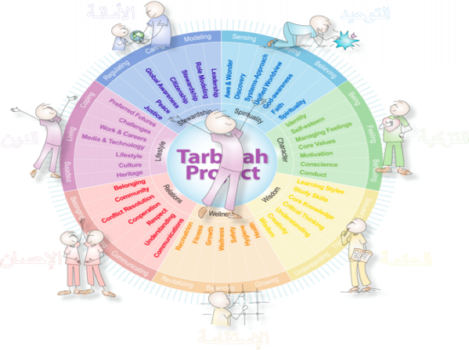

EYFS – Nursery / Reception
UNIT: Feelings
- Identifying and talking about feelings
- Understanding how feelings affect behaviours
- Strategies to manage feelings
- The link between mental and physical health
Key Vocabulary/Questions/Resources: Hadith, Definition, Compilation, Qudsi, : Key vocabulary : Emotion
Week | Learning  Objective | Previous Lesson Recap | Teacher Led/Focus Groups and Independent  Differentiated Objectives/Activities | Plenary | COMPLIANCE LINKS  SMSC / Protective Characteristics / Fundamental British Values
1/2 |  |  | Settling In
3/ 4 | To recognise and describe different feelings | Recap and re visit previous learnings from EYFS | Allah created people with the ability to feel different emotions  EYFS  - Stories that focus on an emotion e.g. sad/happy –  - Make a word wall of feelings vocabulary.  - Statue game – move round to nasheed– on stop call out an emotion word – freeze with that expression.  - Paper plates – draw sad face on one side – happy on the other use as masks and talk about how everyone has these feelings.  - Draw and paint different emotions. Use colours to express feelings.  - Make a class book of feeling pictures and vocabulary.  - focus on other words to describe anger e.g. cross, frustrated, mad irritated, upset annoyed | To understand everyone has similar emotions / feeling as them and to be able to  No one is a true believer unless he desires for his brother that, what he desires for himself. (Bukhari)  Hadith: Qays ibn Sa’d reported: A funeral passed by the Messenger of Allah, peace and blessings be upon him, and he stood up. It was said to him, “It is a Jew.” The Prophet said, “Was he not a soul?” | FBV: Individual liberty, Mutual tolerance and respect
5 | To explain how different feeling can affect behaviour | Recap and re visit previous learnings from week 1 /2
6 | To recognise who to go to for support

KS1 – Year 1-2
UNIT: Feelings
- Identifying and talking about feelings
- Understanding how feelings affect behaviours
- Strategies to manage feelings
- The link between mental and physical health
Key Vocabulary/Questions/Resources: Hadith, Definition, Compilation, Qudsi, : Key vocabulary : Emotion
Week | Learning  Objective | Previous Lesson Recap | Teacher Led/Focus Groups and Independent  Differentiated Objectives/Activities | Plenary | COMPLIANCE LINKS  SMSC / Protective Characteristics / Fundamental British Values
1 | To recognise and describe different feelings | Recap and re visit previous learnings from EYFS | Allah created people with the ability to feel different emotions  - Circle time and discussion on naming and expressing feelings.  - Photographs of people who look angry, happy and kind.  - Paired work to explore body language. Talk about how we recognise how others are feeling from their body language.  - Photographs of people showing different emotions.  - Role-play different situations to express feelings.  - Pass the glasses on‘– what does this look like through different eyes.  - makes me the same as you? What makes us different? How does it feel to be different?  - Use masks – how does this face feel?  - focus on other words to describe anger e.g. cross, frustrated, mad irritated, upset annoyed | To understand that people have similar emotions and feeling as them. To be able to label and recognise them.  No one is a true believer unless he desires for his brother that, what he desires for himself. (Bukhari)  Break down into child friendly language, and understanding Eg: who has a favourite toy? Will you share it or give it to someone you don’t know?  Hadith:  Qays ibn Sa’d reported: A funeral passed by the Messenger of Allah, peace and blessings be upon him, and he stood up. It was said to him, “He is a Jew.” The Prophet said, “Was he not a soul?” | FBV: Individual liberty, Mutual tolerance and respect  SMSC: Spirituality  Moral  Mental health
2 | To explain how different feeling can affect behaviour | Recap and re-visit previous learnings from LKS2 | Allah wants to meet you with your good deeds
3/4 | To be able to manage our negative feelings and actions | Allah wants to meet you with your good deeds | Circle Time rounds to include:  - I feel angry when….  - I feel happy when….  Pupils identify some of the things that someone can do to help them when they have a big feeling, and some of the things that they shouldn’t do:  - For example:  - Do talk about it  - Do something to help you calm down  - Do remember that feelings can change  - Don’t hurt yourself  - Don’t hurt others  - Don’t hurt things or property | Introduce ways of calming down: Breathing techniques.  (Dhikr)  Saying “Astugfirullah”  Sitting, lying down, wudu  Hadith:  Narrated Abu Huraira, Muhammad said "The strong is not the one who overcomes the people by his strength, but the strong is the one who controls himself while in anger" Sahih al-Bukhari  Note: to be broken down and explained that anger is one emotion that is to be used as the last resort  Hadith:  Narrated by Abu Hurairah (may Allah be pleased with him) A man came to the Prophet (may Allah's peace and blessings be upon him) and said: "Advise me." He replied: "Do not get angry." The man repeated that several times and every time he replied: "Do not get angry.  To be able to share as a good act in order to please Allah and establishing acts of kindness | FBV: Individual liberty, Mutual tolerance and respect  Key emotions: Anger, happy, sad, unhappy, upset,
5 | To recognise who to go to for support |  | Worry box  Introduce Safeguarding  Teacher available to talk | Allah tells us to look after ourselves e.g. sleep, eating healthy food etc...and when you need help you must ask for it. | CP
6 | To be able to show empathy | Recap hadith of funeral procession | To recognise feelings from scenarios and give advice. | Never win people arguments, rather defeat them with your smile. Smiling is the best reaction in all situations. | SMSC: Social

LKS2 – Year 3-4
UNIT: Feelings
- Identifying and talking about feelings
- Understanding how feelings affect behaviours
- Strategies to manage feelings
- The link between mental and physical health
Key Vocabulary/Questions/Resources: Hadith, Definition, Compilation, Qudsi, : Key vocabulary : Emotion
Week | Learning  Objective | Previous Lesson Recap | Teacher Led/Focus Groups and Independent  Differentiated Objectives/Activities | Plenary | COMPLIANCE LINKS  SMSC / Protective Characteristics / Fundamental British Values
1/2 | To recognize and describe different feelings  Developing the language of feelings  To be empathetic  Communicating our feelings:  recognising feelings  naming feelings  describing feelings | Recap and re visit previous learnings from KS1  Continue to develop their vocabulary for feelings and their understanding of the ways in which feelings are expressed  become better able to describe their own feelings and those of others | Allah created people with the ability to feel different emotions  Watch both videos and discuss in pairs /groups the emotions felt by Sufi and his mother:  NOTE: use stories as a distancing technique if subject matter is of a sensitive nature  Video 1: Loving Orphans https://web.microsoftstream.com/video/73544548-8fb5-4480-a128-8897ba409ffc  Video 2: Orphans P2  - https://web.microsoftstream.com/video/7b781abe-8fc3-4eb7-a371-a2946184650d  - Talk about how we show sympathy and compassion for others. What does it feel like inside? Talk about helping others in need – what does it feel like when we see other children less fortunate than ourselves?  - Talk about what it means to love yourself and others – what type of love is this? Use pictures of friends and siblings showing affection to each other. Use pictures, newspaper stories of poverty hunger and tragedy. How can we use these feelings in a positive way when thinking about our older relatives and neighbours? | To understand everyone has feelings  No one is a true believer unless he desires for his brother that, what he desires for himself. (Bukhari)  Hadith  Qays ibn Sa’d reported: A funeral passed by the Messenger of Allah, peace and blessings be upon him, and he stood up. It was said to him, “It is a Jew.” The Prophet said, “Was he not a soul?” | FBV: Individual liberty, Mutual tolerance and respect
3 | To explain how different feeling can affect behaviour | Recap and re vist previous learnings from LKS2 | Allah wants to meet you with your good deeds
4 | To be able to manage our negative feelings and actions | Allah wants to meet you with your good deeds | - when I am included…  - when I am left out….  - Talk about which colours come to mind when we feel angry or cross. What other words can we use to express our strong feelings?  - Making and breaking friends.  - What is the difference between hurting my knee and hurting my feelings?  - Discuss the difference between bullying and teasing. Do we all use the same language when referring to bullying? Use stories about bullying and talk about the characters. Who can I ask for help? What do I say? Discuss school procedure for bullying. | Introduce ways of calming down: Breathing techniques.  (Dhikr)  Saying “Astugfirullah”  Sitting, lying down, wudu  Hadith: Narrated Abu Huraira, Muhammad said "The strong is not the one who overcomes the people by his strength, but the strong is the one who controls himself while in anger" Sahih al-Bukhari  Hadith: Narrated by Abu Hurayrah (may Allah be pleased with him) A man came to the Prophet (may Allah's peace and blessings be upon him) and said: "Advise me." He replied: "Do not get angry." The man repeated that several times and every time he replied: "Do not get angry.  To be able to share as a good act in order to please Allah and establishing acts of kindness | FBV: Individual liberty, Mutual tolerance and respect  Key emotions : Anger, happy,sad , unhappy, upset,
5/6 | To recognise other emotions - Purification of the heart) |  | Showing off  Miserliness
Gratitude
Patience

UKS2 – Year 5-6
UNIT: Feelings
- Identifying and talking about feelings
- Understanding how feelings affect behaviours
- Strategies to manage feelings
- The link between mental and physical health
Key Vocabulary/Questions/Resources: Hadith, Definition, Compilation, Qudsi, : Key vocabulary : Emotion
Week | Learning  Objective | Previous Lesson Recap | Teacher Led/Focus Groups and Independent  Differentiated Objectives/Activities | Plenary | COMPLIANCE LINKS  SMSC / Protective Characteristics / Fundamental British Values
1 | To recognize and describe different feelings  Communicating our feelings:  recognising feelings  naming feelings  describing feelings | UKS2 (5/6)  Recap and re visit previous learning from LKS2 | Allah created people with the ability to feel different emotions  UKS2 (5/6)  - Circle time activities to explore the language of feelings.  - Practise in pairs body language – verbal and non verbal signals.  - Explore Strong Feelings – dealing with loss; bereavement; divorce; friendship; love. Use sufi video  - Talk about what it means to be ‘comfortable in ones own skin’ and ' feeling OK with self'.  - Talk about being on your own - how is this different from feeling isolated? What does isolation feel like? Draw pictures to represent isolation. How do we recognise when someone is being left out and ignored? What body language is being shown? What can we do to include others? | To understand that everyone has similar emotions feeling as themable to  No one is a true believer unless he desires for his brother that, what he desires for himself. (Bukhari)  Hadith: Qays ibn Sa’d reported: A funeral passed by the Messenger of Allah, peace and blessings be upon him, and he stood up. It was said to him, “He is a Jew.” The Prophet said, “Was he not a soul?”  - recognise as they approach puberty that emotions change  - be aware of different types of relationship  - see other people’s point of view  - talk about their feelings using appropriate language | FBV: Individual liberty, Mutual tolerance and respect
2 | To explain how different feeling can affect behaviour | Recap and re visit previous learnings from LKS2 | Allah wants to meet you with your good deeds
3 | To be able to manage our negative feelings and actions | Allah wants to meet you with your good deeds | UKS2 Watch or listen together Story surah Kahf  man with 2 gardens, the blind leper, bald hadith  Video: https://web.microsoftstream.com/video/e566df28-a3d0-4ed1-9d7a-496c95664de9  Read and extract from Purification of the Heart  - Greed | Introduce ways of calming down: Breathing techniques.  (Dhikr)  Saying “Astugfirullah”  Sitting, lying down, wudu  Hadith: Narrated Abu Huraira, Muhammad said "The strong is not the one who overcomes the people by his strength, but the strong is the one who controls himself while in anger" Sahih al-Bukhari  Hadith: Narrated by Abu Hurayrah (may Allah be pleased with him) A man came to the Prophet (may Allah's peace and blessings be upon him) and said: "Advise me." He replied: "Do not get angry." The man repeated that several times and every time he replied: "Do not get angry.  To be able to share as a good act in order to please Allah and establishing acts of kindness | FBV: Individual liberty, Mutual tolerance and respect  Key emotions: Anger, happy, sad, unhappy, upset,
4 | To recognise other emotions (Purification of the heart) |  | Showing off  Miserliness
5 | To recognise other emotions (- Purification of the heart) |  | Gratitude  Patience
6 | To be able to show empathy |  | To recognise feelings and emotions and give advice.

Development of Emotional Intelligence: Standards and Indicators

- Students will acquire the knowledge attitudes and interpersonal skills to help them understand and respect self.
- Students will make decisions, set goals and take necessary action to achieve goals.
- Student will understand safety and survival skills

Note : To be used in conjunction with Purification of the heart, PHSE 2020 Framework and the schools Tarbiyah/Nurturing policy document
Teachers to derive Learning objectives using framework strands may cross reference other areas of the school curriculum; eg : Mental Health, Islamic studies, English , Science, Arabic/Quran studies.

Programme of study 6 units:

Autumn 1: Feelings | Spring 1: Making decisions | Summer1: Relationships

Autumn 1 Cycle A/B

Components | Quran and Sunnah | Indicators | Objective: | Practice
Self Awareness | Feelings  Verily, Allâh will not change the (good) condition of a people as long as they do not change their state (of goodness) themselves (by committing sins and by being ungrateful and disobedient to Allâh). (Ar Rad)  Hadith: Narrated by Anas bin Malik.  A man was with the messenger saw, when a man passed by, the former said: O messenger of Allah! I love this man, Allah’s messenger asked “Have you informed him?” He said “No” Allah’s messenger then said “Tell him that you love him” so he went up to the man and said to him” “I love you for the sake of Allah” and the other man replied back “ May Allah ,for whose sake you love me , love you”. | Feelings  - Identify and express feelings and emotions  - learn how to make and keep friends  - Know which emotions they are feeling and why  - Know the verses from the Quran and sunnah that support the children’s self-awareness | FOUNDATION/ KS1  Feelings  - Happy/ love  - Sad  - Anger | - Knowledge of Safeguarding Officers in school  - Worry box as a system in place for communication and support
 | Making Decisions  Hadith  Narrated Abu Sayed Al Khudri “Whosoever of you sees an evil, let him change it with his hand; and if he is not able to do so, then [let him change it] with his tongue; and if he is not able to do so, then with his heart and that is the weakest of faith.”  [Reported by Muslim] | Making Decisions  - Identify right and wrong (Halal/Haram)  - learn how to make the correct decision in different situations  - Understand that Allah sees all and hears all  - Know the verses from the Quran and sunnah that support the children’s self-awareness | Making Decisions  - Recognising situations which involves a decision.  Identify some decisions which a person could make, and who could help them (Drama)  - Describe how some decisions we make can be influenced by other people
 | Relationship  Surah Imran: And when you have decided, then rely upon Allah. Indeed, Allah loves those who rely [upon Him]. (3:159)  Hadith:  “The one who severs the ties with the relatives will not be among the first to enter Paradise.  (Al-Bukhari) | Relationship  Identify different family structure e.g.  Single parent, divorced, foster, adoption, 2 mums/ 2 dads | Relationship  Encouraging pupils to reflect on special people in their own lives and helping them to:  - recognise the different ways family and friends care for each other.  - manage relationships positively in times of change.  - Recognise that families come in different forms | - FBV rule of law  - Behaviour policy  - Court / police
Self Management | Feelings:  Hadith: Narrated Abu Huraira, Muhammad said "The strong is not the one who overcomes the people by his strength, but the strong is the one who controls himself while in anger" Sahih al-Bukhari  Hadith: Narrated by Abu Hurayrah (may Allah be pleased with him) A man came to the Prophet (may Allah's peace and blessings be upon him) and said: "Advise me." He replied: "Do not get angry." The man repeated that several times and every time he replied: "Do not get angry.  Making decision:  Name of Allah : Sameer Al Baseer  Mulk ayah 2  Shams ayah 11  Hadith badawi  Hadith muslim on removing evil | Feelings  - Understand the need of self-control and how to practice it  - Identify personal strength and assets  - Learn techniques for managing strength and Conflict  - Manage their impulsive feelings and distressing emotions  - Know the verses from the Quran and sunnah that support the children’s self-management  Making decisions  - Identify Allah as unseen  - Accountability  - Iman : Muslim , Mumin , Muhsin  - Tafseer of Al Fatiha (map / sat nav )  - Life as a test (reward/sin)  Relationship | Feelings  - To be able to manage feelings and emotions | Parental engagement with school to work with behaviour policy – listening to their children.  Parent workshop to be organised.  - Tarbiyah doc  - PowerPoint on framework  FBV: Rule of law  Protected characteristics  Respect  Spiritual
Empathy | Hadith: Narrated by the messenger (saw)  No one is a true believer unless he desires for his brother that, what he desires for himself. (Bukhari)  Hadith: Qays ibn Sa’d reported: A funeral passed by the Messenger of Allah, peace and blessings be upon him, and he stood up. It was said to him, “It is a Jew.” The Prophet said, “Was he not a soul?” | - Recognise, accept and appreciate individual differences.  - Show sensitivity and understands other perspectives.  - Helping others; based on other people's needs and feelings. (F, R, M)  - Know the verses from the Quran and sunnah that support the children’s Empathy. (F, R, M) | - To show sensitivity and understand other perspectives.  (F, R, M) | SMSC
Social Awareness | Hadith: Narrated by; Al-Nu’man ibn Bashir .  The Messenger of Allah, peace and blessings be upon him, said, “The parable of the believers in their affection, mercy, and compassion for each other is that of a body. When any limb aches, the whole body reacts with sleeplessness and fever.”  Quran: Hujarat v 13:  O mankind, indeed, We have created you from male and female and made you peoples and tribes that you may know one another. Indeed, the most noble of you in the sight of Allah is the most righteous of you. Indeed, Allah is Knowing and Acquainted. | - Recognise accept and appreciate ethnic and cultural diversity  - recognize and respect differences in various family configurations  - Demonstrate a respect and appreciation for individual and cultural differences.  - Know the verses from the Quran and sunnah that support the children’s Social Awareness  (F, R, M) | - Children to be able to implement  - and practise skills learnt outside their own environment and scenarios.  (F, R, M) | - Childline  - NSPCC  - Litter picking  - SMSC

EYFS – Nursery / Reception
UNIT: Making Decisions

Key Vocabulary/Questions/Resources: Hadith, Quran: halal haram (right / wrong) Name of Allah sameer baserr
Week | Learning  Objective | Previous Lesson Recap | Teacher Led/Focus Groups and Independent  Differentiated Objectives/Activities | Plenary | COMPLIANCE LINKS  SMSC / Protective Characteristics / Fundamental British Values
1/2 | - To Identify Allah as the unseen  - The one who has control of everything  - Reward for being good  - Tafseer al fatiha |  | Video 1: Allah made everything- Nasheed  https://web.microsoftstream.com/video/54efd191-2cee-48ff-af27-beda28d42bc5  Video 2:I love Allaah - Nasheed  https://web.microsoftstream.com/video/0ef83f6c-60c9-4c61-be54-93275d33c072
3/ 4 | - To consolidate the school behaviour policy  - To be able to make the right choices |  | All seeing and all hearing Sameer al Baseer | Reward and sanctions and Jannah points reinforced
5 | Reinforce tawhid building |  | Story time/ surah
6 | Reinforce tawhid building |  | Story time/ surah

KS1 – Year 1-2
UNIT: Making Decisions

Key Vocabulary/Questions/Resources: Hadith, Definition, Compilation, Qudsi, : Key vocabulary:
Week | Learning  Objective | Previous Lesson Recap | Teacher Led/Focus Groups and Independent  Differentiated Objectives/Activities | Plenary | COMPLIANCE LINKS  SMSC / Protective Characteristics / Fundamental British Values
1/2 | - To Identify Allah as the unseen  - To understand consequences of any actions |  | Week 1: Re introduce (Prior learning from EYFS) and recite out loud Surah Al Fatiha- in Arabic with children  Read out a fairly simple translation  Get children to read translations. (please edit a child friendly version of the synopsis of the surah.  Talking partners to discuss why certain emotions of Allah were mentioned in describing the two paths.  - which path is the right path and why?  - (Blooms taxonomy)  Week 2: Recap on week 1. Teacher to act out a scenario where they are tempted to take some sweets that do not belong to them. Children to give advantages and disadvantages of taking the sweets. Create a table with notes from the children. Ask children which answer they would choose and why. Practise different scenarios and collect advantages and disadvantages.  Activity- give children different real- life scenarios where they may have to make decisions by looking at the advantages and disadvantages. Stick scenario in book and draw a table with advantages and disadvantages. Children share their thoughts.  Which one will you choose? | Laysa Kamithlihi Shay'un Wa Huwa As-Samī`u Al-Başīru Surah Shams ayah 11  Reward of only seeing Allah in Jannah  Wa Huwa ma^akum aynama kuntum – Hadid aya 4- Allah is with you wherever you may be -  - Behaviour changes in front of those you see eg... Policeman, teacher, Headteacher, traffic light  - Behaviour when no one sees you  - Explain life after: Life is a test / race …. comparable to a big game and the winner will receive a prize / trophy | SMSC: spiritual, moral  FBV: Rule of law  English oracy speaking skills, drama,)
3 | - To recognise all actions carries weight (good/ bad)  - To Identify all actions are recorded | Recap the previous lesson on the 2 different paths. | Did you know that if you have a good intention when making a decision you will be rewarded even more. Even if you are thinking of doing wrong but you decide not to do it, you will be rewarded by Allah. Children to share experiences of when they stop themselves from doing wrong.  Circle time activity- have 4 bags in the middle of the circle of different weight. | - Imam Nawai hadith: intentions  - Who Kiramun katibun are (angels) recording of actions and erasing of actions (within 6 hours) | mathematical link
4 | - To recognise decisions we make can be influenced by other people, or environment |  | Circle time  The eye is a doorway to the heart and it affects how we feel and behave –  - Talking partners : Do you follow everything your friend does ? Introduce key vocab influenced  Introduce and talk about some of the many mediums out there that affect the way we think.  - Digital devices - Different form of media – TV , Film , social media , Youtube  - People around you – family inc extended friends , role models | Muslim is a mirror to another ( you become like them )  Choose your crowd / surrounding  Media infuence | Esafety ,  Cultural Capital  Morality FBV  Literacy :Key vocab influenced
5 | - Identify who to go to for support when decsision making |  | (people who help us ) - list / ppt of people who are in our community that help us eg police lolipop woman , firefighter , imam , teacher ,  Who do go to when you are not sure about something
6 | - Recognise situations which involve a decision.  - Describe how some decisions we make can affect other people. |  | - Introduce different scenarios through circle talk which may lead to decision making. eg breakdown of friendship , new starter joining school, sharing toys and clothing with new sibling or cousins .  - Chn to write about what they would do in one of the situations .  - Write about a situation where they chose to do the right thing even if it didn’t benefit themselves | Being a good citizen in the locality you live in,  obeying the law of the land as a duty in Islam  Healthy relationships - that people will be different and to treat each other with respect and kindness regardless of who they are .  To safeguard and protect themselves is a duty in islam. | Prevent  Rule of law  Individual liberty

LKS2 – Year 3-4
UNIT: Making Decisions
: Key Vocabulary/Questions/Resources: Hadith, Quran: halal haram (right / wrong)
Week | Learning  Objective | Previous Lesson Recap | Teacher Led/Focus Groups and Independent  Differentiated Objectives/Activities | Plenary | COMPLIANCE LINKS  SMSC / Protective Characteristics / Fundamental British Values
1/2 | - To understand the purpose of life  - To understand consequences of any actions
3 | - To recognise any action carries weight (good/ bad)  - To understand that mistakes happen and importance of forgiveness |  | Explain the difference between saying sorry (asking for forgiveness and tauba)  Concept of taubah (Repentance)  Higher level of feeling of remorse or sorry  Mercy / forgiveness Individual level  Forgiveness as an attribute of Allah  Imaan fluctuates and it is something we need to constantly strive in | Explain life after: Life is a test / race …. comparable to a big game and the winner will receive a prize / trophy:  Allazee khalaqal mawta walhayaata liyabluwakum ayyukum ahsanu ‘amalaa; wa huwal ‘azeezul ghafoor (Surah Mulk Ayah 2)  Abu Huraira reported: The Messenger of Allah, peace and blessings be upon him, said, “When Allah completed the creation, he wrote in his book with him upon the throne: Verily, my mercy prevails over my wrath.”
4 | - To understand that actions will be judged by intentions |  |  | Imam Nawawi Actions are according to intentions, and everyone will get what was intended.
5 | Recognise situations where people may be positively or negatively influenced. |  | We all have opinions about things, and these can affect the decisions we make.  Some of our opinions and the decisions we make may be a result of someone or something influencing us.  Influence means when someone or something affects someone else’s opinions or decisions.  Make a list of who or what you think might influence a person’s opinions or decisions, (e.g. parents, family members, teachers).  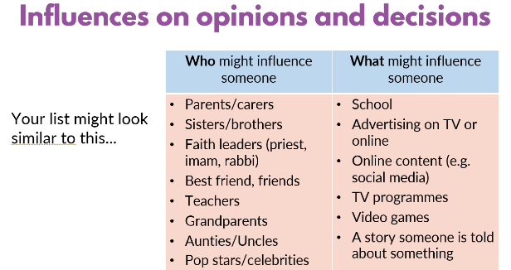 |  | Rule of Law
6 | Identify steps we can take to manage negative influences on our opinions or decisions. |  | - In different situations, some influences are stronger than others.  - Influences can be positive or helpful in some cases and negative or unhelpful in others.  - We can use different strategies in different situations, to manage influences that might affect our decisions.  - That respect and tolerance is given to all regardless of who they are  - But it is always a good idea to consider:  - who or what may be influencing our decisions,  - whether the influence is helpful or unhelpful  - why they might be trying to influence us (e.g. because they really want to help us, or to encourage us to spend money on something) | Quran and Sunnah being the main source of influence.  Surah Kafirun : they live their way we live ours , creates peace and respect/ tolerance | Rule of Law  Protected Characteristics: Marriage / House hold, Gender Race

UKS2 – Year 5-6
UNIT: Making Decisions
Key Vocabulary/Questions/Resources: Hadith, Quran: halal haram (right / wrong)
Week | Learning  Objective | Previous Lesson Recap | Teacher Led/Focus Groups and Independent  Differentiated Objectives/Activities | Plenary | COMPLIANCE LINKS  SMSC / Protective Characteristics / Fundamental British Values
1 | What is the purpose of life? | Islamic studies | - Teacher facilitating class through circle time opening up questions on who, where, what, why we are here? Discuss children’s feedback.  - What do you aspire to do/be when you grow up? Why? | - Explain life after: Life is a test / race …. comparable to a big game and the winner will receive a prize / trophy:  - Alazi khalaqal mawta wal hayat liyablu akum ayukum ahsanu amalah wahual azizuur gahfoor
2 | To identify the levels of Imaan |  | - Muslim , Mumin , Muhsin :  introduce and explain what the above terminology means  - Discuss ways in which these levels can influence a person's actions : talking partners  Children to share their examples of what level they feel they fit into share examples of how they aim to achieve more within the highest categorry and why what actions can you | Hadith of Badawi:
3 | To pillars of ibaadah |  | - Sincerity and conformance with sunnah to enable any action to gain reward | Ibaadah comprehensive term
4 | To identify actions can lose reward through certain emotions | Recap revisit first autumn term 1 | - Riya (showing off) as an emotion  - Pride – what happened Iblis  - (showing off to feed your pride)  - Explain pride as in a parent feeling proud of their child's achievement
5 | To understand that we have an obligation to actively do good and prevent harm |  | - Community level  - And individual level  - Surah asr 4 criterias of salvation doing good is one of them (teacher to visit tafseer of surah asr)  As muslims it is a duty and is rewarded | I heard the Messenger of Allah (ﷺ) say, “Whosoever of you sees an evil, let him change it with his hand; and if he is not able to do so, then [let him change it] with his tongue; and if he is not able to do so, then with his heart — and that is the weakest of faith.” [Muslim] | SMSC: social  FBV: Democracy
6 | To be able to deal with negative emotions |  | TEACHING POINT:  We all will go through many emotions in life good and bad,  - Explain negative emotions hardens the heart and takes us away far from Allah and being able to do good and gain rewards.  Hadith of heart:  Beware! There is a piece of flesh in the body if it becomes good (reformed) the whole body becomes good but if it gets spoilt the whole body gets spoilt and that is the heart. Bukhari  Introduce concept of Envy (read up on Envy on purification of heart book)  Have  To manifest envy is to manifest (introduce word manifest similar to have) one of the characteristics of the most wretched creature, Satan. |  | FBV: Mutal Tolerance  Smsc: Spirituality, Moral

Development of Emotional Intelligence:
Standards and Indicators

- Students will acquire the knowledge attitudes and interpersonal skills to help them understand and respect self.
- Students will make decisions, set goals and take necessary action to achieve goals.
- Student will understand safety and survival skills

Note : To be used in conjunction with Purification of the heart, PHSE 2020 Framework and the schools Tarbiyah/Nurturing policy document
Teachers to derive Learning objectives using framework strands may cross reference other areas of the school curriculum; eg : Mental Health, Islamic studies, English , Science, Arabic/Quran studies.

Programme of study 6 units:

Autumn 1: Feelings | Spring 1: Making decisions | Summer1: Relationships

Autumn 1 Cycle A/B

Autumn 1: Feelings | Spring 1: Making decisions | Summer1: Relationships

Components | Quran and Sunnah | Indicators | Objective: | Practice
Self Awareness | Feelings  Verily, Allâh will not change the (good) condition of a people as long as they do not change their state (of goodness) themselves (by committing sins and by being ungrateful and disobedient to Allâh). (Ar Rad)  Hadith: Narrated by Anas bin Malik.  A man was with the messenger saw, when a man passed by, the former said: O messenger of Allah! I love this man, Allah’s messenger asked “Have you informed him?” He said “No” Allah’s messenger then said “Tell him that you love him” so he went up to the man and said to him” “I love you for the sake of Allah” and the other man replied back “ May Allah ,for whose sake you love me , love you”. | Feelings  - Identify and express feelings and emotions  - learn how to make and keep friends  - Know which emotions they are feeling and why  - Know the verses from the Quran and sunnah that support the children’s self-awareness | FOUNDATION/ KS1  Feelings  - Happy/ love  - Sad  - Anger | - Knowledge of Safeguarding Officers in school  - Worry box as a system in place for communication and support
 | Making Decisions  Hadith  Narrated Abu Sayed Al Khudri “Whosoever of you sees an evil, let him change it with his hand; and if he is not able to do so, then [let him change it] with his tongue; and if he is not able to do so, then with his heart and that is the weakest of faith.”  [Reported by Muslim] | Making Decisions  - Identify right and wrong (Halal/Haram)  - learn how to make the correct decision in different situations  - Understand that Allah sees all and hears all  - Know the verses from the Quran and sunnah that support the children’s self-awareness | Making Decisions  - Recognising situations which involves a decision.  Identify some decisions which a person could make, and who could help them (Drama)  - Describe how some decisions we make can be influenced by other people
 | Relationship  Surah Imran: And when you have decided, then rely upon Allah. Indeed, Allah loves those who rely [upon Him]. (3:159)  Hadith:  “The one who severs the ties with the relatives will not be among the first to enter Paradise.  (Al-Bukhari) | Relationship  Identify different family structure e.g.  Single parent, divorced, foster, adoption, 2 mums/ 2 dads  - identify people who are special to us (our own special people)  - explain what makes them special and why they are important to us  - describe how our special people care for us  - recognise how we can show we care for people special to us | Relationship  Encouraging pupils to reflect on special people in their own lives and helping them to:  - recognise the different ways family and friends care for each other.  - manage relationships positively in times of change.  - Recognise that families come in different forms | - FBV rule of law  - Behaviour policy  - Court / police  - Protected characteristic:
Self Management | Feelings:  Hadith: Narrated Abu Huraira, Muhammad said "The strong is not the one who overcomes the people by his strength, but the strong is the one who controls himself while in anger" Sahih al-Bukhari  Hadith: Narrated by Abu Hurayrah (may Allah be pleased with him) A man came to the Prophet (may Allah's peace and blessings be upon him) and said: "Advise me." He replied: "Do not get angry." The man repeated that several times and every time he replied: "Do not get angry.  Making decision:  Name of Allah : Sameer Al Baseer | Feelings  - Understand the need of self-control and how to practice it  - Identify personal strength and assets  - Learn techniques for managing strength and Conflict  - Manage their impulsive feelings and distressing emotions  - Know the verses from the Quran and sunnah that support the children’s self-management  Making decisions  - Identify Allah as unseen  - Accountability  - Iman : Muslim , Mumin , Muhsin  - Tafseer of Al Fatiha (map / sat nav )  - Life as a test (reward/sin)  Relationship  What is grooming?  Strategies of keeping physically & emotionally  Who are the special people who care for us | Feelings  - To be able to manage feelings and emotions | Parental engagement with school to work with behaviour policy – listening to their children.  Parent workshop to be organised.  - Tarbiyah doc  - PowerPoint on framework  FBV: Rule of law  Protected characteristics  Respect  Spiritual  Online safety (safeguarding)  PREVENT
Empathy | Hadith: Narrated by the messenger (saw)  No one is a true believer unless he desires for his brother that, what he desires for himself. (Bukhari)  Hadith: Qays ibn Sa’d reported: A funeral passed by the Messenger of Allah, peace and blessings be upon him, and he stood up. It was said to him, “It is a Jew.” The Prophet said, “Was he not a soul?” | - Recognise, accept and appreciate individual differences.  - Show sensitivity and understands other perspectives.  - Helping others; based on other people's needs and feelings. (F, R, M)  - Know the verses from the Quran and sunnah that support the children’s Empathy. (F, R, M) | - To show sensitivity and understand other perspectives.  (F, R, M) | SMSC
Social Awareness | Hadith: Narrated by; Al-Nu’man ibn Bashir .  The Messenger of Allah, peace and blessings be upon him, said, “The parable of the believers in their affection, mercy, and compassion for each other is that of a body. When any limb aches, the whole body reacts with sleeplessness and fever.”  Quran: Hujarat v 13:  O mankind, indeed, We have created you from male and female and made you peoples and tribes that you may know one another. Indeed, the most noble of you in the sight of Allah is the most righteous of you. Indeed, Allah is Knowing and Acquainted. | - Recognise accept and appreciate ethnic and cultural diversity  - recognize and respect differences in various family configurations  - Demonstrate a respect and appreciation for individual and cultural differences.  - Know the verses from the Quran and sunnah that support the children’s Social Awareness  (F, R, M) | - Children to be able to implement  - and practise skills learnt outside their own environment and scenarios.  (F, R, M) | - Childline  - NSPCC  - Litter picking  - SMSC  - PREVENT Radicalisation

EYFS – Nursery / Reception
UNIT: Relationships

Key Vocabulary/Questions/Resources: Hadith, Definition, Compilation, Qudsi, : Key vocabulary : Emotion
Week | Learning  Objective | Previous Lesson Recap | Teacher Led/Focus Groups and Independent  Differentiated Objectives/Activities | Plenary | COMPLIANCE LINKS  SMSC / Protective Characteristics / Fundamental British Values
1 | To identify people who are special to us |  | - Re-cap and revisit - People who help us unit
2 | Describe how our special people care for us
3 | E- safety
4
5

KS1 – Year 1-2
UNIT: Relationships

Key Vocabulary/Questions/Resources: Hadith, Definition, Compilation, Qudsi, Key vocabulary : Emotion
Week | Learning  Objective | Previous Lesson Recap | Teacher Led/Focus Groups and Independent  Differentiated Objectives/Activities | Plenary | COMPLIANCE LINKS  SMSC / Protective Characteristics / Fundamental British Values
1 | To identify people who are special to us and the role that they play in our lives  That Families |  | - To identify the people who love and care for them and what they do to help them feel cared for.  - Hadith on mother x3  Other adults in your lives can also take a role of a mother, who may have the attributes of what a mother's role is e.g. grandmother, stepmother, father etc  Resource: Read books from selection based on different family structures  Orphan child Prophet pbuh was taken care by his uncle and foster mother and Grandfather |  | PC :Marriage civil partnership  FBV: MTR
2 | To understand what makes a good friendship  What is anger  What is  kindness |  | - Who do we call friends? Discuss what children want to see in a friendship?  - about what is kind and unkind behaviour, and how this can affect others  - Identify simple strategies to resolve arguments between friends. Positively how to ask for help if a friendship is making them feel unhappy. Kindness as a mark of faith (Hadith) |  | PC, FBV : Mutual tolerance and respect  SMSC: Spirituality
3/4 | To understand how to keep yourself safe in relationships. | Recap – Revisit secret/privacy healthy unhealthy relationships | Week 3  - Define what is a relationship?  - Identify the type of relationship that they know about  - Introduce concept of Privacy; some things are private and the importance of respecting privacy  - Secrets vs Privacy  - healthy and unhealthy times of keeping things private or as a secret  - the support of Allah is there to enable you to do the –make the right choice of breaking a secret/ privacy nothing is hidden from Allah and there is a reward in protecting yourself and others from harm  Week 4  - What body parts are private  - that parts of their body covered by underwear are private  - how to respond safely to adults they don’t know  - about how to respond if physical contact makes them feel uncomfortable or unsafe  - basic techniques for resisting pressure to do something they don’t want to do and which may make them unsafe  - Introduce that similar experiences can be felt online without direct contact  - Islam instructs us to keep our self away from any harm and to protect yourself. (Also, Honesty, not keeping secrets from family members) |  | RSE: safeguarding: keeping self safe from harm  Healthy living and Relationships  Online safety
5 | To understand the importance of always letting a person you trust know about what you do online |  | - Define what online means  - Identify devices that can be used to go online  - Describe incidents or activities where chn can accidently be directed to sites where they didn’t intend  - Introduce and explain the Islamic concept of lowering the gaze or using the blessing of the eyesight appropriately  (There is nothing in the body less thankful than the eye, so do not give it what it asks for, as it will occupy you from remembering Almighty God.)  - Expand negative behaviour by online predators that sometimes people may behave differently online, including by pretending to be someone they are not  - what to do if they feel unsafe or worried for themselves or others; who to ask for help and vocabulary to use when asking for help; importance of keeping trying until they are heard.  Islamic taribiyah: Honouring parents and elders, being brave and always speaking the truth |  | Organise parent e- safety around dangers online safety workshop  Eg parental controls
6 | Purification of Heart:  To understand the importance of forgiveness in strengthening positive relationships  Experiencing letting go |  | Introduce what forgiveness is– expand from some of Allah’s name relating to forgiveness Al Ghafar , ‘The All Forgiving’ and Al Ghafur ‘The forgiving’  Go through scenarios and identify within their own experiences when they have used this emotion  How did they feel when they forgave?  There is a reward in forgiving others hence the heart feels good and you feel good  Abstract scenario with an object where all chn take part in a practical exercise  (hold an object for 2-3 min facilitate by speaking after 2 min  How does it feel? Does your arm ache? Tell chn to put object down, facilitate ask Q: how does it feel , does it feel light? do you feel free from the weight and pain translate this scenario by explaining to forgive is to remove the pain and hurt felt emotionally and letting go is feeling free  Let them pardon and overlook. Would you not love for Allah to forgive you? Allah is Forgiving and Merciful.  Surat An-Nur 24:22

LKS2 – Year 3-4
UNIT: Relationships

Key Vocabulary/Questions/Resources: Hadith, Definition, Compilation, Qudsi, : Key vocabulary : Emotion
Week | Learning  Objective | Previous Lesson Recap | Teacher Led/Focus Groups and Independent  Differentiated Objectives/Activities | Plenary | COMPLIANCE LINKS  SMSC / Protective Characteristics / Fundamental British Values
1 | To identify people who are special to us  explain what makes them special and why they are important to us  To recognise that there are different types of families/households | Revisit and expand on relationships | - Hadith mother x3  - Other adults in your lives can also take a role of a mother, who may have the attributes of what a mother's role is e.g. grandmother, stepmother, father etc  - Resource: Read books from selection based on different family structures  - Orphan child Prophet pbuh was taken care by his uncle and foster mother and Grandfather  - Single parent, adoption, foster, different households e.g. 2 mums (use books: invisible string, mum and dad glue etc...  - No compulsion in religion / kafiroon / hadith your neighbour has a right over you.  - that people who love and care for each other can be in a committed relationship (e.g. marriage), living together, but may also live apart  - that a feature of positive family life is caring relationships; about the different ways in which people care for one another |  | PC- marriage  FBV:IL, MTR
2 | To Identify Sadness  how it can lead to Harm: Depression  Identify how to overcome sadness |  | - What does it mean or feel to be sad?  - Discuss scenarios using family structures as point when someone can feel this emotion eg Divorce, Death, someone walking away giving up -  - Evaluate real sadness from what it means to children in this day and age and allow them to compare with those that have less than them and those who have experienced sadness elsewhere  - Introduce gratitude as a remedy to sadness.  Talk about the time Rasul Alllah s(aw) felt this emotion of sadness (year of sorrow)  Explain what Depression is (a deeper level of sadness that may lead to harm) touch on self-harm /suicide / ,mental health  (analogy of fire in a house – depression is calling out for help as you would do to put out a fire in a house)  - Revisit worry box, safeguarding lead and teachers / people they trust and ChildLine as point of calling for help  Explain feeling depressed is like giving up hope and Islam instructs to seek help and have hope  “Certainly, we have created man to be in distress.” Balad Ayah 4  NOTE: It is very important to note here that Islam did not come to eliminate sadness; it came to teach us how to regulate it. | Show this video:  https://web.microsoftstream.com/video/c161c0e2-d821-43bc-9a41-d5faf6ff41ef | MH – Bereavement / divorce  RSE Marriage and civil partnership (household structures)  FBV- MTR  Growth mindset  Safeguarding  See your school MHFA LEAD
3 | To understand that kindness is a mark of faith. |  | Showing kindness to the people around you, family, friends and people from different backgrounds and opinions. Also online interactions.  Talk about the importance of friendships; strategies for building positive friendships; how positive friendships support wellbeing  Hadith: kindness as a mark of faith  - about the importance of friendships; strategies for building positive friendships; how positive friendships support wellbeing  - what constitutes a positive healthy friendship (e.g. mutual respect, trust, truthfulness, loyalty, kindness, generosity, sharing interests and experiences, support with problems and difficulties); that the same principles apply to online friendships as to face-to-face relationships |  | FBV: MTR  Growth mindset
4 | To know what to do when there is a conflict | Recap revisit emotion unit on anger | Reinforce behaviour policy procedures: by upskilling chn with their communication skills:  Break down the word conflict  - Develop strategies e.g.: school councillors, safeguarding officer, writing a note on worry box, breathing techniques,  Prophet pbuh taught us to remain calm, to collect thought before any reaction – Patience  Islam emphasises and encourages patience in any conflict management and resolution process. Muslims are encouraged to remain patient when faced with hardships to success (Quran, 3:200)  - Technique of Listening and remaining calm  Breathing (revisit emotion anger) hadith on reward of one who controls anger Abu Umamah reported: The Messenger of Allah, peace and blessings be upon him, said, “I guarantee a house on the outskirts of Paradise for one who leaves arguments even if he is right, and a house in the middle of Paradise for one who abandons lies even when joking, and a house in the highest part of Paradise for one who makes his character excellent.”
5 | To understand how anger and pride are barriers that breakdown relationships. | Recap revisit anger | How do you feel when you have an argument or disagreement with someone? What feelings are felt towards that person?  What could be the consequences of these actions?  Pride as an emotion and its harms and treatment (source purification of the soul book)
6 | To understand the importance of forgiveness in strengthening relationships |  | Children to share experiences of when they forgave someone or was forgiven by someone. How did it feel?  Abstract scenario with an object where all chn take part in a practical exercise  (hold an object for 2-3 min facilitate by speaking after 2 min  How does it feel? Does your arm ache? Tell chn to put object down, facilitate ask Q: how does it feel, does it feel light? do you feel free from the weight and pain  When you do not forgive, how does it make you feel? How does it affect your relationship with the other person? | Abu Huraira reported: The Messenger of Allah, peace and blessings be upon him, said, “When Allah completed the creation, he wrote in his book with him upon the throne: Verily, my mercy prevails over my wrath.”

UKS2 – Year 5-6
UNIT: Relationships

Key Vocabulary/Questions/Resources: Hadith, Definition, Compilation, Qudsi, : Key vocabulary : Emotion
Week | Learning  Objective | Previous Lesson Recap | Teacher Led/Focus Groups and Independent  Differentiated Objectives/Activities | Plenary | COMPLIANCE LINKS  SMSC / Protective Characteristics / Fundamental British Values
1 | To develop confidence when facing and addressing a difficulty |  | - Expand emotions: Confidence and Trust (Tawakul)  - Hadith 19 Imam Nawai  - About marriage and civil partnership as a legal declaration of commitment made by two adults who love and care for each other, which is intended to be lifelong | Tawakkul in Allah when choosing to do the right thing – no harm will come | SMSC: Spiritual Development
2 | To know about taking care of their body.  - To understanding that they have autonomy and the right to protect their body from inappropriate and unwanted contact.  - To judge what kind of physical contact is acceptable or unacceptable and how to respond.  - To understand the concept of ‘keeping something confidential or secret’, when we should or should not agree to this and when it is right to ‘break a confidence’ or ‘share a secret’. |  | What can we do when things do not feel right?  - Concept of lowering gaze:  - Romantic love and love as a universal concept  - Teaching respect for others e.g. their body space and right  - What is a Secret? Explain healthy and unhealthy situations.  - Knowing who to go to if you are worried about your health.  - Secret developed online /offline  - that forcing anyone to marry against their will is a crime; that help and support is available to people who are worried about this for themselves or others  - to recognise other shared characteristics of healthy family life, including commitment, care, spending time together; being there for each other in times of difficulty  - how to recognise if family relationships are making them feel unhappy or unsafe, and how to seek help or advice | Islam teaches you to look after yourself both physically and mentally we are regarded as whole being  Emotional and romantic Love exist in a Marriage Relationship as sacred unit to express Love  Showing respect to different households and non-marital relationships as an Islamic duty. | SRE, online safety: cyber bullying  Child protection  FBV  Individual liberty.  PSHE: HEALTH AND WELLBEING Healthy lifestyles (physical wellbeing)
3 | To recognise ways in which a relationship can be unhealthy and who to talk to if they need support. |  | - Ask the children to think about their relationships What ‘rules’ both specific and general, must they keep in order to get along with them?  - What happens if the rules are broken or changed, or if the relationship changes in ways which cause concern or unease, or which puts pressure on them?  - Responsibility of managing your own health in terms of getting help and support for all types of harm both visible and non-visible (emotional) harm.  - how and when to seek support, including which adults to speak to in and outside school, if they are worried about their health  - Discuss with chn people they may follow / look up to in the media e.g. social media e.g. influencers / film and entertainment industry | Chn will be able to:  - describe some of the ways people might behave in an unhealthy relationship.  - name people we can talk to if we feel uncomfortable or worried.  - explain what grooming is and some of the ways of recognising it.  - e.g. online (including social media, the responsible use of ICT and mobile phones).  - Islam and role model as influencers | Safeguarding  Online safety  FBV:  - individual liberty,  - Mutual tolerance and respect  - Rule of law  - PC: civil partnership marriage, sexual orientation gender reassignment  - RE  - Healthy eating (Bulimia, anorexia, six pack etc)
4 | To identify what can be harmful grooming | Recap on week 3 media influencers and followers | Grooming breakdown,  Online and physical grooming eg gangs, misled by social followers/ influencers/ sexual predators, radicalisation  Islam says it is a duty to protect oneself from any harm)  Daily adhkaars as a protection  Wisdom, honesty and sincerity as an emotion |  | Safeguarding policy: county line eg gangs  Prevent
5 | To develop strategies for keeping physically and emotionally safe | Recap revisit emotion / feelings | - Physical safety, eg Drugs, intoxicant addiction (games tv, alcohol) peer pressure, lowering gaze (soft porn) Cp up skirting, Epstein  - about the risks and effects of legal drugs common to everyday life (e.g. cigarettes, e-cigarettes/vaping, alcohol and medicines) and their impact on health; recognise that drug use can become a habit which can be difficult to break  - to recognise that there are laws surrounding the use of legal drugs and that some drugs are illegal to own, use and give to others  - about why people choose to use or not use drugs (including nicotine, alcohol and medicines);  - about the mixed messages in the media about drugs, including alcohol and smoking/vaping  - about the organisations that can support people concerning alcohol, tobacco and nicotine or other drug use; people they can talk to if they have concerns | That some mubah/ permissible acts can become harmful  Worry box  Safeguarding officers  School councillors  Childline  Police | Mental Health  Policy: Up skirting keeping safe
6 | To discuss and debate topical issues, respect other people’s point of view and constructively challenge those they disagree with | Recap revisit surah kafiroon  Genders, transgender / different households | Discuss that for some people gender identity does not correspond with their biological sex (Hijrah community in India)  Also discuss about case of age identity not corresponding with body appearance |  | Public speaking skills  FBV: MRT  Protected characteristic: gender,

PSHE ISLAMIC TARBIYAH/ NURTURING

ADDEDNUM

Nurturing Young Minds / Tarbiyah

At Buttercup Primary School we have a vision and devised an integrated approach to education that seeks to nurture the character and inner spirit of children and empower them to self-discovery, wholeness and social consciousness. The result has been a distinctive and powerful approach to contemporary Islamic education.
The term tarbiyah, it is one of the truly beautiful words in Arabic deeply rich in meaning. Usually it is translated as education.
The word tarbiyah means, "to cause something to develop from stage to stage until reaching its completion [full potential]."5 This implies that something (the fitrah, or intrinsic nature) already exists within the child and that education is a process of unfolding and bringing out, more than a process of instilling and pouring in. This is similar to the modern-day notion of developmental stages.

Tarbiyah / Nurturing:

- Human development in general,
- Curriculum development,
- Staff development (both professional and personal (including spiritual development)
- Community development (including parent education and community service learning

building (tarbiyah), Nurture i.e., empowering students, in the educational process, both in their own personal growth and within the educational experience as a whole. The implantation of this is therefore built around the PSHE 2020 framework.
The following are key areas of development in achieving

The school curriculum focuses on several areas of development in aiming to achieve this Tarbiyah, through continuous work within the school curriculum on Mental health, spiritual , moral , social as well as cultural development of our children. All of which are critical to the overall goal of total human development. Our main goal is to give the children a holistic environment so that they are able to gain experiences and necessary skills that are needed in a safe environment. So that they can be better prepared for their future life in this world and the next. Our children will be able show love tolerance and live amongst others who are indifferent from them , so that they build a bright future in this world together.

Islam-Imaan-Ihsan
Along with the principle of tawhid, the Tarbiyah utilizes a broad understanding of the concepts of islam, iman and ihsan as key elements of its educational model. Here, these elements represent the dimensions of: 1) doing, body, kinesthetic (islam) ; 2) knowing, mind, cognitive (iman); and 3) being, soul, affective (ihsan).
We have used the 3 areas to adapt a curriculum that has 7 elements .Each of the seven elements of the model is directly connected to Islam , Iman and ihsan the tarbiyah / nurturing model is therefore fully integrated. To reflects the philosophical and pragmatic view of the nature of the curriculum and instruction. The concept of tawhid is the central, pivotal element in the model

Key Principles

Fitrah.
Each child is endowed with a God-given nature, known as the fitrah. Like the seed of a tree, it contains the essential programming needed to grow. In the right environment, it will naturally unfold and develop. This is contrary to the notion of tabula rasa (blank slate) of John Locke and others, and suggests instead the complementary blend of both nature and nurture.
Uniqueness. Each child (and each brain) is unique, based on the unique genetics, natural talents and life experiences of that child. Each child has his or her own individual personality, temperament and abilities. This is the individualized part of the child’s fitrah, the part that makes him or her a unique creation of God. Education must acknowledge this unique aspect of each child—and that children are not identical objects on an assembly line.

Holistic: Tawhīd. Authentic education must encompass and engage the whole child—spiritually, morally, intellectually, physically, emotionally and socially. It must open up to the child a “big picture” view of the world as a network of interconnected and interdependent relationships and systems. Ultimately, holistic education must seek to connect the heart, mind and soul of the learner experientially to the Source of all wholeness, holiness and wellbeing.
Integrative: Tawhīd. Education must be integrative in the broad range of topics it addresses and its treatment of these topics; integrative across time, place and cultures; integrative across the curriculum; integrating knowledge, beliefs, and values with action, application and service. These integrative aspects have the potential to truly enhance the power of the learning experience. Additionally, learning is mind-body integrated. All learning is dependent on the body's physiological state. Nutrition, hormones.
Developmental Stages: Tarbiyah. Developmental windows for learning exist, but vary between children. Children develop in stages as a function of natural gifts, genetics and environment. As noted earlier, the word tarbiyah itself conveys this idea of developing from “stage to stage” until reaching one’s full potential.
Emotion-based: Ayat Allah. Emotion drives attention, motivation, meaning and memory. Emotional experiences code our learning as important.23 The Quran draws our attention to the fact that awe, wonder and “being there” experience are the natural starting point of the learning process. Conversely, stress & threat inhibit normal learning and thwart its effectiveness.24
Pattern & Meaning Seeking: Sunnat Allah. We gain meaning through patterns; meaning comes from understanding the larger pattern of things. In search of meaning, the brain seeks patterns, associations and connections between new data and prior knowledge.25 This search for meaning is innate.
Intelligence and understanding are the ability to make connections and construct patterns.26 The Quran calls us to discover the recurring “patterns” in nature and human history.
Challenging (Enrichment): Ibdā’. Students must be challenged to thoughtfully examine what they are studying, to participate assertively in group discussions, to work productively in cooperative learning activities, and to come to grips with controversial issues. Such activities and experiences help foster the skills needed to produce competent citizens able to present and defend their beliefs and principles effectively. Challenging, authentic learning stimulates curiosity, creativity and higher-order thinking.
Higher-Order Thinking (Problem Solving): Ijtihād. Higher-order thinking involves the manipulation of information and ideas by synthesizing, generalizing, explaining, hypothesizing, or arriving at conclusions that produce new meaning and understanding.27 Of course, the brain is continuously responding and adapting to the changing requirements of the environment; humans have survived throughout the ages by problem-solving and flexible thinking.
Deep Knowledge: Hikmah. Understanding (and wisdom) is a key goal of knowledge and education. “Deep knowledge” involves addressing the central ideas of a topic or discipline with enough thoroughness to explore connections and relationships, and to produce complex understanding.28 The Quran (62:2) notes that the real goal of knowledge is deep understanding (hikmah, or wisdom), not information.
Hands-on (Active): Amal. Like the roots of a tree, children must get their hands dirty in order for knowledge and understanding to take root.29 This is done through active learning experiences. Effective teaching and learning must emphasize hands-on and minds-on activities that call for students to interact with what they are learning and use it in their lives in some meaningful way. Teachers must be prepared to take advantage of unfolding events and teachable moments to develop examples that relate directly to students, and to implement other practices that facilitate active and meaningful instruction. One of the major, recurring themes of the Quran is the importance of

joining theory with hands-on practice and application.
- Real-world Connections (Relevance): Students should feel that the content they are studying is worth learning because it is directly meaningful and relevant to their personal lives (lifestyle/lifeway). Students must see the usefulness and potential application of knowledge to their everyday lives. Real-world connections involve making connections between the knowledge gained and the larger issues of the world outside the classroom.
- Values-based: Akhlaq. By focusing on values and by considering the ethical dimensions of topics, education becomes a powerful vehicle for character and moral development. Educators need to realize that every aspect of the teaching-learning experience conveys values to students and provides opportunities for them to learn about values.
- Social Brain (Substantive Conversation, Cooperative Learning): Hiwar, Ta’awun. Language is the primary means of human communication. A great deal of learning takes place by talking and interacting with others, especially in learning communities. Substantive conversation involves dialogue and extended conversation with peers and experts about a particular subject or topic in order to build shared understanding. Groups, teams and cooperative learning experiences benefit our understanding of new learning and its application.30 Essentially, the Noble Prophet (?) utilized similar notions as social brain, substantive conversation, and cooperative learning in formulating the learning communities of early Islam.31
- Non-conscious Learning (Modeling): Qudwah, Suhbah. Much of what we learn is not taught directly, but simply "picked up." Real learning is not forced, but orchestrated. This highlights the importance of association, role- modeling and mentoring. In fact, the Companions of the Prophet (?) received their special designation of sahabah because of their association with him in this type of learning community.

Educational Aims
The overall framework is set out of broad educational aims that has been articulated in the PSHE 2020 document and the schools islamic ethos. Accordingly, the aim of Islamic education is to produce a total, well- rounded person who is:
- God-conscious: Is aware of God and the interconnectedness of creation in all that one thinks, feels and does. (Tawhīd – Unity & Systems)
- Principled: Has a sound grasp of the principles of moral reasoning and a commitment to self-reflection, self-direction, and moral action, with an emphasis on integrity, honesty, compassion and justice. (Tazkiyah – Power/Force, Duality, Causation)
- Knowledgeable: Has a deep understanding of the major patterns and recurring issues of humankind and the impact of significant events and discoveries on the course of human development. (Hikmah – Space, Relations & Structure)
- Well-balanced: Understands the scope and importance of balance and wellbeing in one’s personal and collective life, and actively works to establish it therein. (Istiqāmah – Form & Substance)
- Cooperative: Has an understanding of the role of good communications, cooperation, fairness, and friendship in establishing and maintaining meaningful and healthy relations between individuals and groups. (Ihsān
– Motion & Interaction)
- Committed: Has a commitment to a lifestyle consistent with the principles and practices of Islam, especially as reflected in one’s daily interactions with others. (Dīn – Time & Pattern)
- Caring: Has a strong sense of caring, stewardship, service and social activism, and a commitment to using one’s life to make a difference in the world. (Amānah – Function & Outcome)

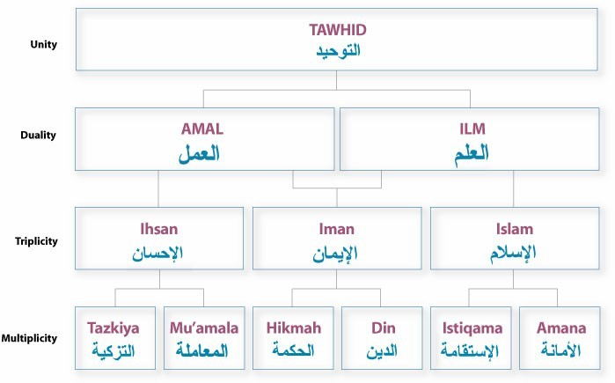
Figure 4: Tarbiyah Curriculum Framework

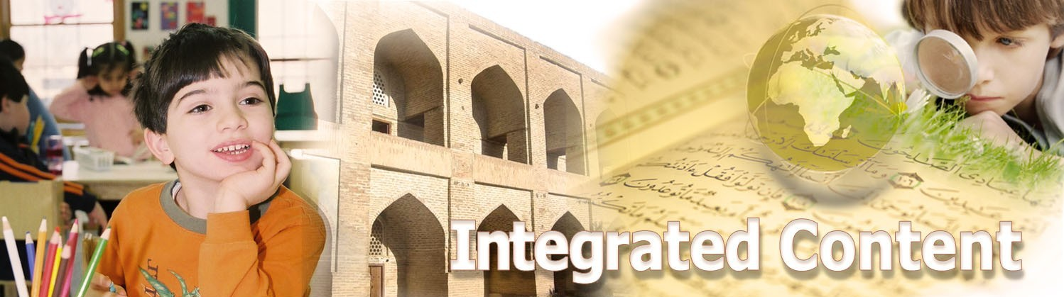

Seven Integrated Strands
Within the Nurturing framework, the curriculum is closely tied to the universal structure presented in the previous section and to its seven principal components. It is worth noting here that the Quran (15:87) similarly refers to the “recurring seven.”40 These components represent the seven developmental areas, or strands, that constitute the holistic makeup of the child and his connection to the world. These strands comprise the rope, or handhold, that a student needs to develop in order to maintain a state of balance and wellbeing (istiqamah) throughout life. Muslims are instructed to pray and work towards this central goal every day.

Framework of Knowledge, Education & Personal Development

1 2 |  |  |  | 3 | 4 | 5 | 6 | 7
 | Islamic | Tawhīd | Tazkiyah | Hikmah | Istiqamah | Ihsan | Din | Amanah
Education | Educational | Spirituality | Character | Wisdom | Wellness | Interactions | Lifestyle | Stewardship
 | Curricular | God- awareness | Noble Character | Useful Knowledge | Healthy Living | Human Relations | Daily Living | Public Service
 | Instructional | Curiosity | Character | Contemplation | Connections | Collaboration | Cultivation | Caring
 | Learning Styles* | Existential | Intrapersonal | Cognitive** | Bodily | Interpersonal | Artistic | Natural
 | Interrogative | Wow | Who | Where | What | How | When | Why
Development | Transformational | Spiritual | Moral | Intellectual | Physical | Emotional | Creative | Social
 | Character | Wholeness | Goodness | Wiseness | Uprightness | Kindness | Integrity | Justness
 | Outcomes | God- conscious | Principle d | Knowledgeabl e | Well- balanced | Cooperative | Committed | Responsible

In addition to integrating the content of the curriculum, a second issue here is integrating our view of the child—as a whole person.

For most people, the practical goal of education is to fill a student’s mind with as much information as possible (even if much of it is quickly forgotten or becomes obsolete). The real purpose of education, however, is for a goal far greater than this, which is to guide and assist students in their overall development as whole people. This is the heart of real education: total human development.

The Content Strands
Each strand of the Tarbiyah curriculum revolves around a single universal concept, or big idea, along with a set of ancillary concepts and themes. These concepts are woven together within and between the other strands of the framework. Structurally, each strand consists of three major learning threads, known as powerful ideas. These correspond to the three learning domains of affect (feeling, ihsan), cognition (knowing, iman) and kinesthetics (doing, islam) This guarantees the integration of these three dimensions into each strand of the curriculum.
The structure and components of the Tarbiyah curriculum are listed below, followed by a brief overview of the seven strands of the curriculum.

Spiritual Literacy
God Consciousness: Wholeness, Holiness & Systems
- Awe & Wonder: Discovering God's Wonder
- Wholeness & Worldview: God, the World & Me
- Faith & Piety: Building on Faith

Moral Literacy
Noble Character: Force & Causation
- Values & Identity: Knowing Yourself
- Conscience & Conviction: A Heart of Gold
- Character & Conduct: Actions Speak Louder

Intellectual Literacy
Useful Knowledge: Space, Connection, Relation, Structure
- Learning & Literacy: Learning to Learn
- Useful Knowledge: Love of Learning
- Problem Solving: Finding Solutions

Physical Literacy
Healthy Living: Form & Proportion
- Health & Wellness: The Sacred Vessel
- Fitness & Exercise: Keeping in Shape
- Recreation & Enrichment: Renewing Ourselves

Interpersonal Literacy
Human Relations: Motion & Interaction
- Communications & Understanding: Understanding & Being Understood
- Relationships & Cooperation: Getting Along With Others
- Community & Belonging: A Sense of Belonging

Cultural Literacy
Daily Living: Time, Pattern, Change
- Culture & Confidence: Drawing Strength From the Past
- Lifestyle & Modern Living: Islam a Way of Living
- Change & Challenges: Facing the Challenge, Facing the Future

Social Literacy
Public Service: Function, Purpose & Outcome
- Justice & Peace: Caring for Allah's Creation
- Service & Stewardship: Making a Difference
- Exampleship: Leading by Example

Strand 1: Spiritual Literacy
God-consciousness (Tawhīd – ﻟاﺘوﺤﻴد)

Spiritual literacy is the first strand of the Tarbiyah curriculum. Its main theme is oneness, unity and systems. It is the center point and pivot around which all the other strands of the curriculum connect, emanate and return. This reflects the view that God is the beginning and the end of the cycle of creation and existence (Quran 37:4), and that spiritual literacy is the central aspect of the child’s wholesome (holistic) growth and development. When nurtured properly, it plays a constructive and transformative role in the life of the individual and society. This is done by opening up to the child a sense of the creative power (jalāl), beauty and wonder (jamāl), and perfection (kamāl) of God’s work in creation, and by guiding the child to discover the underlying universal pattern (sunnah) that is woven throughout all of it.
Spiritual literacy is rooted in the concept of oneness (tawhīd). This is the foundational principle of Islam and its worldview. The Quran (37:4) makes clear this central principle of oneness:

“Your God is surely One, Lord of the heavens and earth and what is between them both.”45

The Islamic worldview is therefore rooted in the belief that there is a single and sole creative force responsible for the cosmos and that the One God created and unified the elements of creation within a single, integrated system, known as the uni-verse.
Oneness is the main idea and central concept of this strand of the curriculum. Wholeness, wholesomeness, holiness (sacredness) and unity, along with the concept of “systems,” are the key concepts of this unit.46
Also related are the concepts of integration, completeness, synergy, simplicity and identity. All of these are important conceptual building blocks in the child’s construction of his view of the world and his place in it.
Unity in Diversity is the overarching theme of this unit. Realizing the underlying unity of creation, despite its multiplicity and diversity of forms and functions, is one of the key learnings of the unit. The goal here is God- consciousness, or being fully and continually aware of God in all that one thinks, feels and does. This means being aware (‘ilm) of the sacred imprint of God (‘alamāt) in creation (‘ālam). This means discerning the universal paradigm that unifies creation into a single, whole system all the parts of which, by their very existence, are in constant praise (tasbīh) of the Creator (Quran 17:44 and 24:41).
Awareness of God and the sacredness of God’s creation is, at its core, the heart of spiritual and religious education.

Modern man has cut himself off from this sense of the sacred. The challenge for educators today is how to restore to wholeness the connection between the children of modernity and the sacred vision of life and creation that was once their heritage. Developing the student’s sensibility (taqwa) to the presence of God, through His ever-present signs, and to the interconnectedness of creation is the central goal of the unit. Further, the goal is to develop his/her understanding of God’s unfolding plan for the world and man’s role in it, nurturing in each student a personal commitment to God and to a life of spiritual piety and discipline.

Strand 2: Moral Literacy
Noble Character (Tazkiyah – ﺔ&ﻟاﺘزﻜ)
Moral literacy is the second component of the Tarbiyah curriculum, which focuses on the moral aspect of the child’s development.
The Noble Prophet (?) said that in order for belief to have real meaning it most be translated into action. Ultimately, it is how we treat other people (mu’āmalāt) that reflects our true beliefs and values (dīn).
The goal of this component of the curriculum is noble character. The Quran (62:2) suggests that, after God-consciousness, character is the next important building block in the process
of human development. The focus of this part of the curriculum is developing a solid understanding of what good character is and helping students to achieve it in their personal lives by adopting a moral lifestyle. This includes the areas of moral knowledge and reasoning, moral feelings or conscience, and moral actions or character. This component addresses such issues as values clarification, goal setting and decision making, and includes such concepts as moral tradition, ethics, conscience, self-control, empathy, free will, and other issues of related to character development.

Strand 3: Intellectual Literacy
Intellectual literacy is the third component of the curriculum. This focuses on the intellectual
aspect of the child’s development. In the Islamic view, knowledge is closely related to character and, ideally, these two elements are mutually inclusive and interrelated. That is to say, knowledge aids us in understanding the requirements and benefits of noble character, and noble character prepares us to receive the sacred gift of knowledge (‘ilm) and wisdom (hikmah).

Useful Knowledge (Hikmah – ﻤﺔ)ﻟاﺤ)
Useful knowledge is the aim of this component of the curriculum. Useful knowledge is all knowledge that brings us closer to God and can be used in a positive way to benefit humanity and creation.
Seeking this knowledge is an obligation for each and every Muslim. This component focuses on developing in students a love of learning and training them in how to learn and other habits of mind. Integrated subject area knowledge (from various disciplines such as Mathematics, English, etc.) as well as training in critical thinking and problem solving are important components of this segment of the curriculum. Together, they provide students with the knowledge base and intellectual skills needed to succeed in their quest to discern the universal patterns (sunan) in creation, as well as to succeed academically and to handle the challenges they will face later in life and society.

Strand 4: Physical Literacy
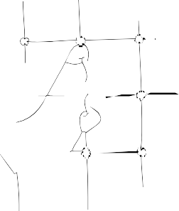
Healthy Living (Istiqāmah – ﻹاﺴﺘﻘﺎﻤﺔ)
Physical literacy is the fourth strand of the curriculum and focuses on the physical aspect of the child’s development. In the Tarbiyah framework, this is not an ancillary or secondary part of the curriculum. It is an essential and integral part, because all other aspects of human development are tied to it and are expressed through it. Spiritual, moral and intellectual development all depend on a healthy body. This reflects the integrated (and paradoxical) nature of human development.

The aim of this component of the curriculum is healthy living. This emphasizes that health is an important part of total human development and highlights that our body is a perfectly designed system and one of God’s greatest miracles in creation. It further emphasizes the responsibility we have as individuals towards our health as a God-given trust (‘amanah). Fitness, wellness and balance (istiqamah) are the key elements of this component.
of the curriculum. In addition, it explores with students a holistic and Islam view on such topics as personal hygiene, junk food, over-eating, smoking, drugs, consumerism and other key topics. Finally, recreation, rejuvenation and restoration, creativity and enjoyment are explored as important elements of a balanced lifestyle and of total human development.
These three components of the curriculum framework— soul, mind and body—focus on the various “internal” aspects of the learner as an individual. The next three components focus on the “external” aspects of the learner in relation to the larger society and the world.

Strand 5: Interpersonal Literacy Human Relations (Ihsān – ﻹاﺤﺴﺎن)
Interpersonal literacy is the fifth component of the curriculum, focusing on the emotional and interpersonal aspect of the child’s development. Human relations are a concern of all religions and philosophies.
Inherent to all of them is the tenet, “treat others as you would like to be treated yourself.” This is the golden rule of human relations. It is a principle that urges us toward the highest and
most equitable standards of behavior in all of our dealings with other people.
The aim of this component of the curriculum is good “human relations.” (husn al-mu’āmalah). Good human relations, however, do not just happen. They are the product of spiritual awareness, moral conscience and knowledge of the skills necessary for equitable and cordial relations between people. This part of the curriculum highlights the development of communication skills and the ability to live and work cooperatively as
part of a group. Also, it focuses on issues of identity and the sense of belonging to our families, communities and society at-large.

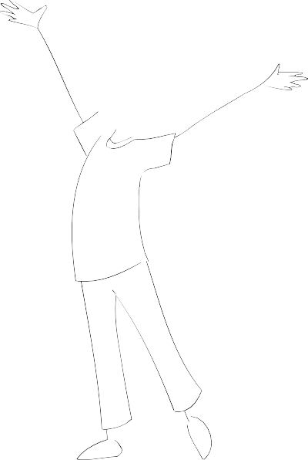
Strand 6: Cultural Literacy Daily Living (Dīn – ﻟادﻴن)49
Cultural literacy is the sixth strand of the curriculum.
This focuses on lifestyle and culture as part of human development. How we live, that is to say, our lifeway, is the clearest reflection of who we really are and what we really believe in, both individually and as a society. Working to align our lives with our principles and values is an important goal of holistic education.
The focus of this part of the curriculum is belief in action. The goal is to guide and assist students in translating their values into a way of living. This includes helping students understand the major, recurring issues of humankind and how previous generations attempted to address them, that Islam itself is a total and complete way of
living, and that Islam had and continues to have an important contribution to make in addressing the problems and challenges of humankind today and as we go into the future. This component includes such concepts as culture, tradition, lifestyle, integrity, change, challenges and futures.

Strand 7: Social Literacy
Public Service (Amānah – ﻷاﻤﺎﻨﺔ)
Social literacy is the seventh and culminating component of the Tarbiyah curriculum. It focuses on the social aspect of the child’s development. It represents the culmination of student learning in all areas of
character education because it is the application of the values that have been taught. As children and adults develop spiritually and morally, they realize that serving others is serving God.

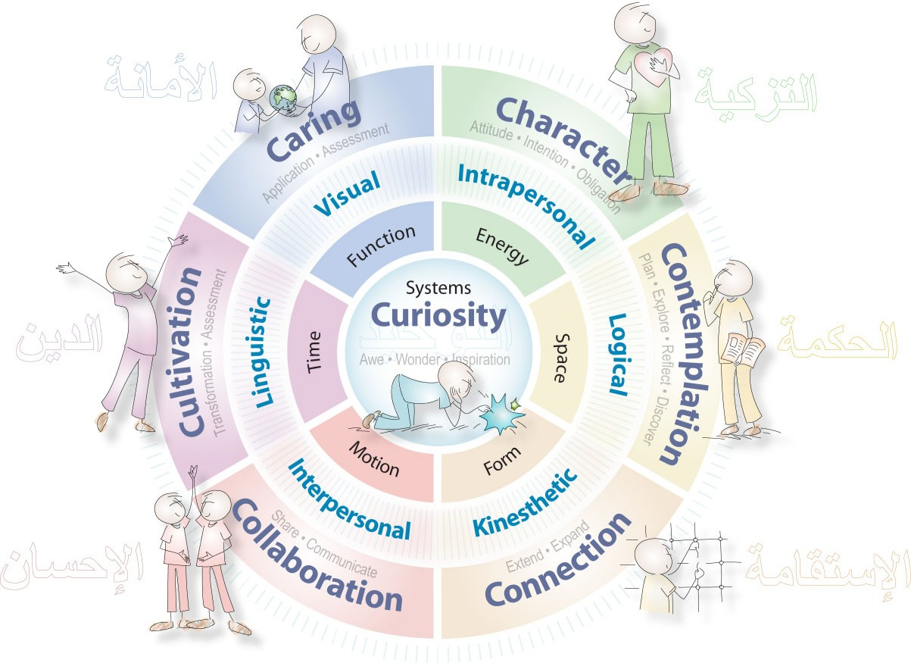

Figure 8: Integrated Learning Model, Seven C’s

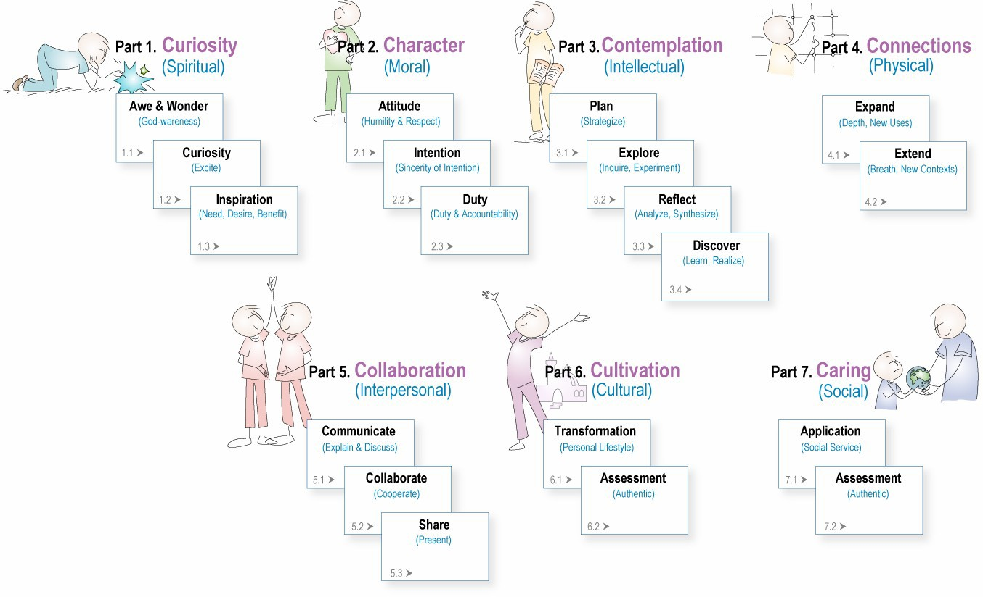

Figure 9: Integrated Learning Model, Components

The Process
The Integrated Learning Model consists of a 7-part process that parallels the seven content strands of the holistic curriculum. This effectively integrates both the content and process of learning into a single, unified learning system and eliminates the content-process dichotomy noted earlier.
This is a significant design feature of the nurturing model.
The seven components of this instructional model (referred to as the Seven C’s) are listed and then briefly described below:
- Curiosity: Awe & Wonder (Excite)
- Character: Purifying & Planning (Prepare)
- Contemplating: Exploring & Reflecting (Explore)
- Connecting: Thinking & Discovering (Extend)
- Collaborating: Communicating & Sharing (Exchange)
- Cultivating: Applying Personally (Transform)
- Caring: Applying Socially, Participating (Apply)

Phase 1: Curiosity (Spiritual Aspect)
In the Islamic view, knowledge and learning begin with and connect us inexorably with the Creator According to the Quran (62:2), the starting point of learning is experiencing the awe and wonder of God’s signs in creation (ayah). The first part of the learning process therefore involves guiding students to experience a sense of the awe & wonder of God’s creation (awe) through “being there” experiences. These signs are found in nature, history and in scripture, and are intended to “spark the interest” (motivate) and activate the heart and mind in the learning process. The experience of “awe and wonder” naturally and instinctively activates the child’s God- awareness, curiosity and interest in learning (wonder). Next, students are assisted in developing questions from these signs (ponder) that will guide their exploratory learning. Finally, in this initial phase, the importance and the benefit of the learning activity should be related to the child’s prior knowledge within the context of the child’s life as a whole (tawhid). From the Islamic perspective, this phase is essentially spiritual in nature and speaks to the existential aspect of learning.

Phase 2: Character (Moral Aspect)
Following the lead of the Quran, the second phase of the learning process consists of “preparation in character” (tazkiyah). Since
Islam sees the acquisition of knowledge as a sacred act and trust, it believes that a person must properly prepare (even qualify) himself before being a suitable receptacle for such sacred knowledge. Humility before God and purity of intention are the starting point of all actions in Islam, most especially learning.
The second aspect therefore involves assisting students in preparing themselves for learning. This includes:
- developing a sense of humility before the signs of Allah (humility);
- acknowledging the efforts and accumulated knowledge of earlier generations and drawing inspiration and courage from those efforts (respect & inspiration);
- understanding the real purpose of learning (purpose), 4) clarifying and aligning one’s intention accordingly (sincerity of intention),

56 The Quran (8:2) uses the phrase, “their hearts are humbled at the remembrance of Allah and when His signs are presented to them, they are strengthened in faith.”

5) realising that acquiring knowledge is a sacred activity that carries with it certain moral and social responsibility to action (‘amanah). This phase is essentially moral in nature and draws on the intrapersonal dimension of the learner.

Phase 3: Contemplation (Intellectual Aspect)
The third aspect of the learning process involves guiding students through the four steps of discovery learning. This includes:
- planning a strategy to find answers to their questions (plan);
- investigating by doing hands-on activities, using resources to gather information and recording their findings (explore);
- reflecting on their findings (reflect);
- summarising the new understandings they have learned (discovery). This phase is essentially intellectual in nature and focuses on the logical (cognitive) dimension of learning.

Phase 4: Connections (Physical & Practical Aspect)
The fourth aspect involves guiding students to solidify (i.e., make concrete and real) their new understanding by testing it in new ways (expand) and in new contexts (extend). This is done by making connections to other areas and contexts and to real world situations. This phase is practical in nature and incorporates the visual and kinesthetic styles of learning.

Phase 5: Collaboration (Interpersonal Aspect)
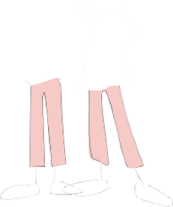
The fifth aspect of the learning process involves assisting the children in utilising cooperative learning
(collaboration) throughout the learning process, and assisting them in sharing what they have learned with different audiences in different ways (sharing), including through oral and written communication and multi-sensory, multimedia presentations (communication). This phase is primarily interpersonal in nature and incorporates the interpersonal and the verbal-linguistic styles of learning.

Phase 6: Cultivation (Cultural Aspect)
The sixth aspect of this model involves guiding students to examine and reflect on
the significance of what they have learned for themselves personally and to identify ways of applying it in their personal lives and
integrating it into their personal lifestyle (transformation). This phase includes ways of authentically assessing the student’s personal application of their learning (assessment). According to their age and ability, the student should play a key role in defining and carrying out this assessment.

The student’s Individualized Learning Map
should serve as a baseline for this assessment. From the Islamic perspective, this phase represents the true “transfer of knowledge” that teachers seek to achieve with their students. This transfer is not merely an intellectual change, but more importantly, a
psychological one, resonating at the core of who he or she is as a person. This phase is practical in nature and speaks to the visual-spatial dimension of learning.

Phase 7: Caring (Social Aspect)
The seventh and culminating aspect of the ILM² learning process involves guiding students to identify ways to use what they have learned by applying it for the
good of others through service (service). This should be in the form of service- learning projects that can function as a culminating and
authentic assessment of the learning unit (assessment). For Islam, this is the culmination of this self-transformation process: serving God through service to the world (‘ibadah). This completes the circle and the cycle of God- centered education, beginning and ending with God. This phase is social in nature and incorporates the kinesthetic (doing) dimension of learning.

Tarbiyah Programs
Tawhid & Tarbiyah as a Technology

PILLARS OF POWER
The pillars of Islam are meant to serve as a dynamo in the individual and collective life of Muslims. The Pillars of Power program emphasizes the basic pillars of Islam and their importance as a source of strength in the daily life of a Muslim. In addition to developing the students’ factual knowledge of the pillars and how they are performed, the program focuses on developing concepts and values in students, and emphasizing students’ understanding the real purpose of these pillars in the life of a Muslim.
Emphasis is also placed on the application of these pillars in the individual life of the student and the collective life of the school and the community at-large.
VALUE OF THE Week
In the Value of the week program teachers organise their values education program by using the 99 names of Allah for each theme. Each week, the school focuses on one core value. This program provided the school with a values-based theme for each week. Teachers are requested and expected to find “teachable moments”, or opportunities, to incorporate the weeks’s theme into the complete Primary School curriculum inc NC and Islamic studies.
Teachers and students are encouraged to find and create stories, poems, songs and artwork that tie into the week’s value /theme.

CHILDREN OF CHARITY
The Children for Charity program is a service-learning program of systematic charity work by students. The purpose of this program is to get students to think about the needs of others and to “do something” to make the lives of others better. The focus of this program is not on collecting money, but rather on instilling in Muslim
children a sense of social responsibility, a desire for helping others, and providing them with opportunities to develop the important values of giving and sharing, collective decision making (shariah), prioritisng, cooperation, PR and marketing a message (da’wah) and other core Islamic values.
Charity is an integral part of the Islamic way of life, a learned behavior that is acquired by example and through hands-on-practice. Our school curriculum includes lessons in sadaqa which teach children a sense of social responsibility and instill a desire to actually “do” something to help others. Students learn that every act of kindness is charity. Through some thematic weeks such as seerah , Charity week held during Ramadan we create opportunities such as assisting in sheltered homes for the elderly and various other projects for the children to experience
The primary focus for our school is not on collecting money for some cause or organization. We emphasize providing concrete opportunities for students themselves to develop the important value of giving and sharing, as well as collective decision making (sharah), prioritizing and evaluating service projects of merit,
and cooperation in planning, executing and describing the projects.

LEADERSHIP
Leadership is embedded with the whole school program of PSHE 2020. Opportunities such as School Council, Khateeb,/Naseeha training are some activities that are embedded into the school life to identify and nurture leaders among the student population in school.
The schools leadership program concentrates on developing the students’ skills through the PSHE and some core subject areas in creating opportunities where critical thinking, problem solving, decision making, survival research, healthy living and relationships are taught.
Children will be exposed to project planning management, and public speaking.

Appendices
Figure 10: Curriculum Strands(Centered)

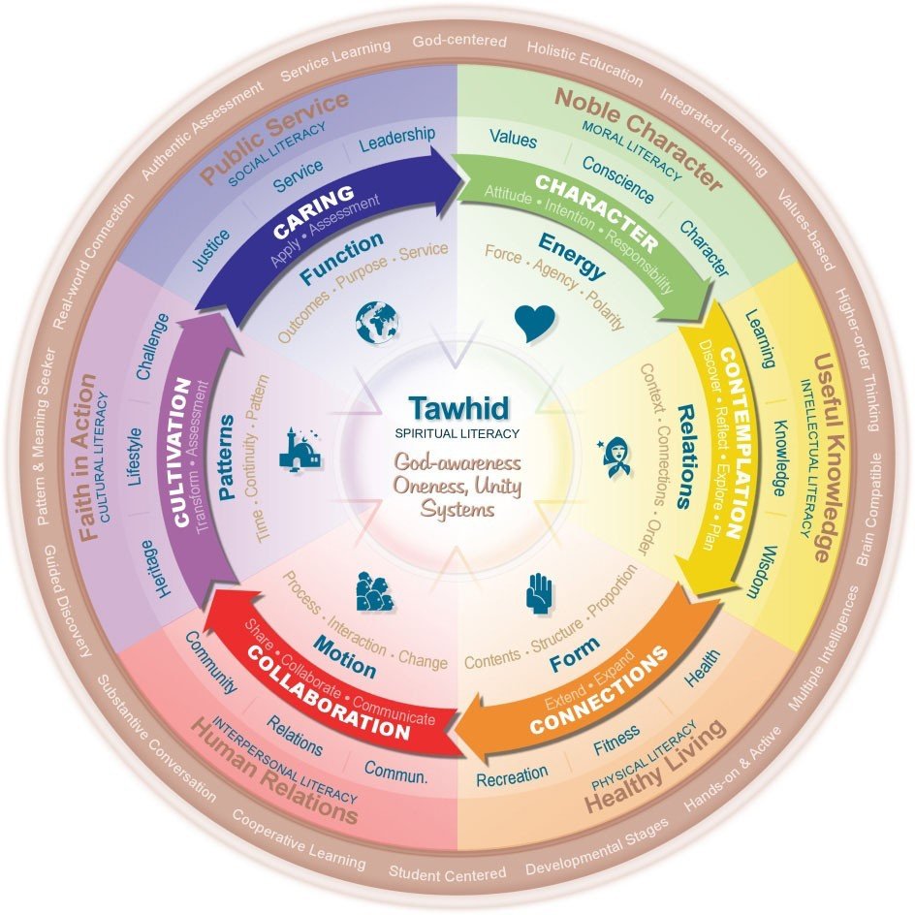

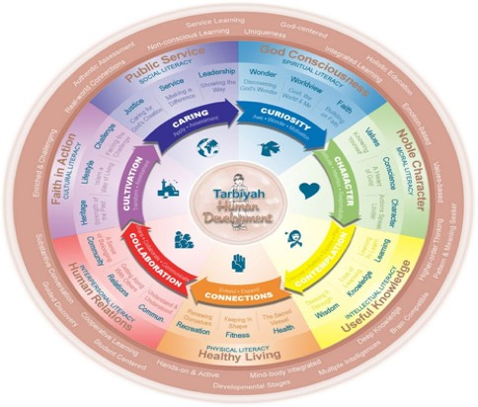

Figure 12: Key Learning Areas

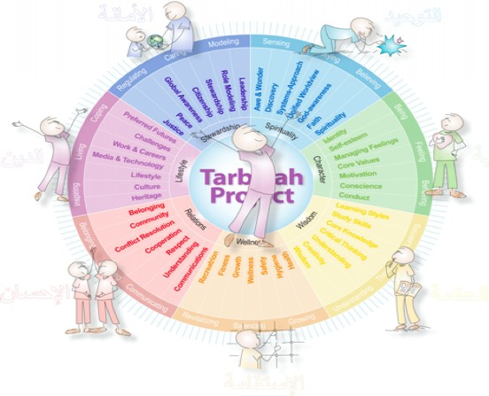

Figure 14: Key Outcomes and Indicators

