Year 2 Homework

We would like you to have a go at spelling these words, try to write it out four times, correct yourself if you make a mistake, practice make perfect!
Example:
Word: monster
monster
monster
monster
The monster likes to walk around the forest

Spelling words | X1 | X2 | X3 | X4
Hiking
Nicer
Forest
Park
trouble
Once you have completed these words, please practice spelling out the word of the week.
Our word of the week is turbulent
Definition of turbulent : like a plane that get knocked around by heavy cloud.

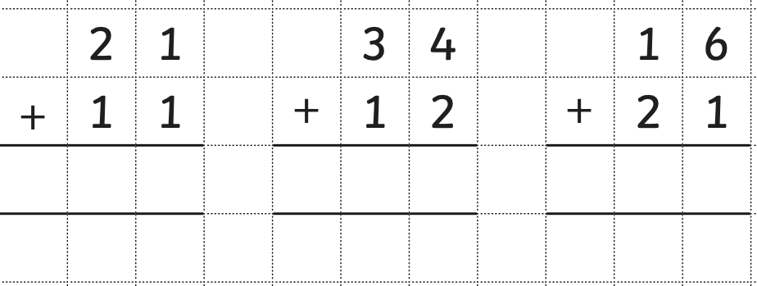

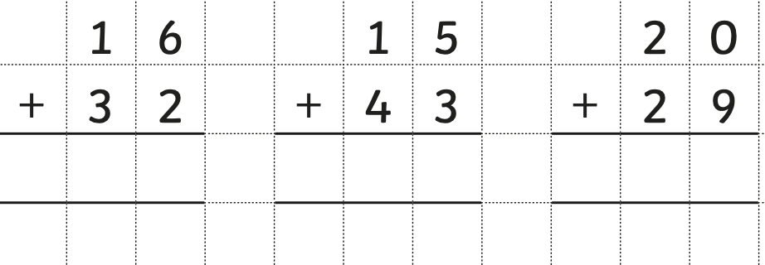

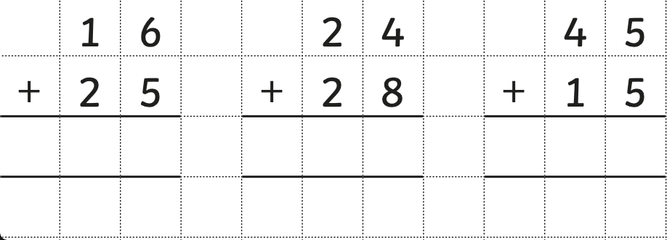

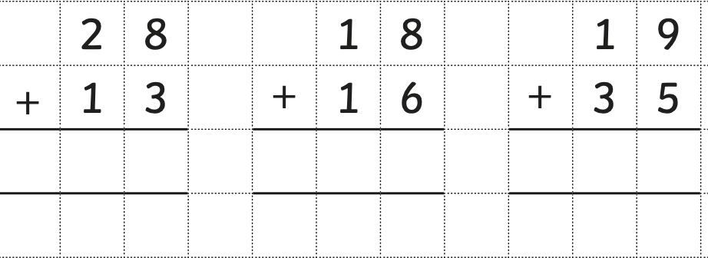

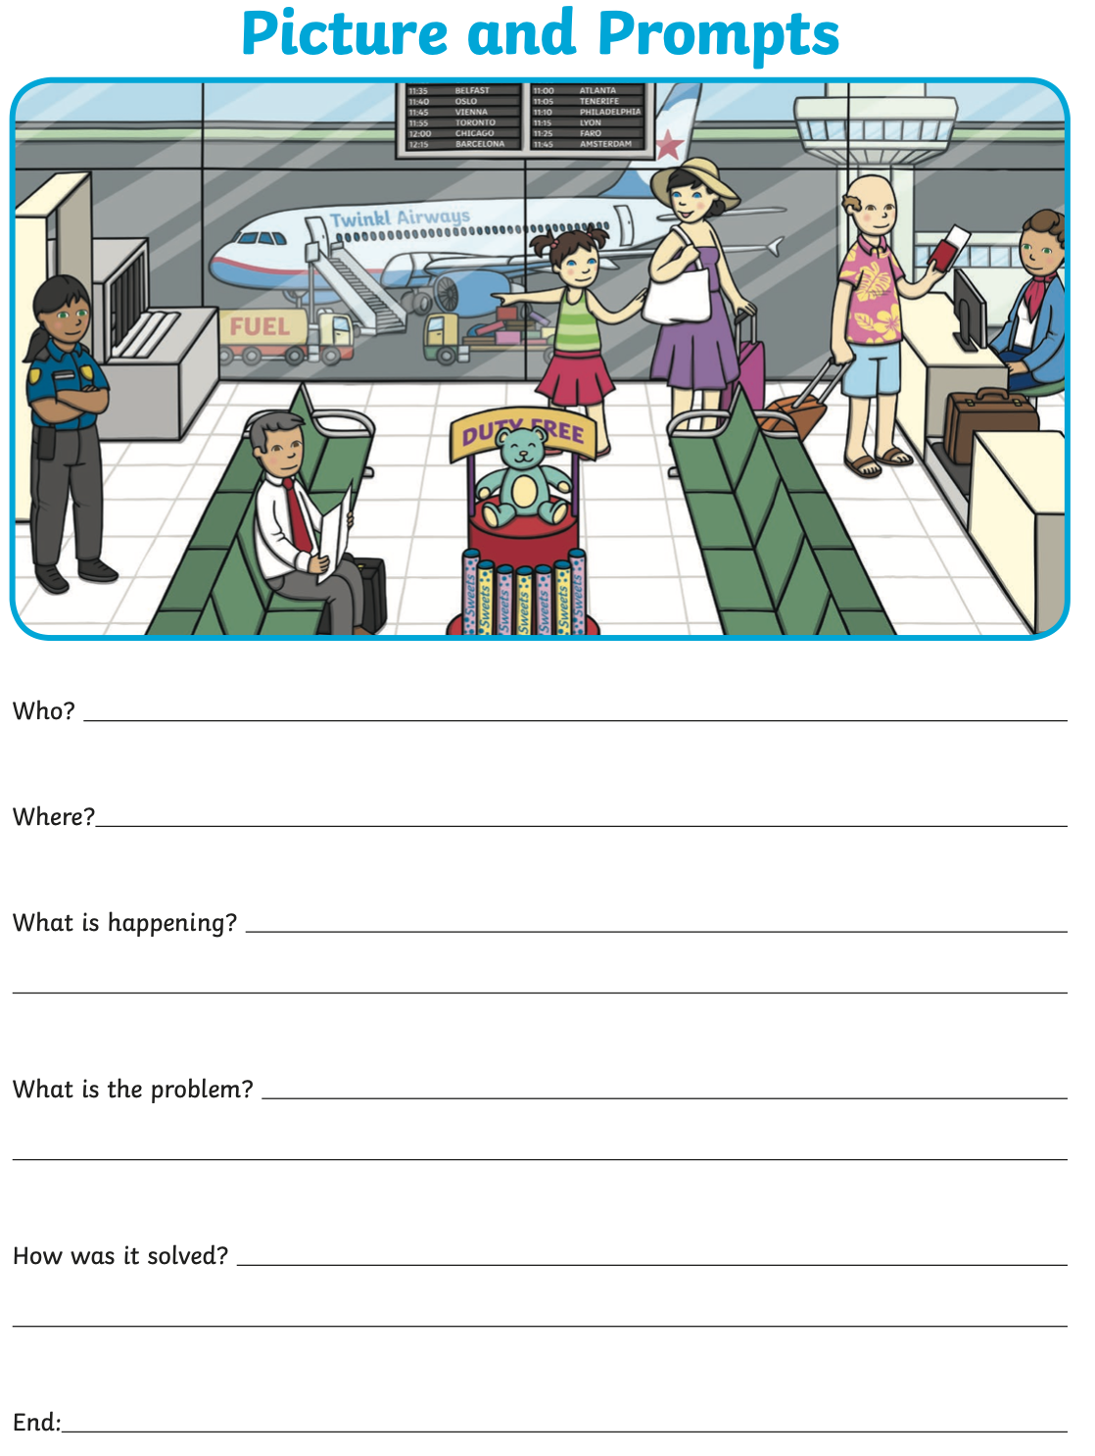

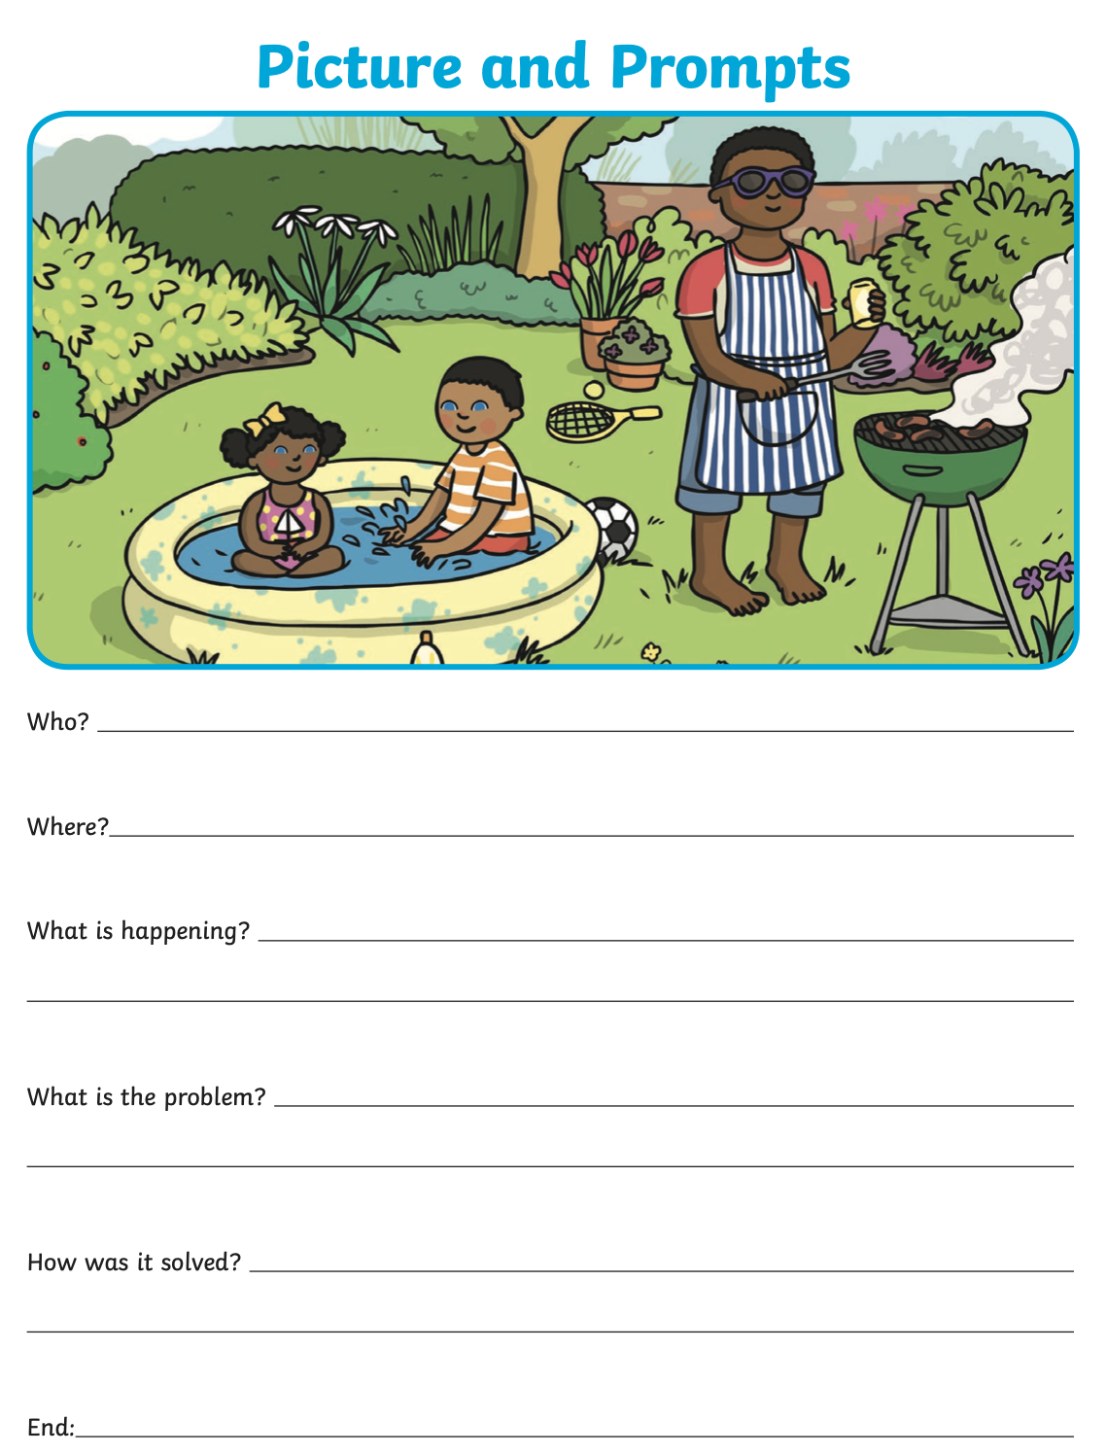

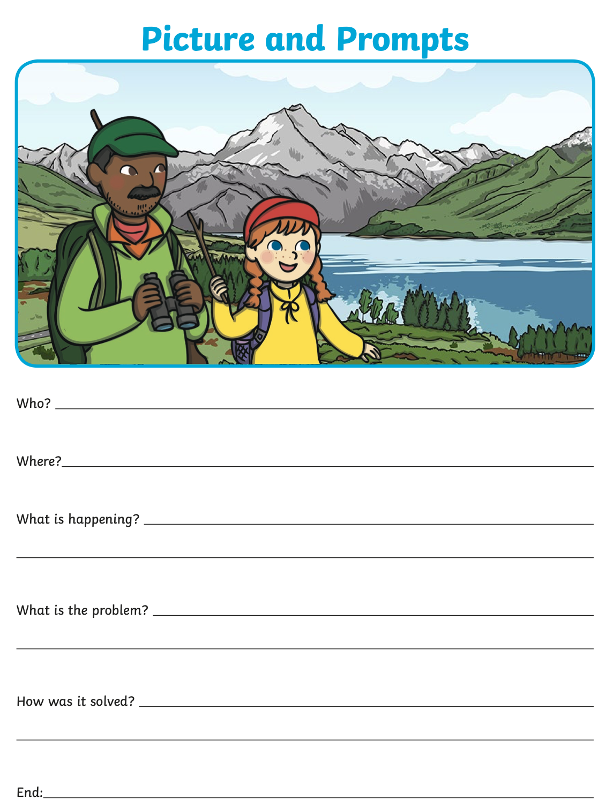

PLEASE REMEMBER TO HAND IN YOUR HOMEWORK ON WEDNESDAY

