Year 1 Homework

Write out and practise your spelling words four times. You need to write down a sentence each for every spelling word.
Example:
Word: cat
cat
cat
Spelling  words | X1 | X2 | X3 | X4
hunting
hunted
hunter
buzzing
buzzed
The cat loves to drink milk.
This week, we have introduced our new word of the week, please practise spelling out the word a few times and writing down the definition.
Our word of the week this week is: Turbulent
Definition: violent and unstable (e.g like a plane that gets knocked around by heavy clouds).

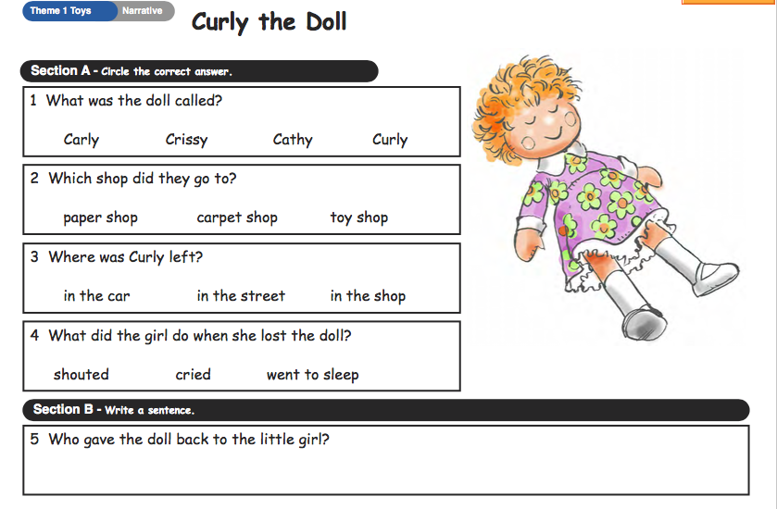
English: Read about Curly the Doll and answer the questions below.

