Year 2 Homework

We would like you to have a go at spelling these words, try to write it out four times, correct yourself if you make a mistake, practice make perfect!
Example:
Word:
fly
fly fly
fly
fly

The fly loves to eat honey

Spelling words | X1 | X2 | X3 | X4
babies
replies
copier
sugar
crude
Once you have completed these words, please practice spelling out the word of the week.
Our word of the week is crude
Definition of ominous: behaving in a rude or offensive way.

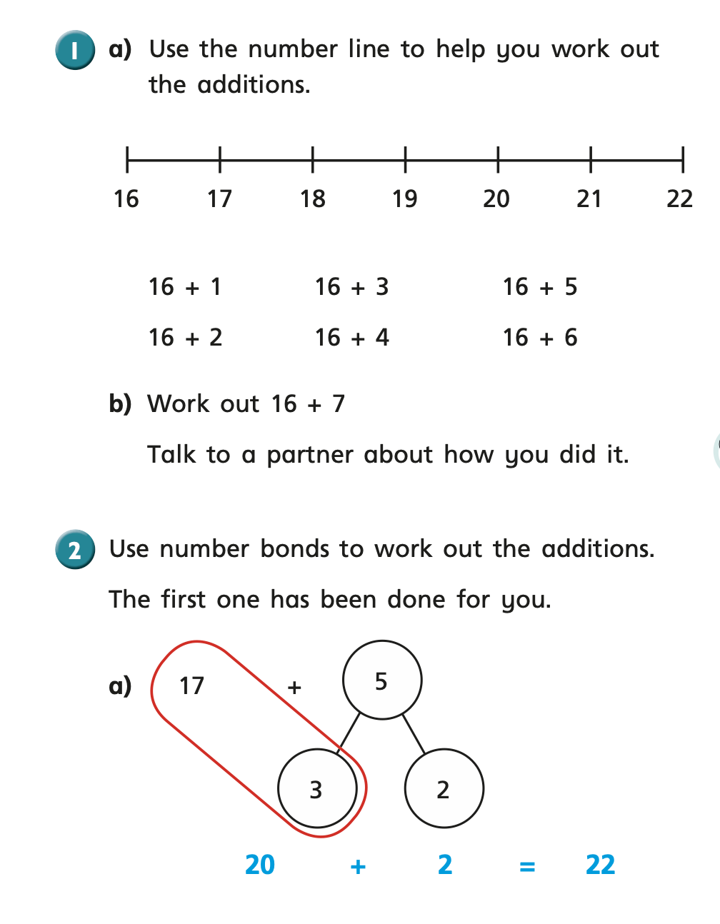
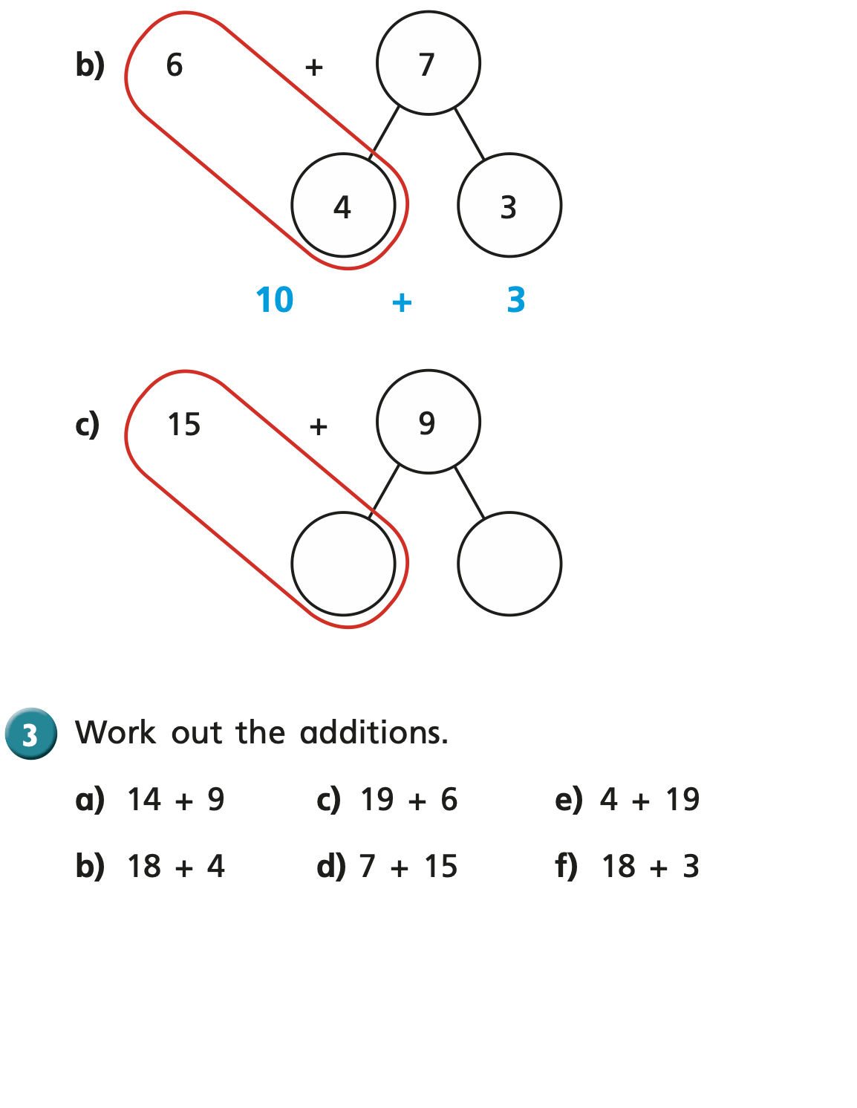
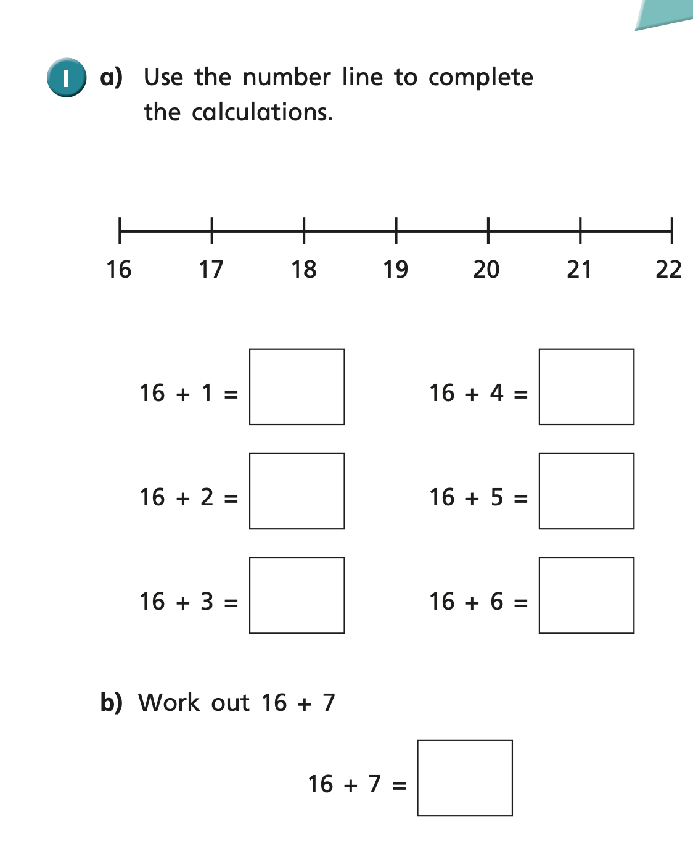

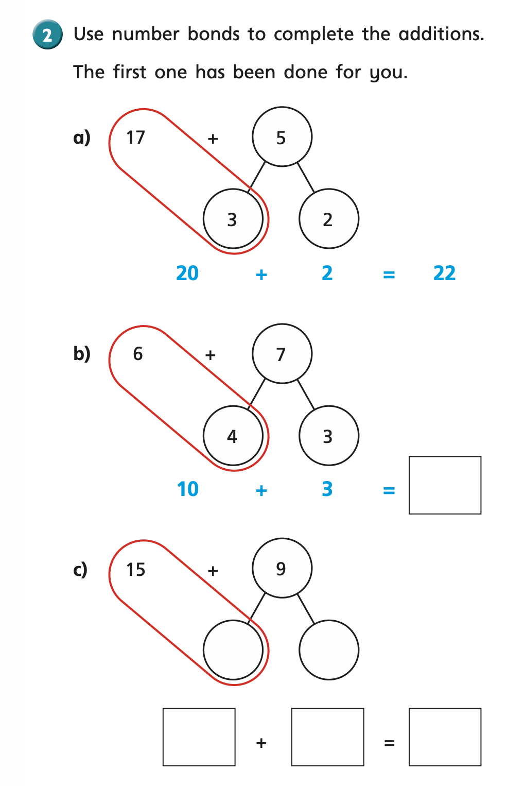

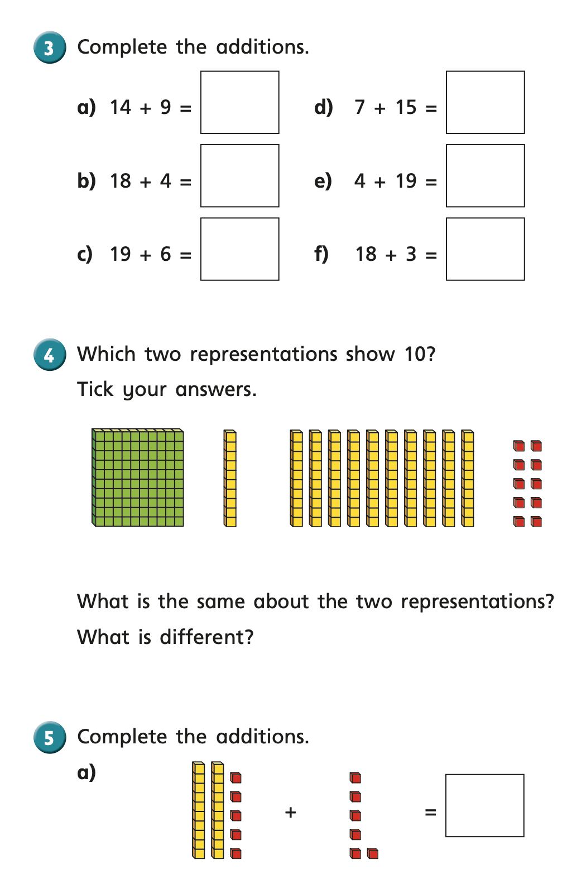
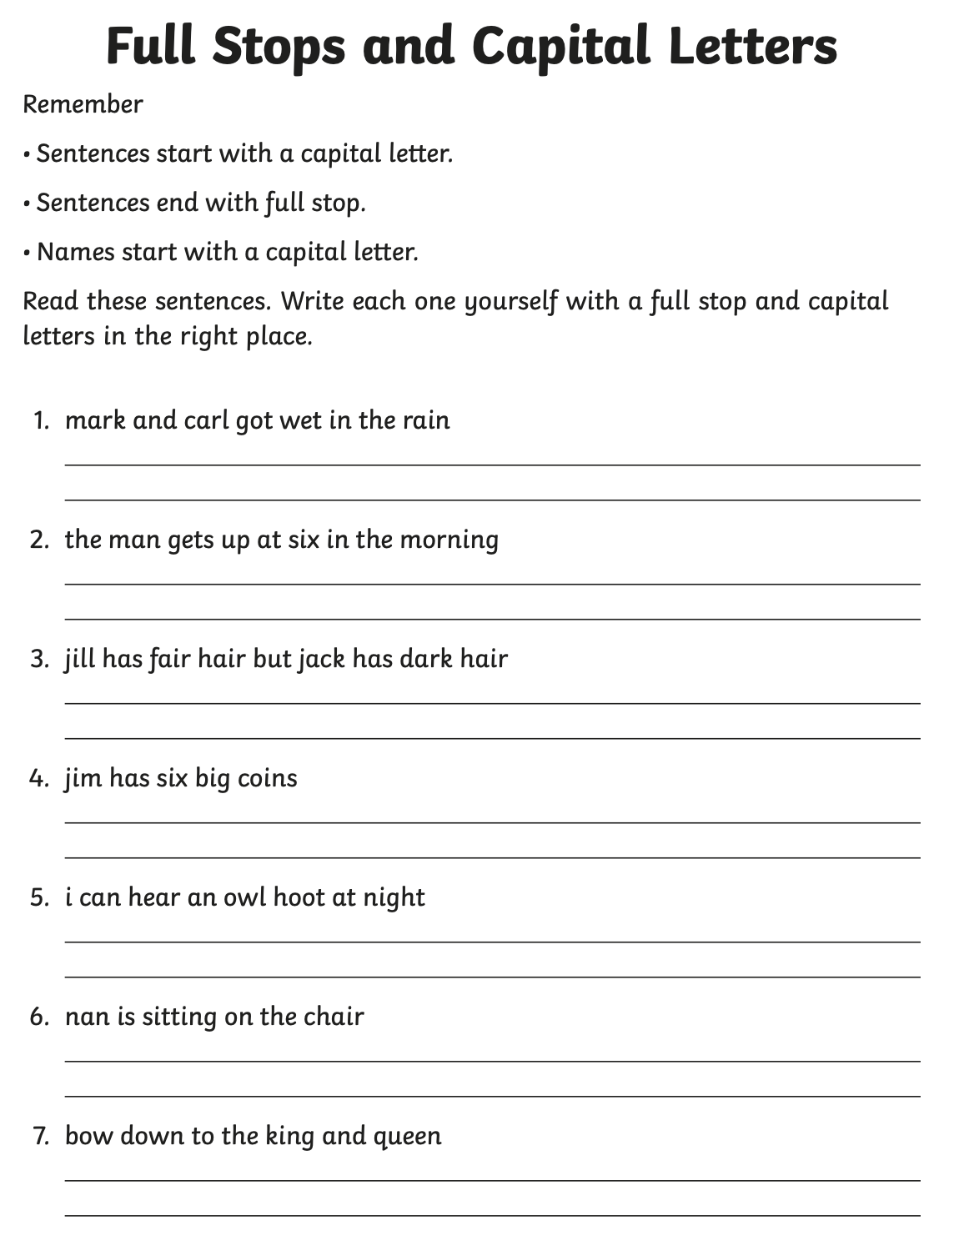
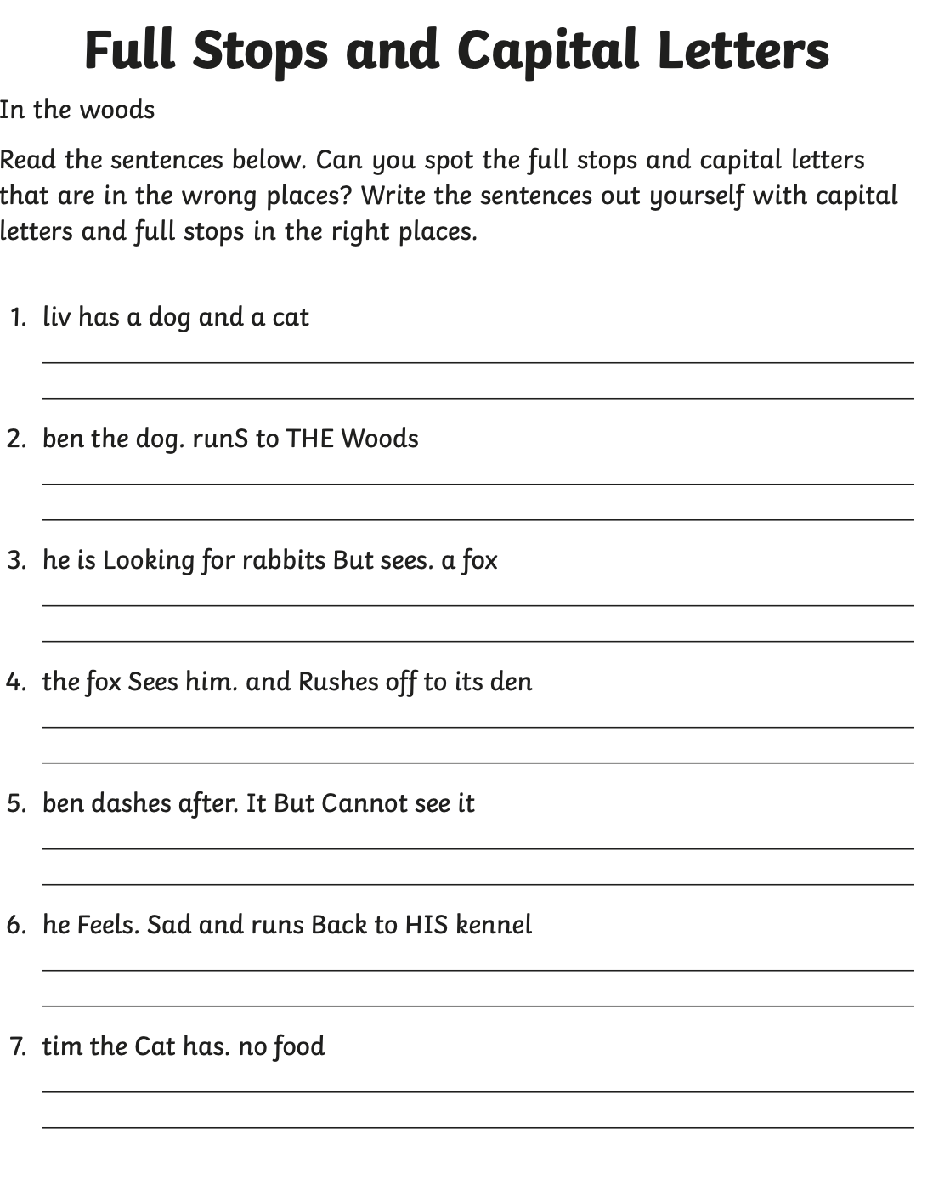

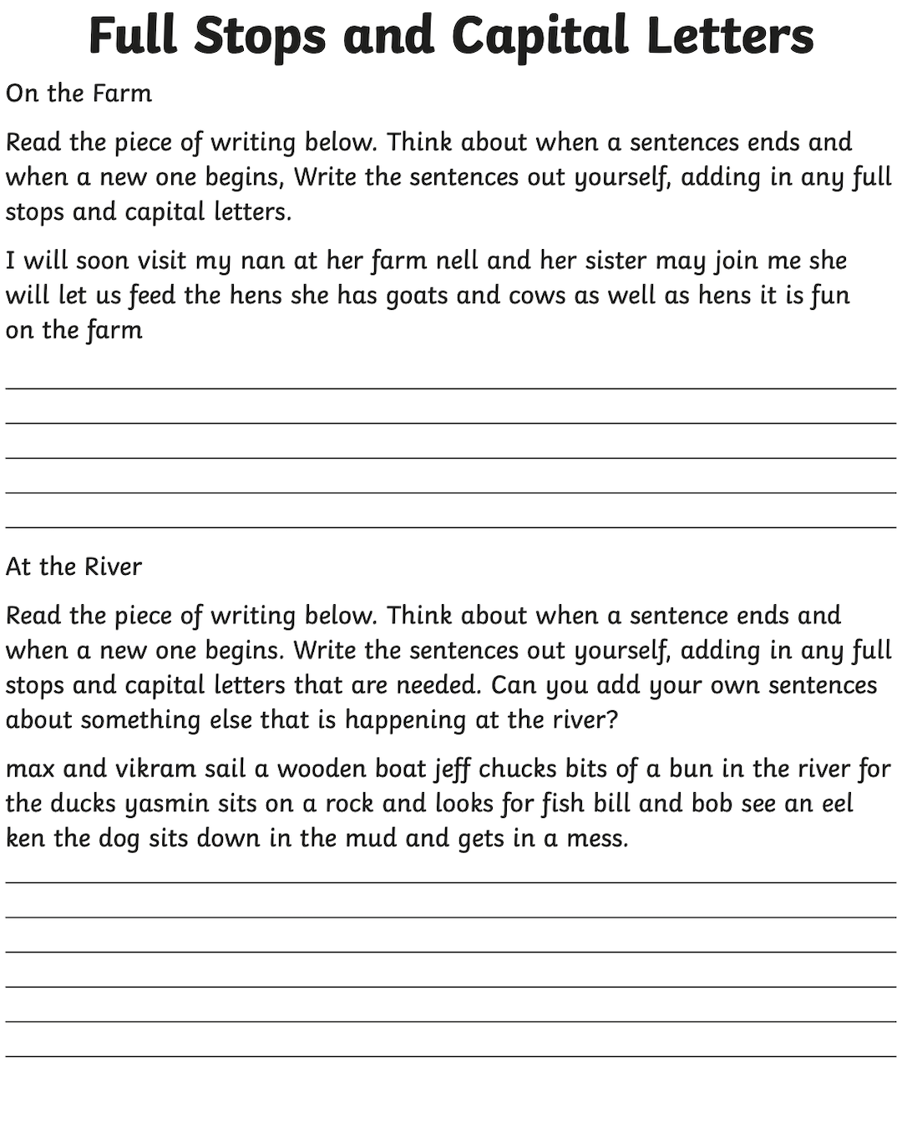

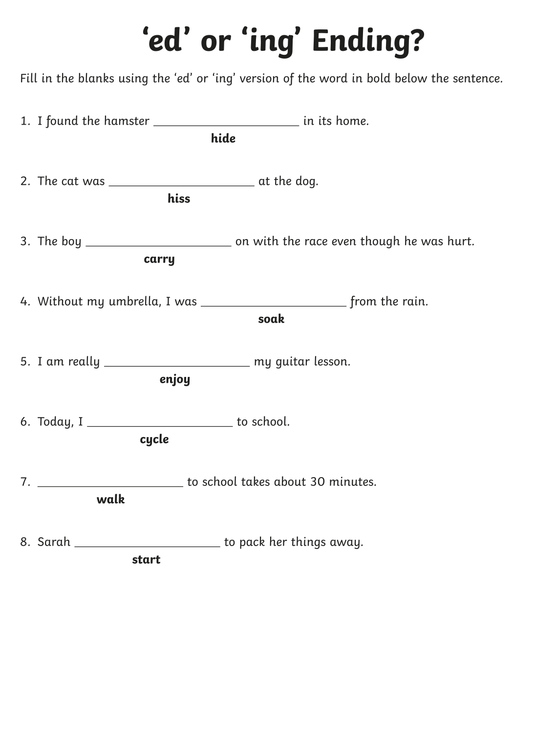

PLEASE REMEMBER TO HAND IN YOUR HOMEWORK ON WEDNESDAY AFTER HALF-TERM.

