Year 2 Homework

We would like you to have a go at spelling these words, try to write it out four times, correct yourself if you make a mistake, practice make perfect!
Example:
Word: cat cat
cat cat cat
The cat loves to drink milk

Spelling words | X1 | X2 | X3 | X4
Change
Child
Village
Badge
Ominous
Once you have completed these words, please practice spelling out the word of the week.
Our word of the week is ominous
Definition of ominous: giving a worrying idea that something bad is
going to happen.

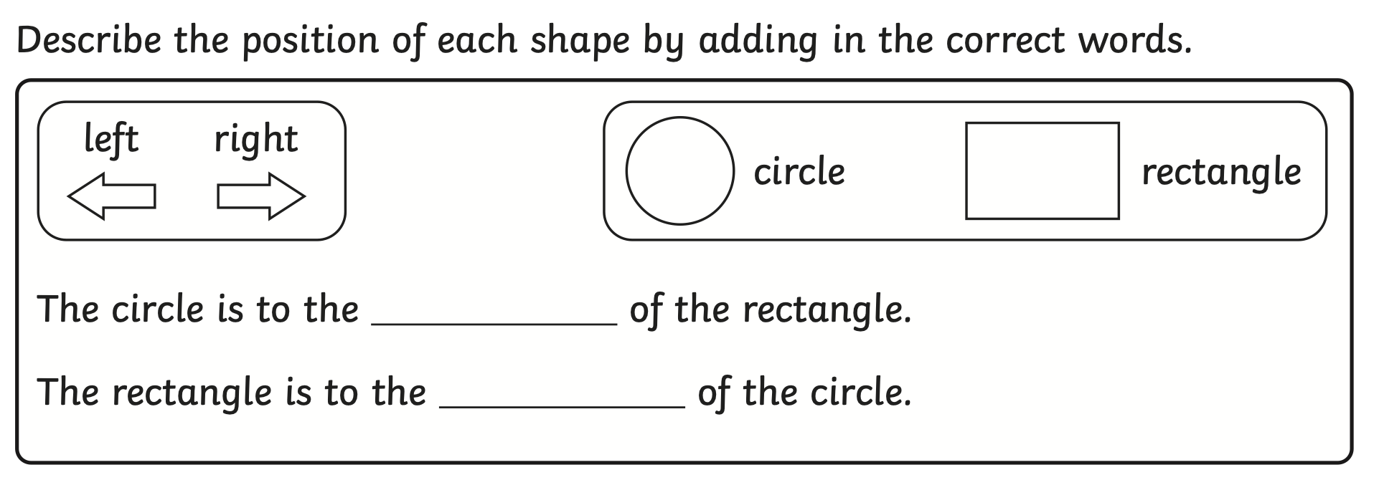

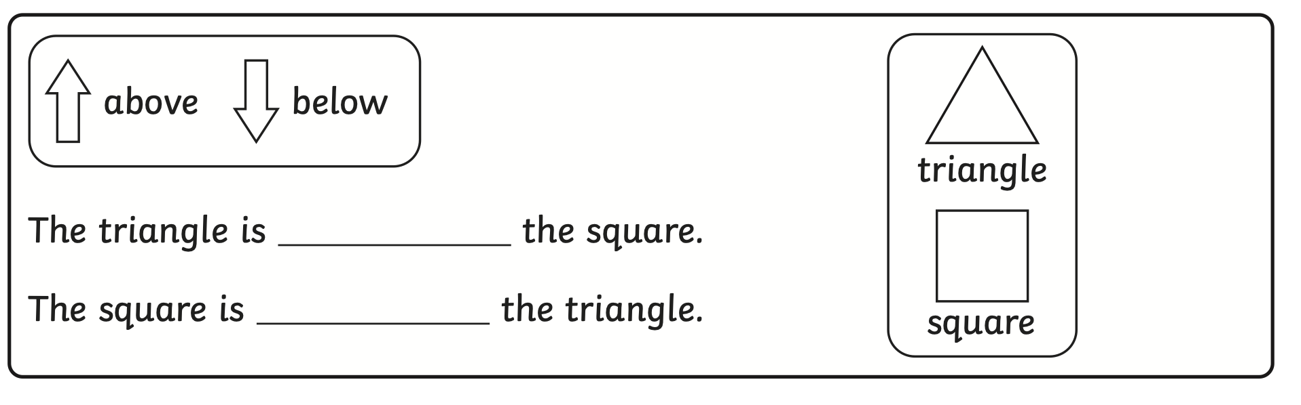

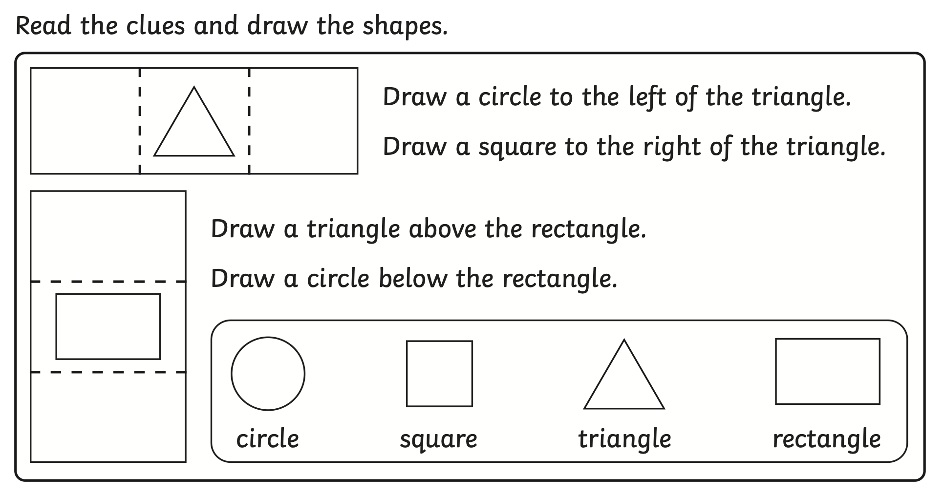

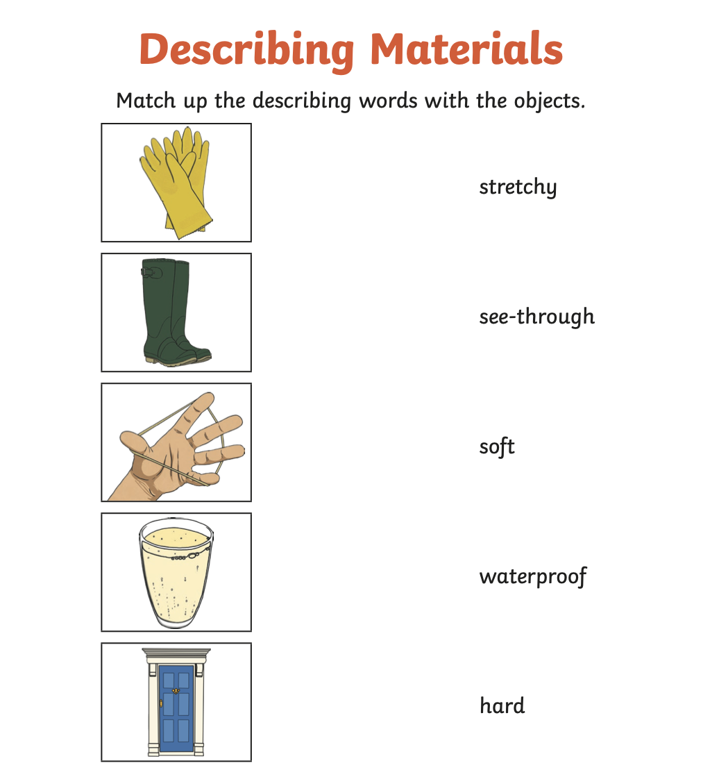

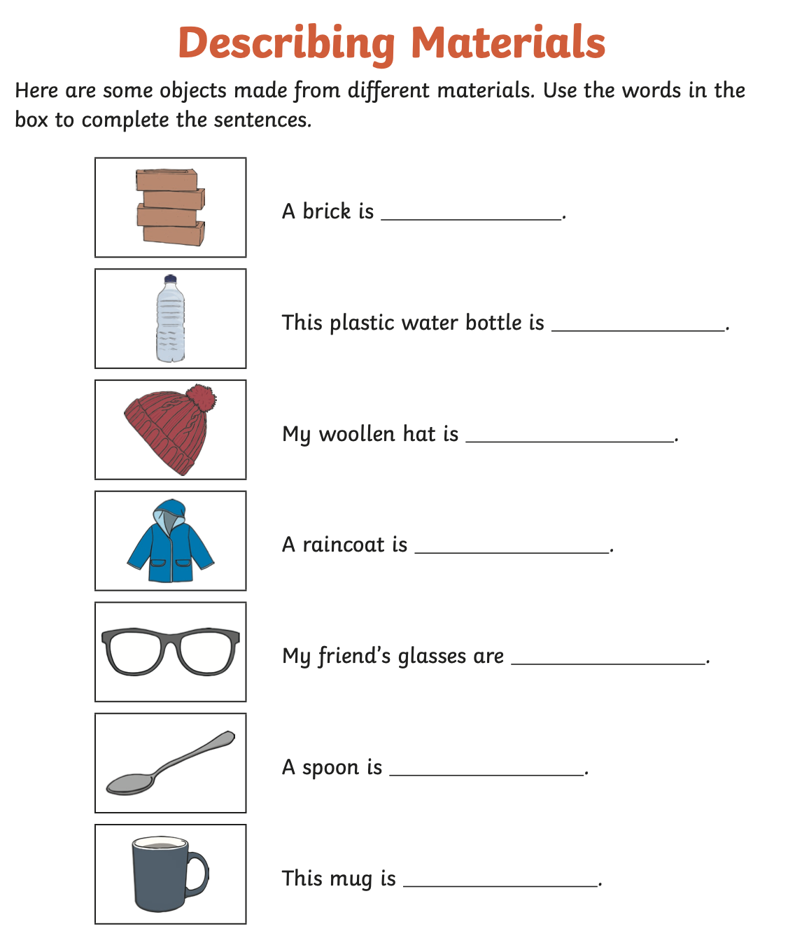

For pioneer personalities, Yr1 and Yr2 will be looking at British broadcaster, natural historian, and author David Attenborough.

Children are encouraged to write a leaflet or poster and will be doing an assembly discussing the pioneer with the rest of the school.

https://www.youtube.com/watch?v=oAh-U0WBfl4

PLEASE REMEMBER TO HAND IN YOUR HOMEWORK BY NEXT WEDNESDAY.

