Year 3&4 Homework – Week 6
**Homework is due in on every Tuesday, please complete it in your red homework books and hand it in on time. **
YEAR 3 and 4 MATHS:
In Maths this week, Year 3 and 4have been learning about adding 3 and 4 digit numbers. Please complete the questions in the pages below. Feel free to challenge yourself and attempt the trickier questions

YEAR 3 MATHS:

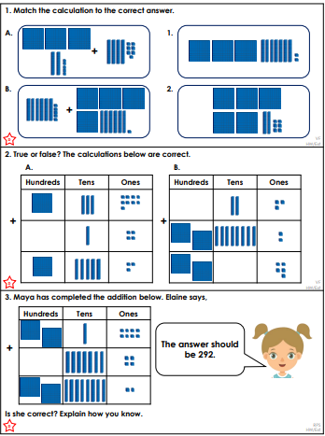
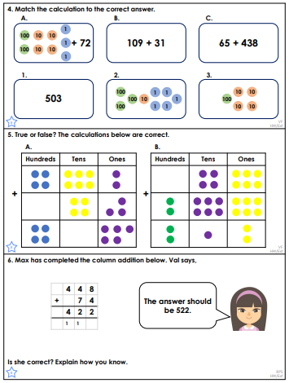
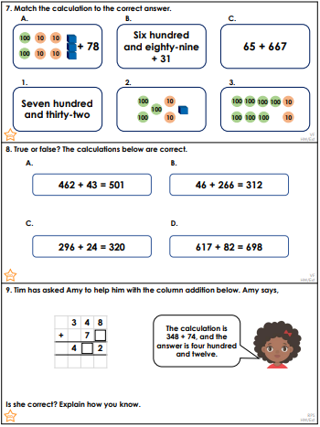YEAR 4 MATHS:

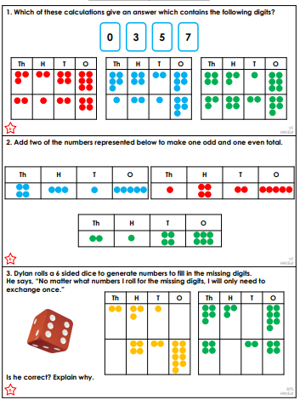
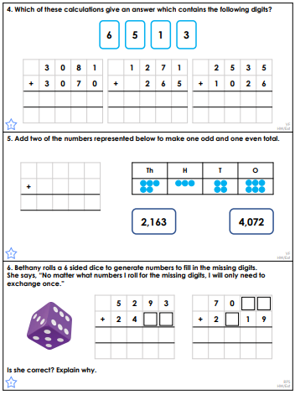
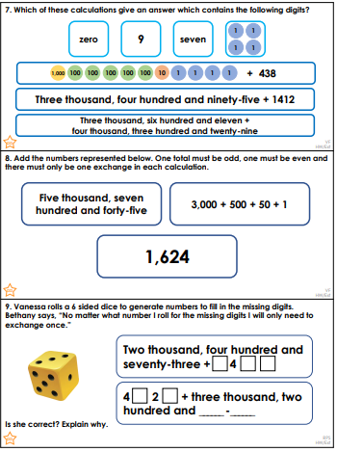
Challenge:
