Year 3 & 4 Homework – Week 2

**Homework is due in on every Tuesday, please complete it in your red homework books and hand it in on time. **

YEAR 3 and 4 MATHS:
In Maths this week, Year 3 have been learning to count in hundreds. Please complete the questions in the pages below. Feel free to challenge yourself and attempt the more tricker questions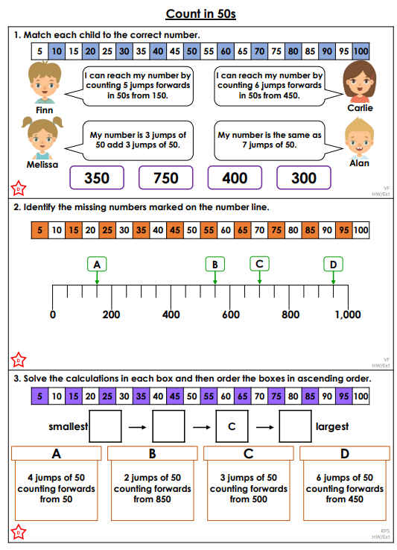
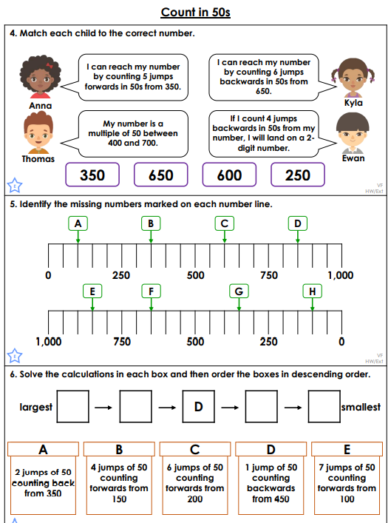
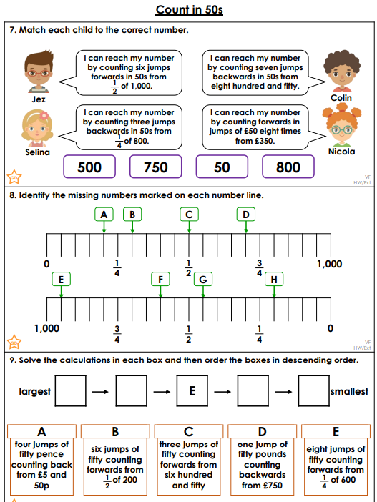

Year 4 Maths
Year 4 have been learning about Roman Numerals to solve problems. Complete the worksheet below to consolidate your learning. Please feel free to challenge yourself with the more tricker questions!
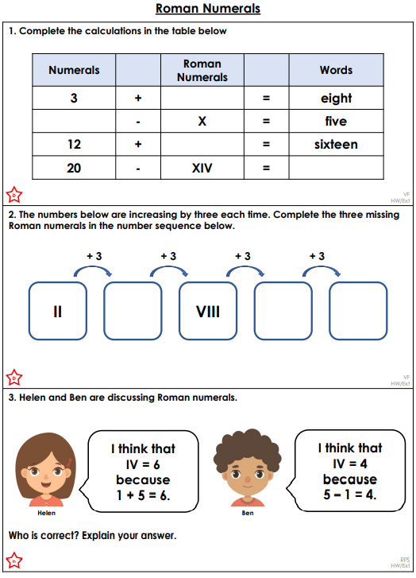
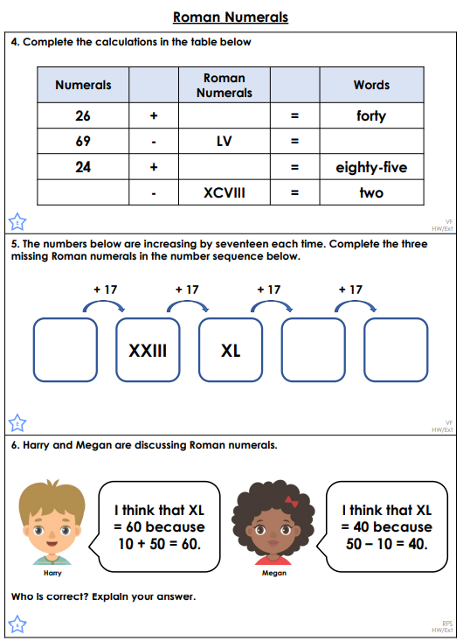
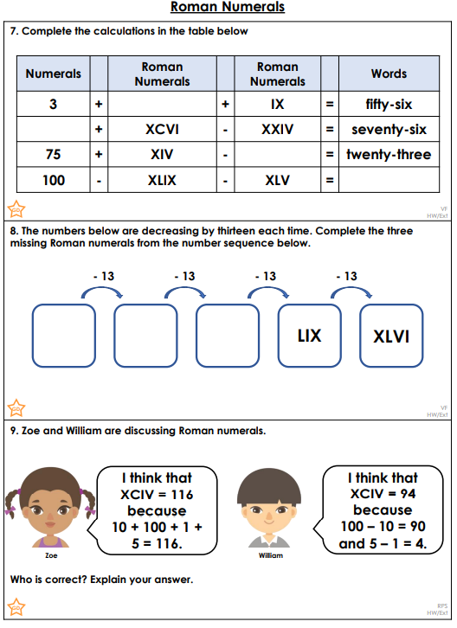

GREATER DEPTH:
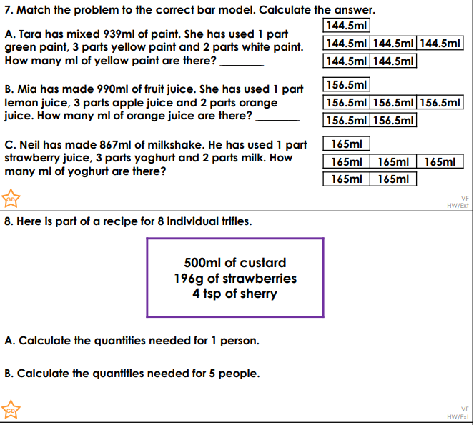
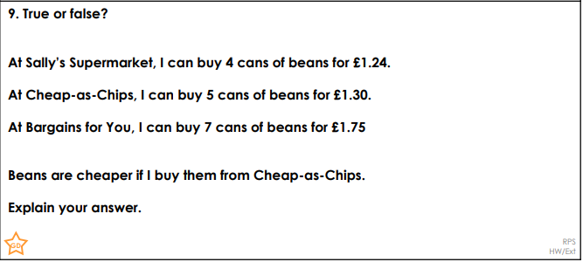

ENGLISH
Both Year 5 & 6 – Please read the text below and answer the reading comprehension questions.

