Year 1 Homework

We would like you to have a go at spelling these words, try to write it out four times, correct yourself if you make a mistake, practise make perfect!
Example:
Word: cat
cat
cat
cat
cat
Spelling words | X1 | X2 | X3 | X4
Today
School
Because
Children
Drenched
The cat loves to drink milk

Once you have completed these words, please practice spelling out the word of the week.
Our word of the week is drenched
Definition of drenched : Soaking wet.
Wet thoroughly; soak.

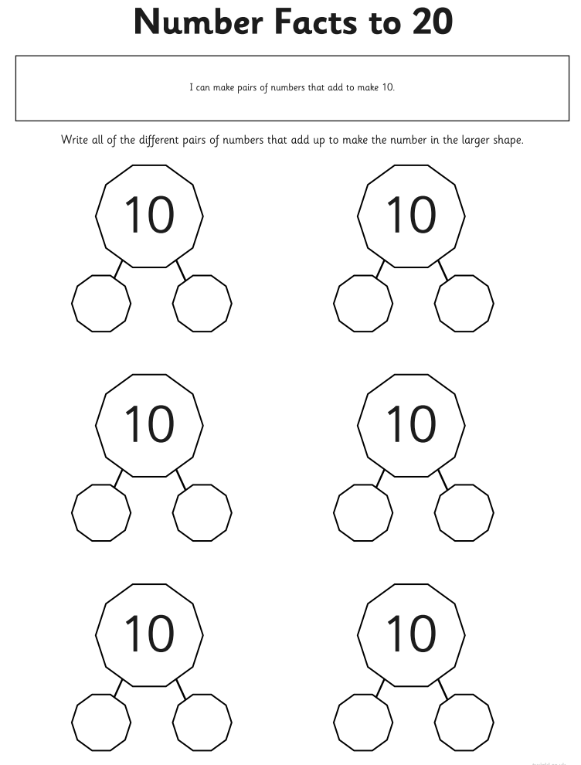
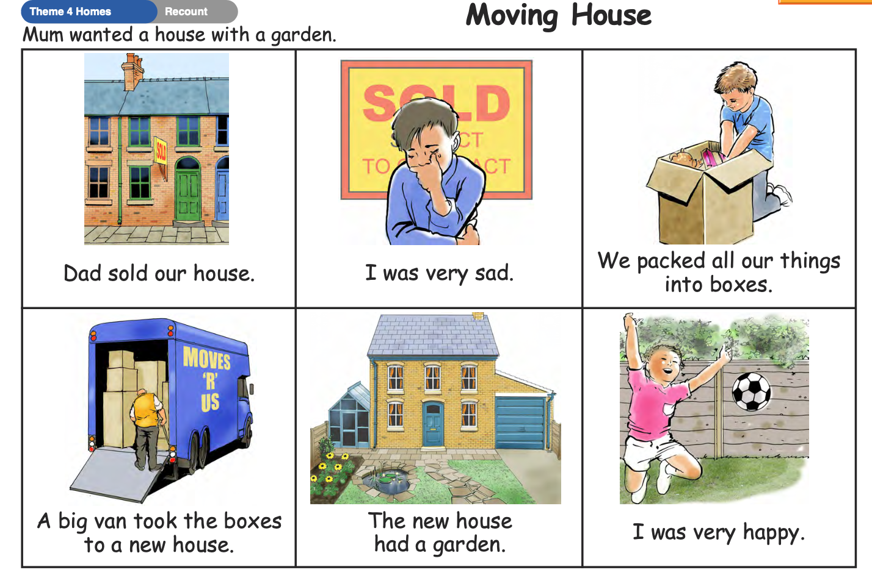
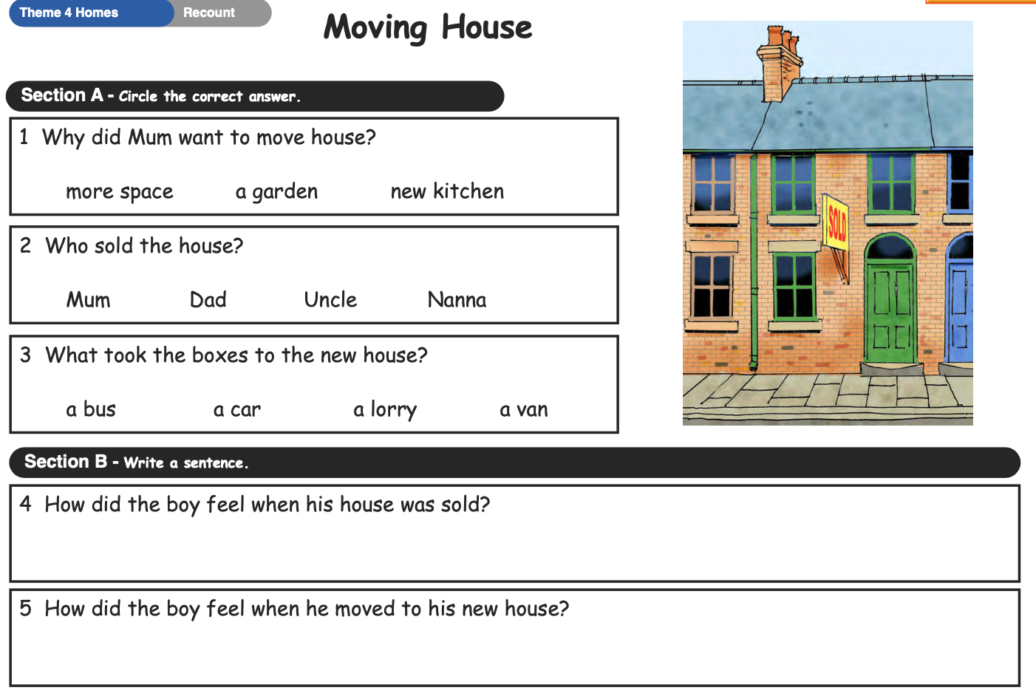

PLEASE REMEMBER TO HAND IN YOUR HOMEWORK BY NEXT TUESDAY

