Next week we are going to be focusing on counting backwards. Please watch the following videos to help encourage your child to count backwards.
Counting Stars 1-10 - Counting Backwards and Forwards Numbers Video for Kids - ELF Kids Videos
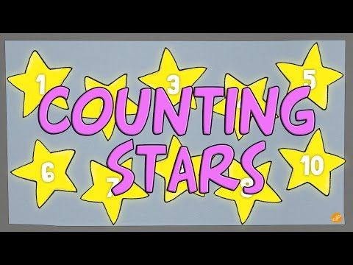
Zoom Zoom Zoom We're Going to The Moon Song | Rocket Song for Kids | Space Songs for Kids
