**Half term**

**Year 5 and 6 reading comprehension**

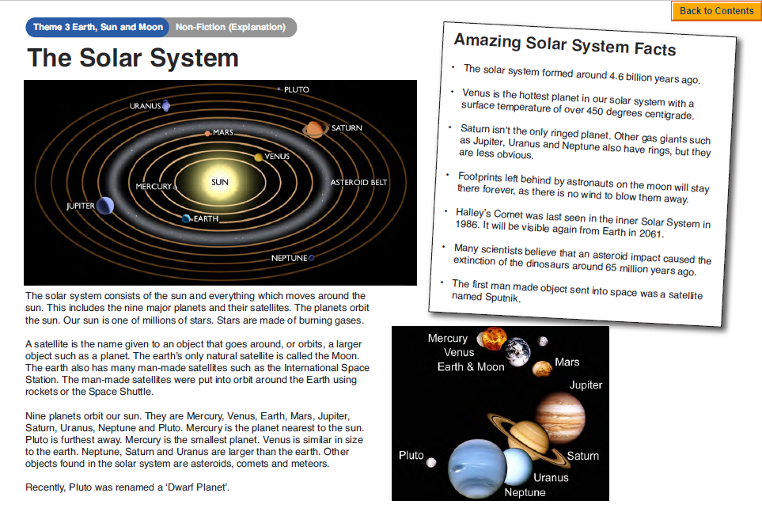

**Questions**

