**Week 6**

**Reading comprehension**

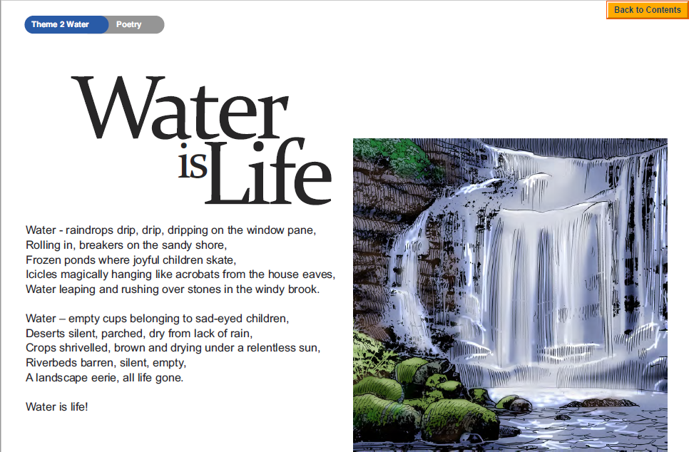

**Questions**

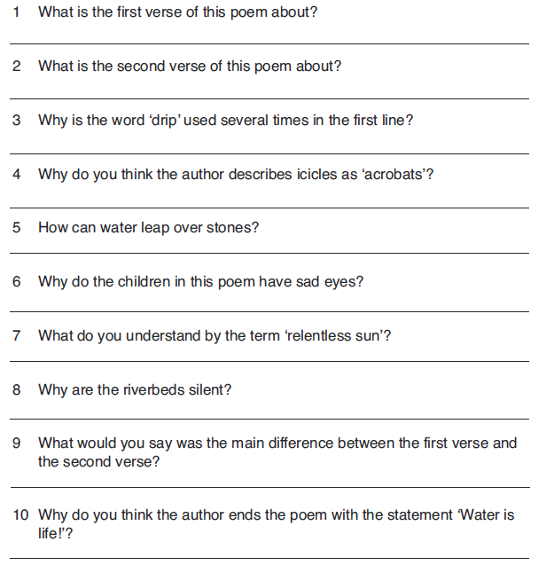

**Challenge: Write your own poem about water.**