Week 6
Year 5 and 6 Reading comprehension

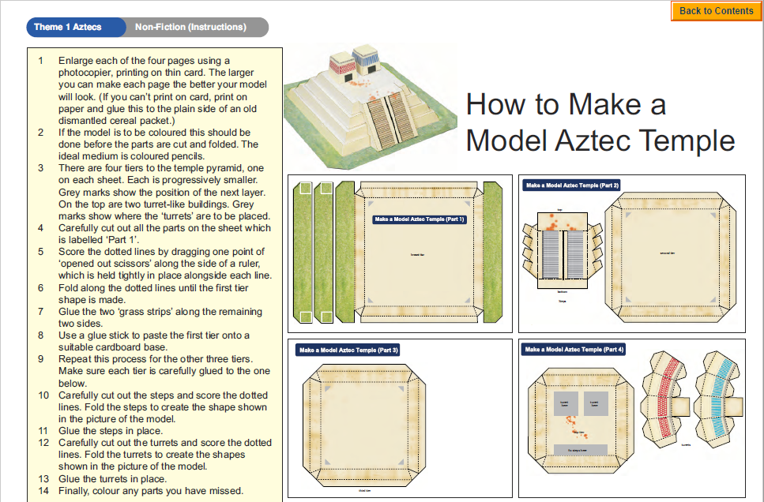
Questions
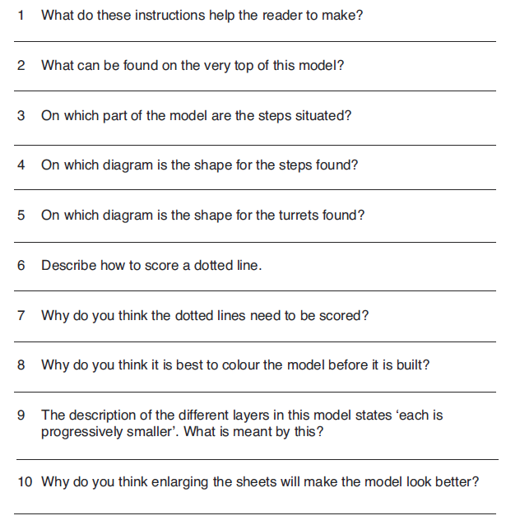
Challenge: write a brief set of instructions telling how to dismantle a breakfast cereal packet and reassemble it inside out so the outside surfaces are completely blank.

