Week 5
Year 5 and 6 Reading comprehension
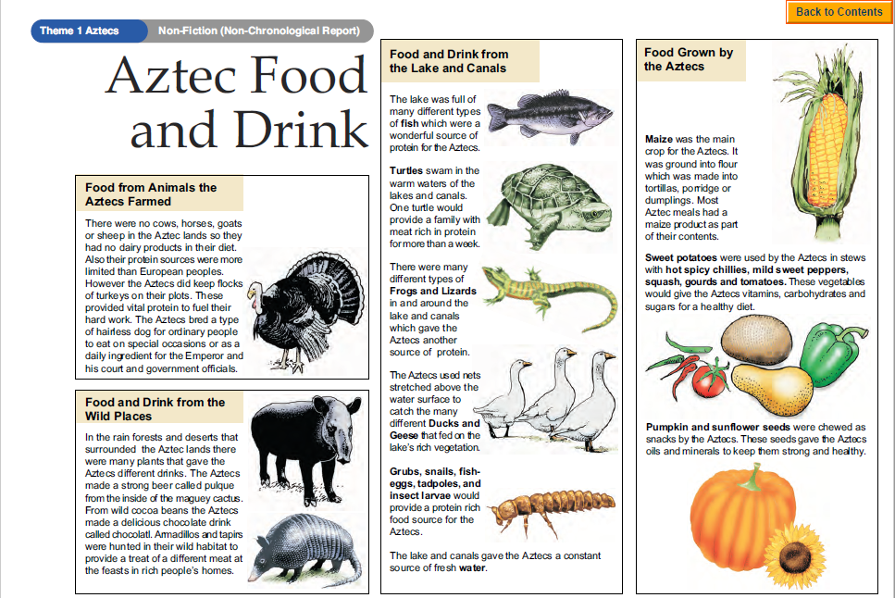
Questions
Year 5- Answer questions 1-7
Year 6- Answer questions 1-9
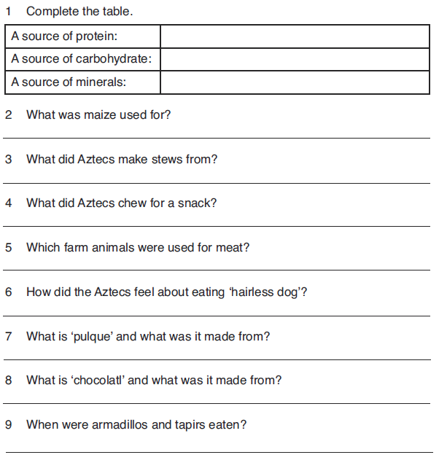Challenge: Write a short menu to describe the different food courses to be served at an imaginary Aztec feast.

