Week 5
English comprehension – Year 3 & 4
L.O: To answer reading comprehension questions by deducing and inferring information. Read the extract, then read the questions and find evidence from the text to answer the questions.
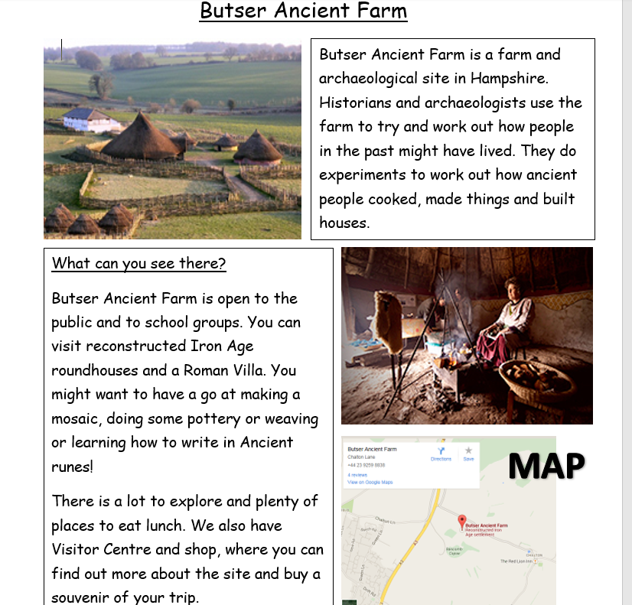
When can you visit?
Butser Ancient Farm is open all year round: Monday - Friday in October to March and 7 days a week in the Spring and Summer months. 10 am – 5pm (4pm in Winter)
We are just outside the village of Chalton, near Waterlooville.

Questions- Year 3 can answer questions 1 to 5
Year 4 should attempt to answer all the questions.
Please answer in full sentences e.g. Why might someone want to visit Butser Ancient Farm?
Answer- Someone want to visit Butser Ancient Farm because……….
- Where is Butser Ancient Farm?

- Why might someone want to visit Butser Ancient Farm?

- List four things you could see or do at Butser.

- Would it be possible to visit Butser Ancient Farm on Saturday 17th February?

- Why do you think the writer has used text boxes?

- Why do you think the author has chosen to include a map?

