Year 1 & 2
Flip learning-Science
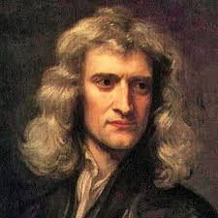
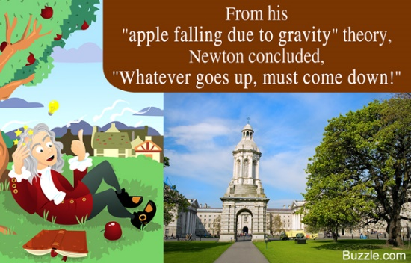
Look at the following pictures and discuss what they mean with your family.
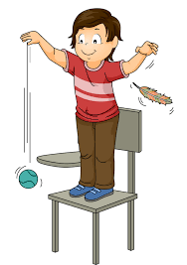
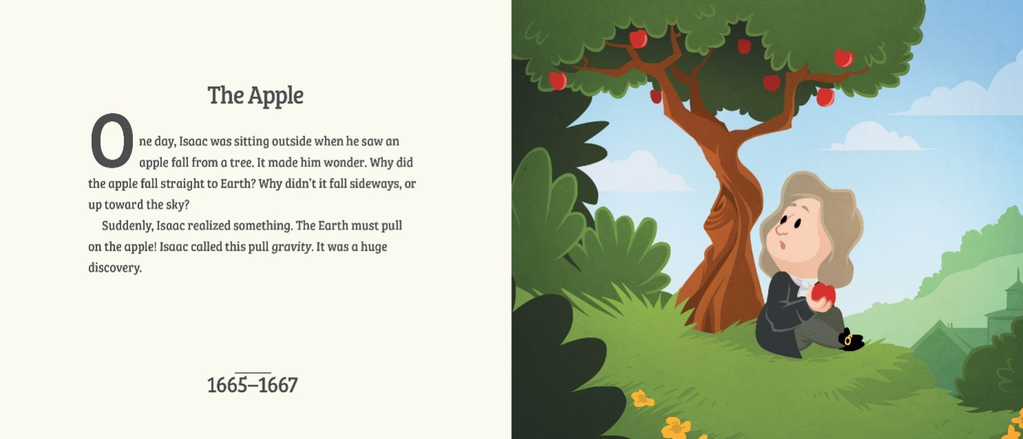
Sir Isaac Newton was one of the most famous scientists in the world!
He was a: Mathematician Natural philosopher
Physicist Theologian
Alchemist Astronomer

The man who discovered gravity and the three vital laws of motion, he was also the first one to build a reflecting telescope, to study the speed of sound, and to observe spectrum of colors through a prism. The list is endless!

