Year 1 Homework
SPELLING
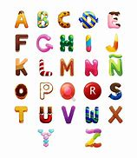
Year 1 students to practise and write out each word x4 and then form a sentence including the word. Please make sure you write it out in your homework books.
Example, word: it
it
it
it
it
it was really cold outside.
Year 1 spelling words:
- they 6. we
- be
- he
- me
- she
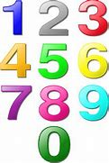
TIMETABLES
Year one to write out and practise their 2 and 5 timetables.
Please make sure you write this out on your homework books, write it out twice or three times. Practise makes perfect! Try to say it out loud so you can remember and memorise. Try to write up to the number 40.
Example, 2 timetables.
2,4,6,8,10,12,14,16,18,20,22,24,26,28,30…
2,4,6,8,10…

HOMEWORK TO BE HANDED IN BY TUESDAY MORNING!!! (6/10/20)

