Year 4 - Week 5 – Homework

Thursday 8th October 2020

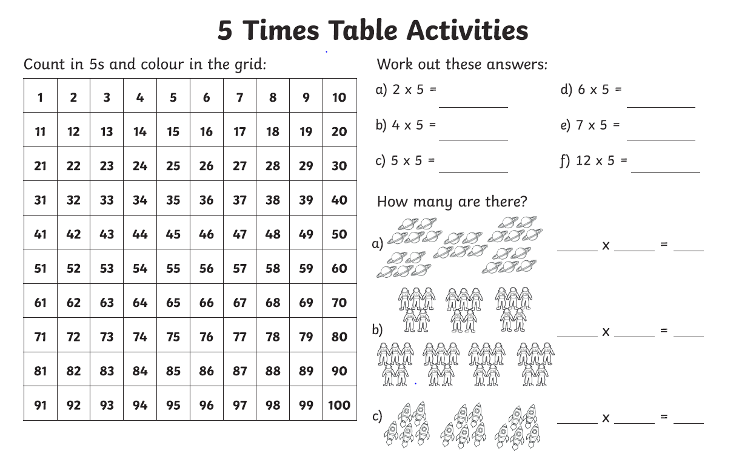
Week 5 – Year 4 Spelling - Homophones

ate | eight
write | right
nose | knows
throne | thrown
site | sight
role | roll

Word of the Day – Contemporary means modern, immediate and current
Please write two sentences using the word of the day.

