Thursday 8st October 2020
Year 3 Homework
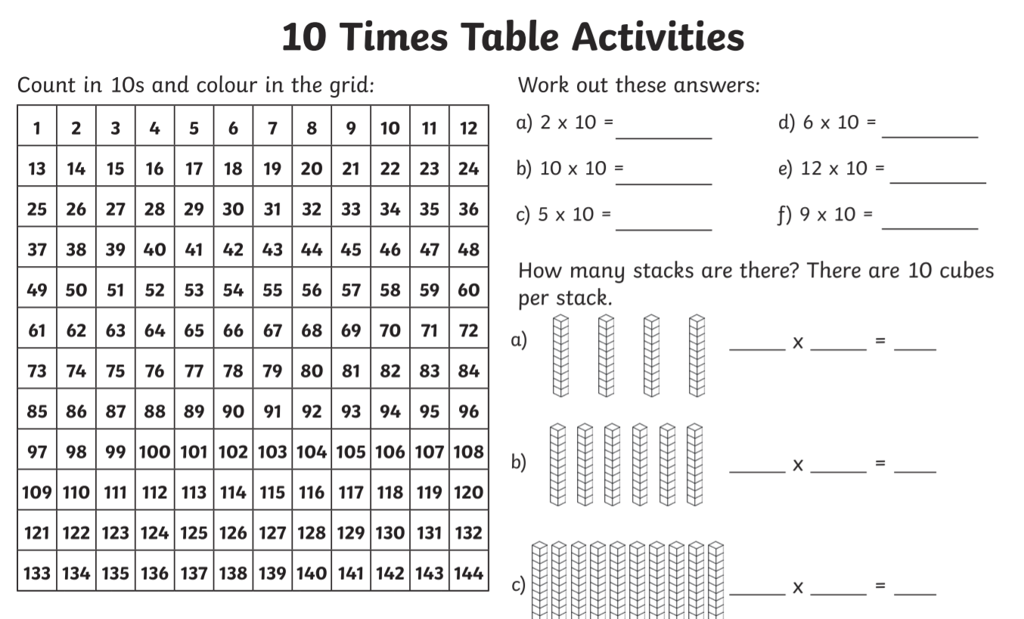

Week 5 - Year 3 Spelling - Homophones
ate | eight
write | right
nose | knows
throne | thrown
site | sight
role | roll

Word of the Day – Contemporary means modern, immediate and current
Please write two sentences using the word of the day.

