Year 4 - Week 4 – Homework

Thursday 1st October 2020
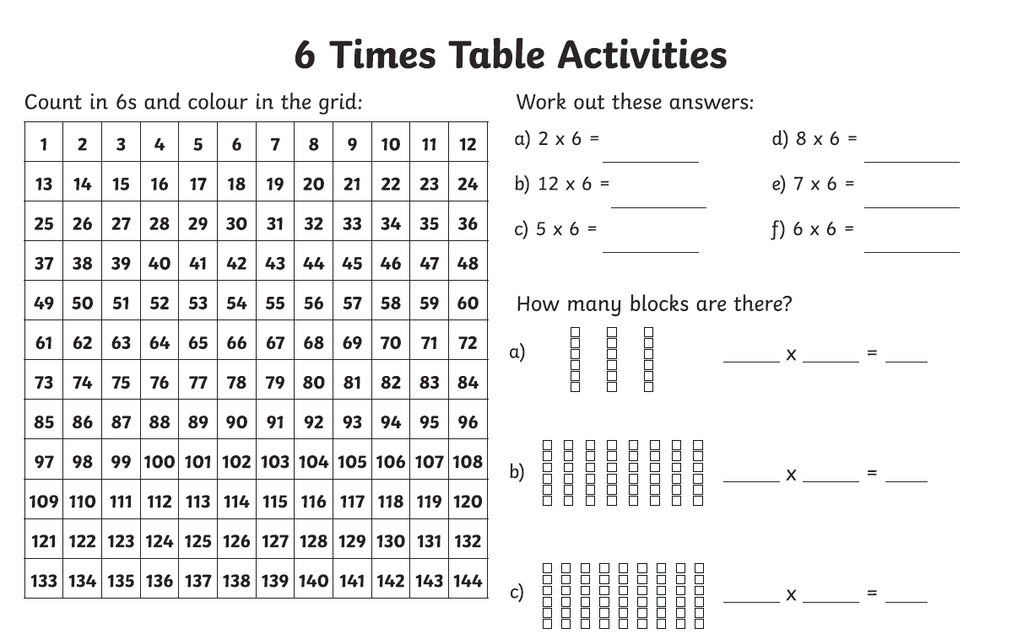

Week 4 – Year 4 Spelling
