**Year 5 & 6 Homework Week 6**

**Homework is due in on Wednesday 21st October please complete in your red books and hand in on time. Please bring your homework book in time!**

**Words of the week: Inferior and flamboyant**

**For the words above, find out the definition and create your own sentences.**

**For science, we will be learning about Earth and Space. Research facts and create a power point or poster to show in class.**

**Spelling tests will be done on Friday** so please learn the spellings below. Write the definition for and create a sentence for each word below. Just an extra challenge for those who would like to, can you add brackets into your sentence?

observant

hesitation

tolerant

tolerance

toleration

substance

substantial

observance

observation

expectant

expectation

hesitant

hesitancy

**In maths this week, we have been learning division using the short division method. But, I would like you to review all four operations.**

**Complete the questions below, using the methods we have been learning in class.**

Addition:

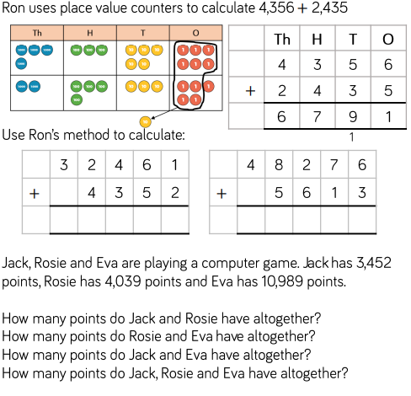

Subtraction: use the column method

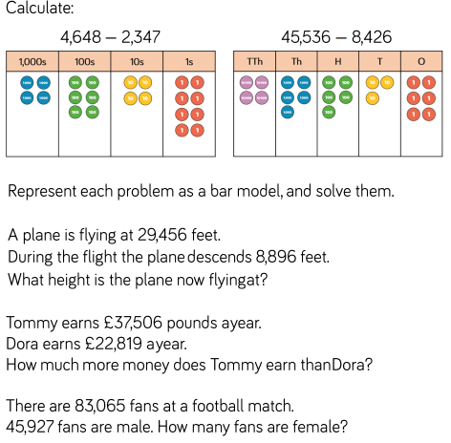

Multiplication:

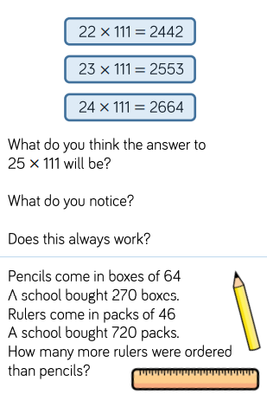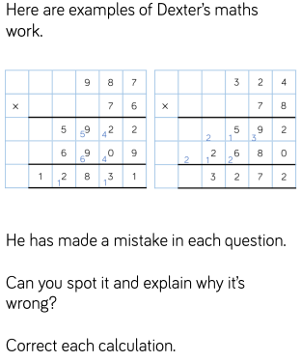

Division: Use the short division method

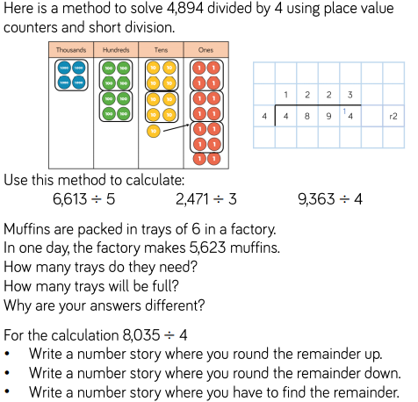

English Homework

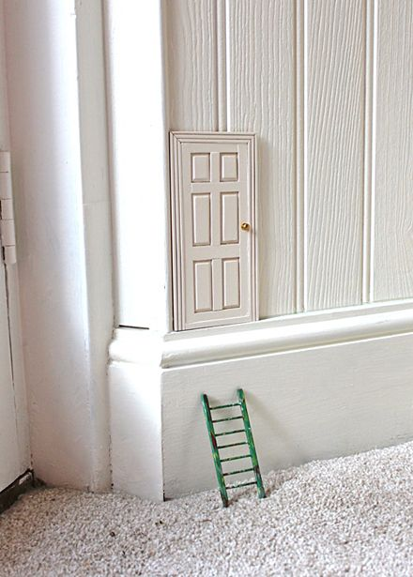

One day, you find this door at the corner of your room. What do you do? Who uses that door? Where does the door take you?

Create your own story about the tiny door you have discovered in your room. Use the checklist below to help.

