Nursery Homework
We have been learning about Autumn and the Autumn weather.
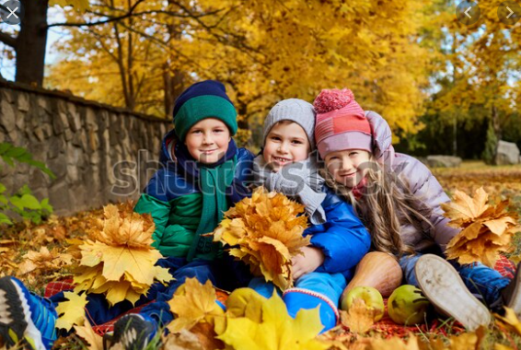

Look at the picture above of children playing outdoors in Autumn, ask your child the following questions:

- What are the children wearing?
- What clothing do you wear in Autumn/Winter?
- Encourage discussion about what the children are wearing and why?
Challenge:
Can you draw yourself with a hat, a scarf, a coat and a pair of wellington boots? Have a go! 😊

