YOU CAN (NOT) REPLAY
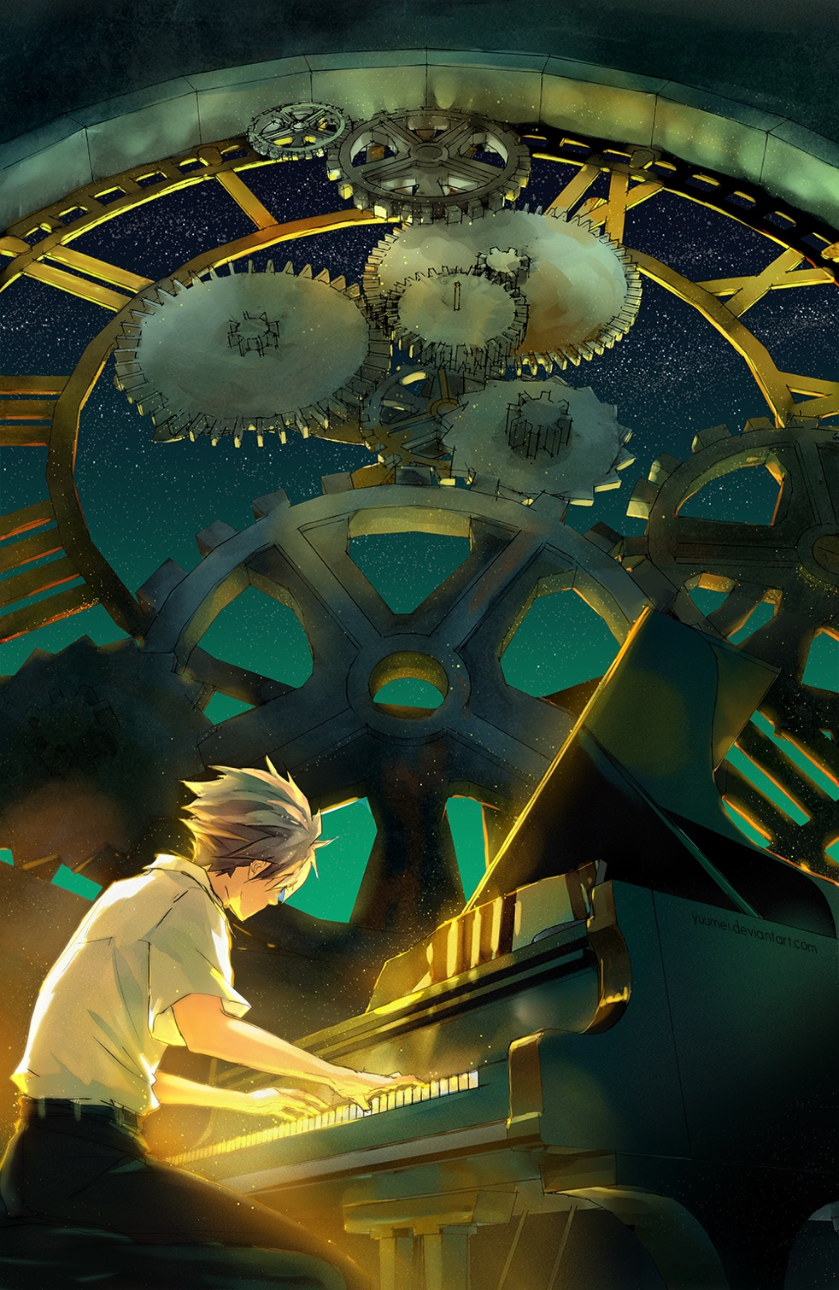

- What is this person doing?
- Are the piano and the cogs in the background connected?
- Why is the person glowing?
- What do you think the title means? What if the title was ‘You Can Replay’? How does ‘not’ change the meaning? Why is ‘not’ in brackets?
- How could you link this picture and its title to the idea of life and death?
- Do you know of any other books or films about a piano? Link to, and compare with, The Piano, Monkey Symphony and The Bear and The Piano.

