Year 2 Homework
Spelling
Year two to write out each word four times and then make a sentence including the word.
Example:
Word: here
here
here
here
here
I left my pencil over here.
Spelling words
- last
- past
- father
- class
- grass
Once you have completed these words, please practice spelling out the word of the week. Our word of the week is swagger.
Definition of swagger: how you walk when you are feeling on top of the world

Please write out two different sentences using our word of the week.

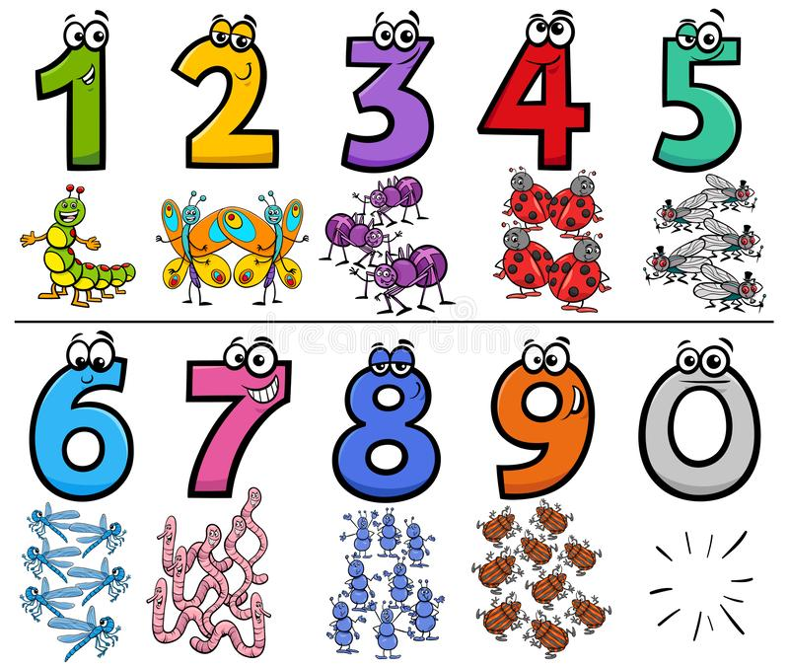
Timetables
Year two to practice their 4 and 6 timetables. Please try your best to write it out at least twice. Do not worry if you get it wrong, practice makes perfect!

Example:
4,8,12,16,20,24,28,32,36,40,44,48,52,56,60…

PLEASE REMEMBER TO HAND IN YOUR HOMEWORK BY TUESDAY 20TH OCTOBER 2020

