Year 2 Homework
Spelling
Year two to write out each word four times and then make a sentence including the word.
Example:
Word: break
break
break
break
break
After our maths lesson, we had a break.

Spelling  words | X1 | X2 | X3 | X4
badge
bridge
edge
age
huge

Once you have completed these words, please practice spelling out the word of the week. Our word of the week is grating.
We would like you to find out what grating means and write down the definition.
After you have done this, please write out two different sentences using our word of the week.

Timetables
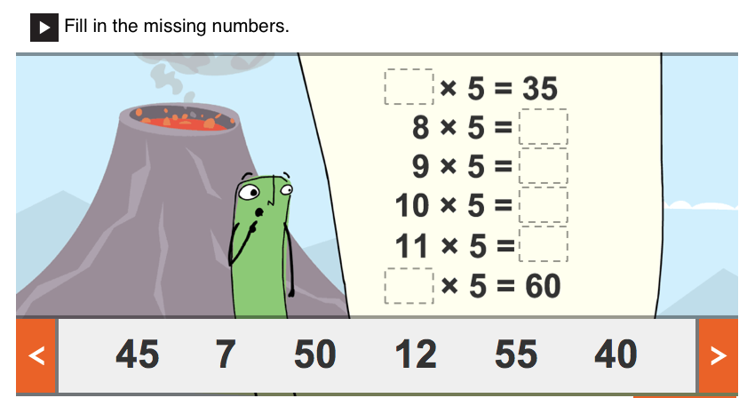

PLEASE REMEMBER TO HAND IN YOUR HOMEWORK BY MONDAY 2ND NOVEMBER 2020.

