Year 4 - Week 7 – Homework Thursday 22nd October 2020
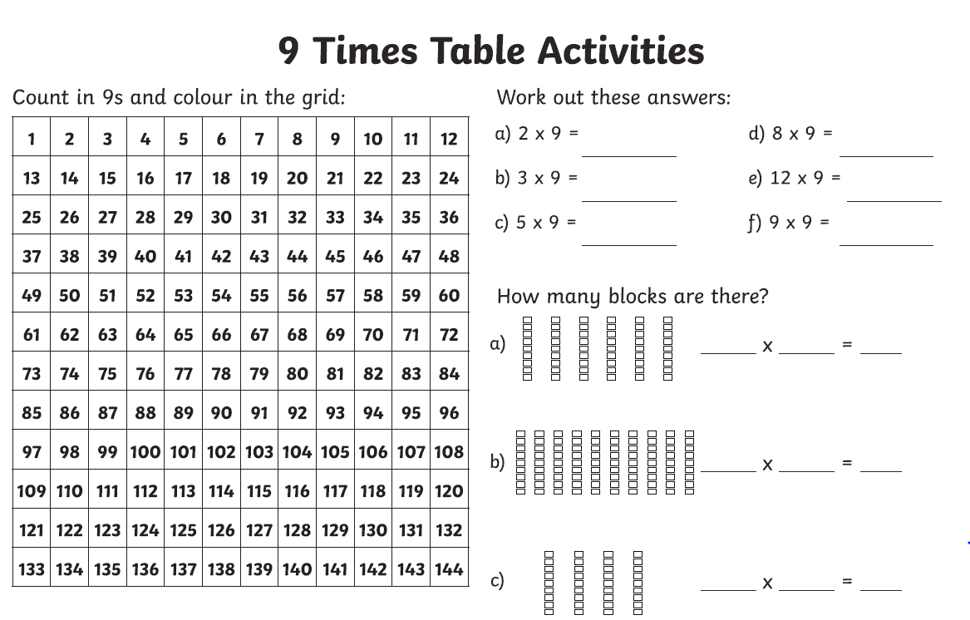
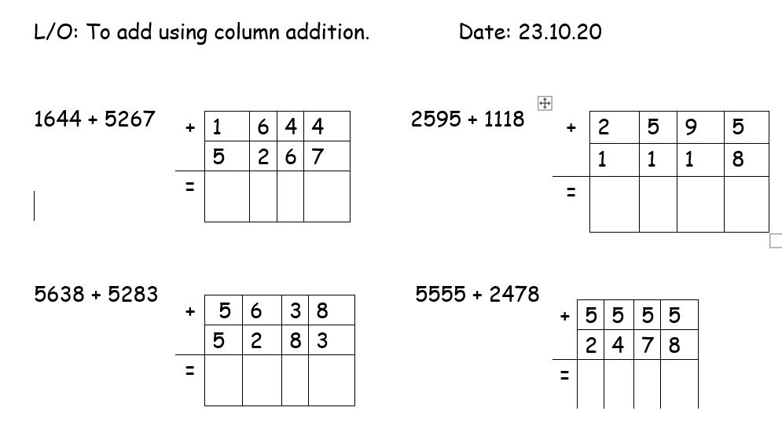
Word of the Day – PIONEER
Find the definition of the word PIONEER and write two sentences using the word of the day.
Spelling - Prefixes
illegal
illegible
autobiography
autograph
inactive
incorrect
Word list
breath
breathe

