Year 4 - Week 6 – Homework

Thursday 15th October 2020
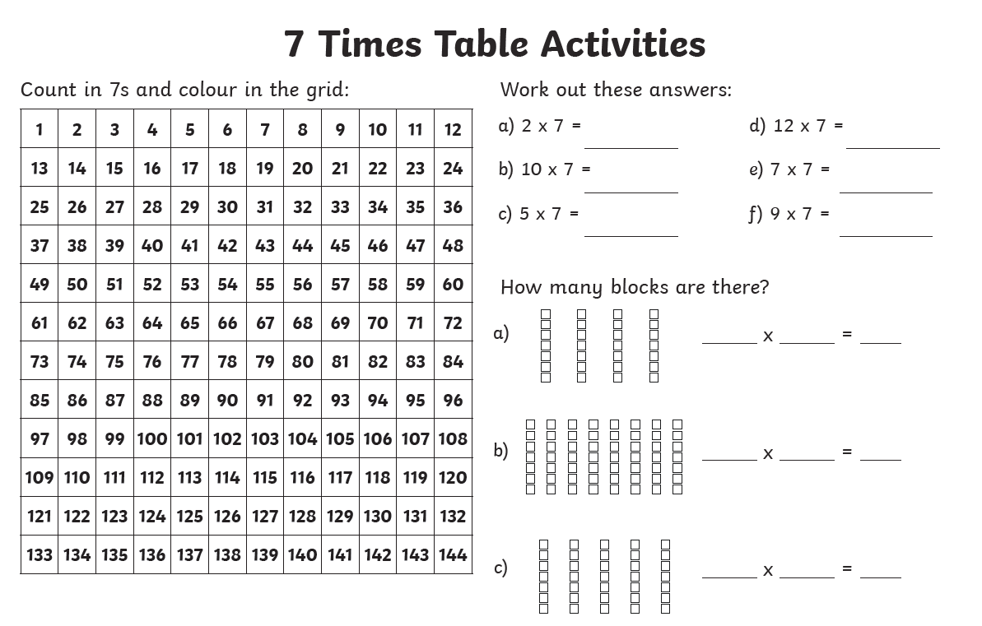
Write the following numbers in Roman Numerals
1)46
2)58
2) 183
3) 113
5) 330

Week 6 – Year 4 Spelling
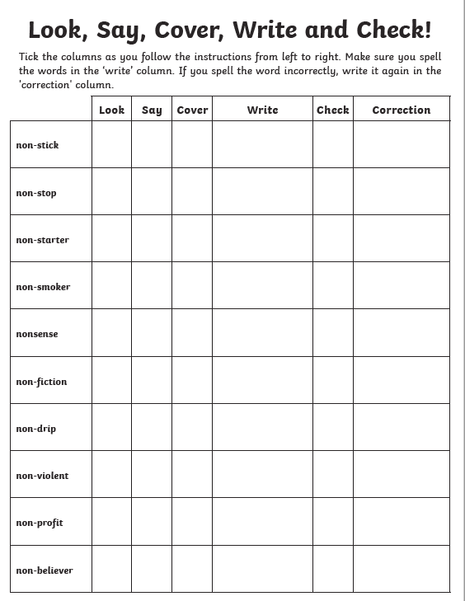
Word of the Day – CONVENTIONAL
Find the definition of the word conventional and write two sentences using the word of the day.

