Thursday 15th October 2020
Year 3 Homework
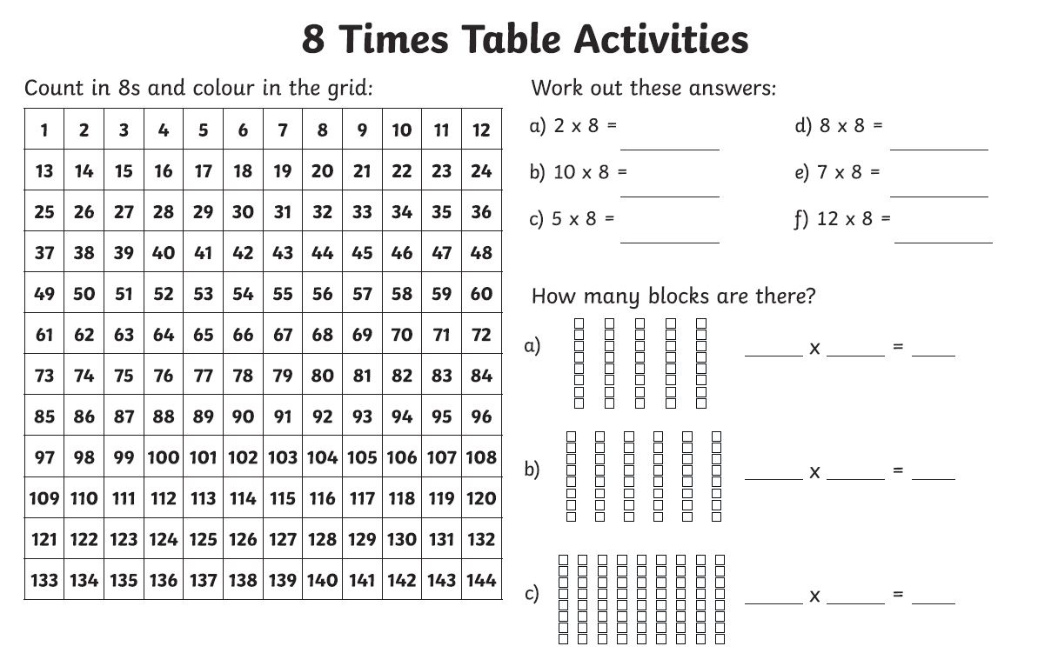

Write the following numbers in Roman Numerals
1)12
2) 18
3) 50
5) 35

Week 6 - Year 3 Spelling – Homophones
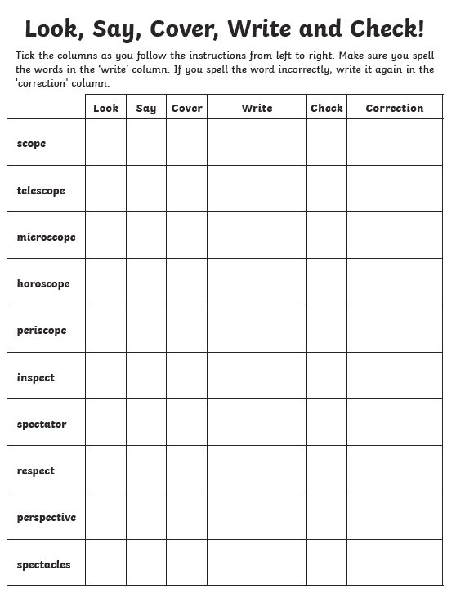

Word of the Day – CONVENTIONAL
Find the definition of the word conventional and write two sentences using the word of the day.

