Year 1 Homework
SPELLING
Year 1 students to practise and write out each word x4 and then form a sentence including the word. Please make sure you write it out in your homework books.
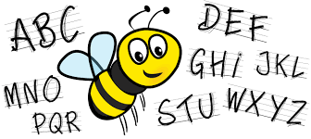
Example, word: They
They
They
They
They
They went to the park.
Year 1 spelling words:
- The 6. about
- a
- do
- to
- today
TIMETABLES
Year one to write out and practise their 2, 5 and 10 timetables.
Please make sure you write this out on your homework books, write it out twice or three times. Practise makes perfect! Try to say it out loud so you can remember and memorise. If you can, try to write up to 20.

Example, 2 timetables.
2,4,6,8,10,12,14,16,18,20…
2,4,6,8,10…

HOMEWORK TO BE HANDED IN BY WEDNESDAY MORNING!!! (16/09/20)

