W1 – Maths Year 3/4 Flip Learning
Watch this place value number videos to understand the basics of place value before we start this topic on Monday insha Allah.

Click here
https://www.bbc.co.uk/bitesize/topics/zsjqtfr/articles/z9w3g82

https://www.youtube.com/watch?v=T5Qf0qSSJFI

Remember! The first digit of a 3-digit number is always 100, second number is 10s and the last number is 1s. look at the example below
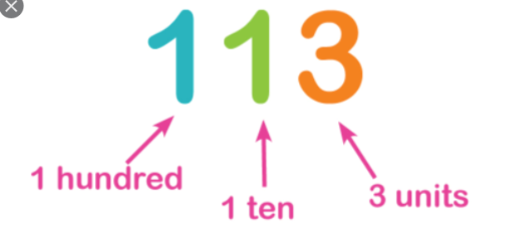 or tens

