Thursday 10th September 2020

Year 3 Homework
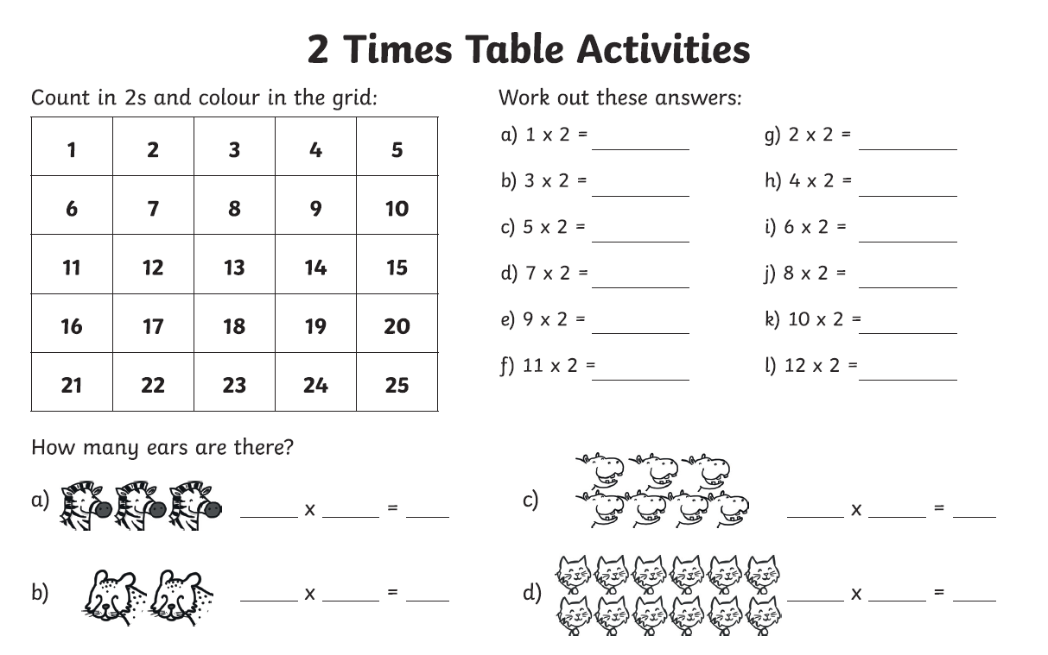

Week 1 - Year 3 Spelling
