**W1: English Flip Learning**

**Task:**

**This is the book we will be reading for this term. Look at the picture and answer the following questions in your homework book.**

**Due: Monday 14th September 2020 – I will be asking you questions at the beginning of our English lessons. Please be prepared.**

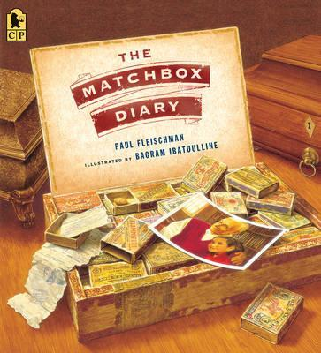

**I predict this book is about:**

**I think this because:**

**The big clues that made me think this are:**