Year 4 - Week 3 – Homework

Thursday 24th September 2020
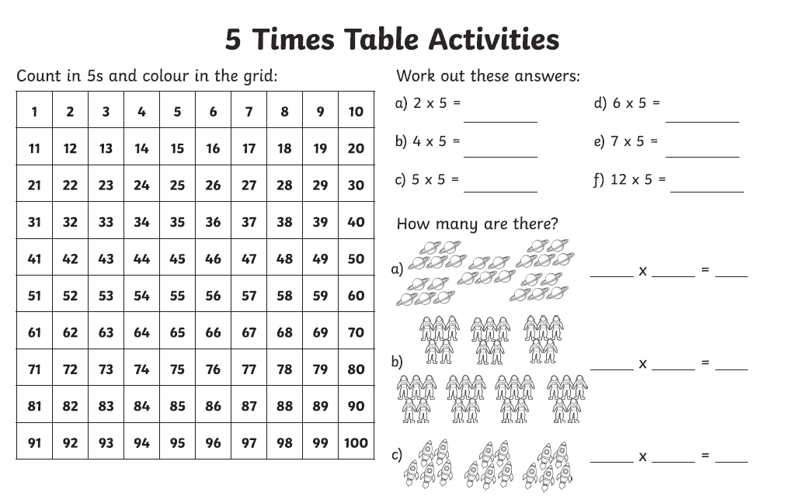

Week 3 – Year 4 Spelling
