Thursday 24th September 2020
Year 3 Homework
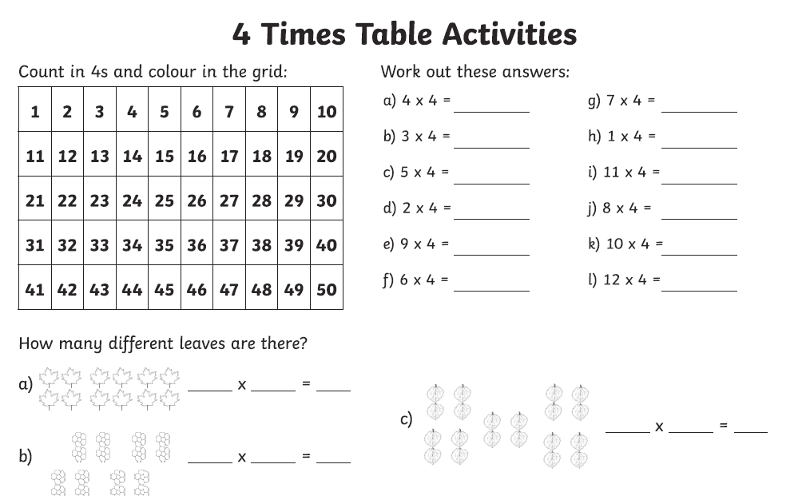

Week 3 - Year 3 Spelling
