Week 18 - Monday 20th July 2020
Year ¾

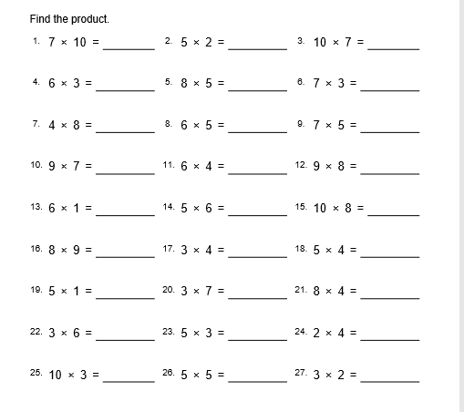

Year 4 Challenge

