Week 18 Monday 20th July 2020 - English comprehension – Year 3 & 4 L.O: To answer reading comprehension questions by deducing and inferring information. Complete the following Questions once you have read the article on ‘Marcus Rashford campaigns for kids meals.’
Tuesday 21st July 2020
Students MUST write the date and title in their books. Copy the question in your book and answer.

Tuesday 21st July 2020
Spellings
Write and learn the following words in your book.
Write the words 5 times.
Write the definitions down using a dictionary or Google search.
Use each word in a sentence.
Do not forget to use a capital letter and full stop in your sentences.
Challenge- can you use at least 2 of the words from the list in a sentence?
Example- I thought the second route will be easier.
- Therefore
- Though
- Although
- Thought
- Through
- Various
- Women

Week 18
Wednesday 22nd July 2020 English writing – Year 3 & 4: Little Red Riding Hood
Task: LO: I can write an alternative ending to a Traditional Tale
Task: Can you plan an alternative ending to this traditional tale? Use the same characters, and setting, but different events. Try and be as creative as you can be. Keep the FIRST part of the story the SAME and then begin to change the middle and end.
Use this plan >>> to help you write down your alternative (different) endings.

Key Word:
Alternative: Different

Week 18
Thursday 23rd July 2020
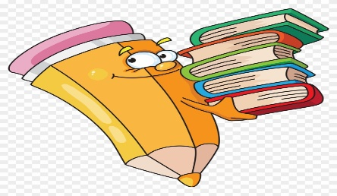
Reading and book review – Year 3 & 4
Copy and Paste the link https://www.win.tue.nl/~marko/latex/exercises/day2/snowwhite2.pdf
Book review by: ________________________________________________________
Title:_____________________________________________
Author: ___________________________________________
Non-fiction Fiction
What is the book about?
______________________________________________________________________________________
_____________________________________________________________________________________
Who would this book be suitable for? Age/interests

______________________________________________________________________________________
What was your favourite part? (Describe)
______________________________________________________________________________________
Year 4 challenge: Would you/would you not recommend the book to someone else? Why?

Week 18
Friday 24th July 2020
Comprehension: Make sure you date your work and write the title. Remember answers should be written in full sentences.
Year 3: Complete question 1-6
Year 4: Complete ALL

