Week 18
Monday 20th July 2020
English comprehension – Year 1 & 2

Celebrating the NHS

NHS stands for National Health Service. It began in 1948 and helps people when they are hurt or unwell.

People in the NHS

Many people work for the NHS. There are lots of jobs in the NHS. They are all needed to make sure that people are well.

Celebrating the NHS
People in the UK wanted to thank the NHS workers for all that they do. They have been celebrating in lots of ways:

Questions
- What do the letters NHS stand for? Tick one.
National Health Service
National Help Service
National Help and Support
- When did the NHS begin? Tick one.
1940
1948
1952

- Who works for the NHS? Tick one.
teacher farmer cleaner

- What have children put in their windows? Tick one.
cats
rainbows
cars

- How have people been celebrating? Tick one.
clapping flying
eating

Tuesday 21st July 2020 English Spag – Year 1 & 2
Spag - Task

Year 2 Challenge

Week 18
Tuesday 21st July 2020
Spellings
Write and learn the following words in your book.
Write the words 5 times.
Use each word in a sentence.
Do not forget to use a capital letter and full stop in your sentences.
Challenge- Can you use at least 2 of the words from the list in a sentence?
Example- I would like a bit of the pizza again.
- come
- some
- you
- there
- hold
- again
- bit

Week 18
Wednesday 22nd July 2020
English writing activity – Year 1 & 2

1.Story time
Go back to https://www.youtube.com/watch?v=0Bfh37iJRpU and listen to Dear Greenpeace.
  - Have you ever seen a whale? How would you feel if you saw one?

What is in Emily’s pond?
What else might Emily have seen in her pond if it was not a whale?
  - On What could have been in Emily’s pond, draw pictures of things she might have seen – a giant frog, a massive fish, a funny monster... even a shape-shifting alien!
  - Label each one with a descriptive caption: a really big frog; a huge monster with blue skin.

Writing a letter
Write a letter to a relative or friend telling them what you think was in Emily’s pond. Use your best handwriting.
  - Lay your letter out properly. Look again at Emily’s first letter to make sure you have got everything in the right place.
  - Include a good description of the creature.
  - Don’t forget to use a friendly, cheerful sign-off: lots of love; love from; a big hug from, etc.
  - If you are not feeling very confident, use the letter template.
  - Now try this Fun-Time Extra
- Post your letter and see if you get a reply!

What could have been in Emily’s pond?

Emily’s First letter

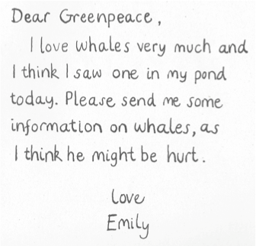

Letter template

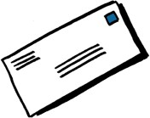

Dear

In Dear Greenpeace, Emily says she has seen a

I think she saw

Please write back and let me know what you think.

Thursday 23rd July 2020
Reading and book review – Year 1 & 2
Read this book online https://stories.audible.com/pdp/B085GKPR6D?ref=adbl_ent_anon_ds_pdp_pc_cntr-0-5

The Lion and the Mouse Written By: Lavanya R. N

Then answer the following questions about your book.
Title:_____________________________________________
Author: ___________________________________________

What did you like about the book?

What was your favourite part? (Describe)

Draw a picture of your favourite scene

Week 18
Friday 24th July 2020
English spelling
Spelling
Write and learn the following words in your book.
Write the words 5 times.
Use each word in a sentence.
Do not forget to use a capital letter and full stop in your sentences.
Challenge- can you use a comma in your sentences?
Example- I need to find my blue, woolly cardigan to wear.
- own
- find
- always
- second
- thought
- blue
- after

