Summer 2
Reception Writing Tasks

Dear Parents/Carers,

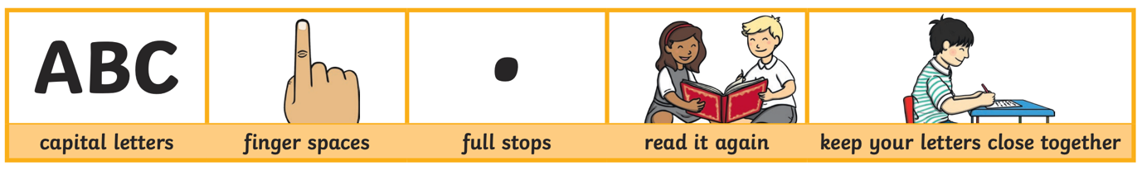
Your child will be expected to complete one writing tasks each day. Please ensure your child is writing in full sentences independently.

Encourage your child to use the above key when writing their sentences.

Success Criteria:
Has your child used capital letters?
Has your child used finger spaces after each word?
Has your child used a full stop at the end of their sentence?
Can your child read what they have written, and does it make sense?
Has your child made sure they have written their letters correctly in a way that can be understood and read by others?

Monday 20th July 2020

Tuesday 21st July 2020

Use describing words to describe this minibeasts

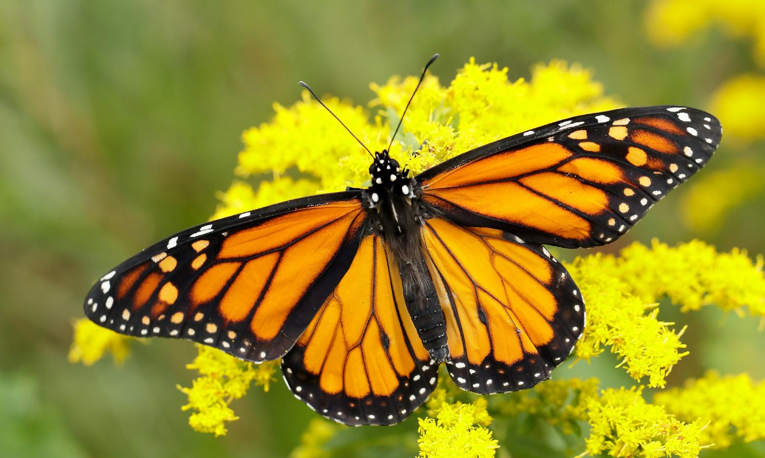

Wednesday 22nd July 2020

Thursday 23rd July 2020

Friday 24th July 2020
