Week 17 - Monday 13th July 2020
Year 3/4
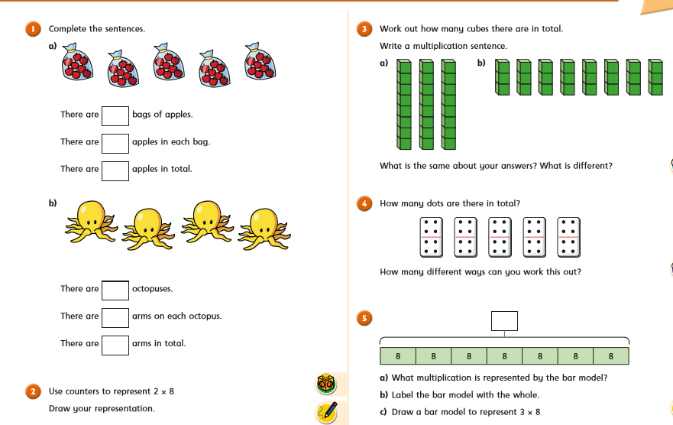

Year 4 Challenge
