Week 17
Monday 13th July 2020
English comprehension – Year 1 & 2
On the Farm
There are lots of farms. Some grow plants. Some raise animals.

Feeding the Animals
The farmer gives the animals food. Cows eat grass and hay. Chickens eat seeds and corn.

Getting the Eggs
The hens lay eggs. The farmer takes the eggs from the coop. The eggs are sold in boxes.

Planting the Seeds
The seeds are planted in spring. Soon, the plants will grow.

Picking the Crops
The farmer picks the crops. They are sold at a shop or market.

Questions
- Which animal is milked every day? Tick one.
cow hen horse

- Which foods are made from milk? Tick two.
butter eggs cheese

- When are seeds planted? Tick one.
winter autumn spring

- What do farmers do during harvest? Tick one.
Sell the eggs. Make the cheese. Pick the crops.

- What do cows eat? Tick one. grass and hay
seeds and corn eggs and milk

Tuesday 14th July 2020 English Spag – Year 1 & 2
Spag - Task
Year 2 Challenge

Week 16
Tuesday 14th July 2020
Spellings
Write and learn the following words in your book.
Write the words 5 times.
Use each word in a sentence.
Do not forget to use a capital letter and full stop in your sentences.
Challenge- Can you use at least 2 of the words from the list in a sentence?
Example- I can't stay up at night.
- won't
- about
- much
- people
- sister
- can't
- night

Week 16
Wednesday 15th July 2020
English writing activity – Year 1 & 2
1. Read Handa’s Hen story
on https://www.youtube.com/watch?v=-9FZqX1CBqE and listen to it
  - How many stars out of five would you give the story? Use the word
because to explain why you give the book that many stars.

Answering questions
Look at the set of Questions about Handa’s Hen
  - Read and respond to each question in turn.

Writing time
Make your own Mini Story Book and write the new version of Handa’s story that you planned yesterday.
  - Turn the first row on your Planner into a full sentence: Handa had lost her pet... cat. Continue with the next line: When she went looking for her cat she saw one...
  - Keep going with the remaining sentences.
  - Use your best handwriting and word spacing. Be sure to spell your number words correctly.
  - Make sure you use capital letters and full stops for all your sentences.

Now try these Fun-Time Extras
- Decorate the pages of your book with pictures.
- Read your finished story aloud to your family.

Questions about Handa’s Hen

- Circle the word that best describes the place where Handa lives.
a city a town a village

- Circle the word you think is incorrect in this sentence.
Handa lives with her aunt.

- Who is Akeyo? Circle the correct answer.
Handa’s sister A friend of Handa’s Grandma Handa’s best friend

- Write a sentence saying how Handa feels when she discovers that Mondy is missing.

- Write a sentence saying how Handa and Akeyo feel when they find Mondy and her chicks.

- What do you think might happen next to Handa and Akeyo?

Mini Story Books Instructions

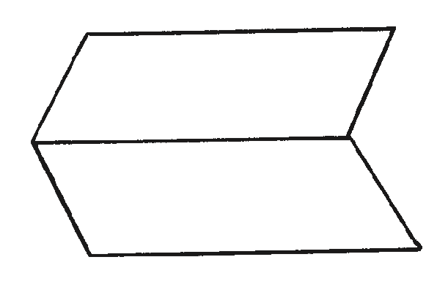
  - Fold a sheet of paper in half lengthways and then unfold it.

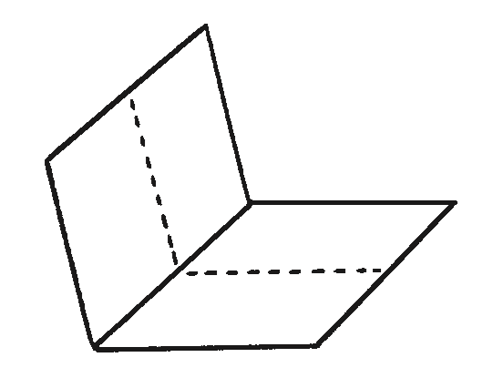
  - Fold the same sheet of paper in half widthways and leave it folded.

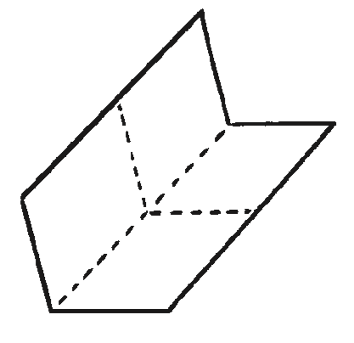
  - Fold it in half again in the same direction and then unfold the last fold.

  - Cut along the centre crease until you reach the middle of the piece of paper.
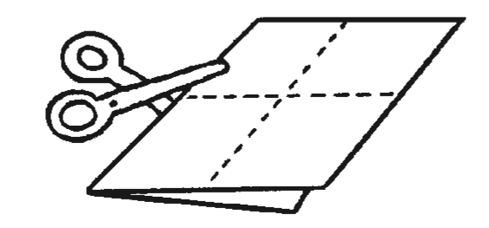
  - Unfold the paper completely. There should be a slit through the middle of the paper. Fold the paper in half lengthways again and then push the two ends inwards towards each other to create a star shape with four arms.
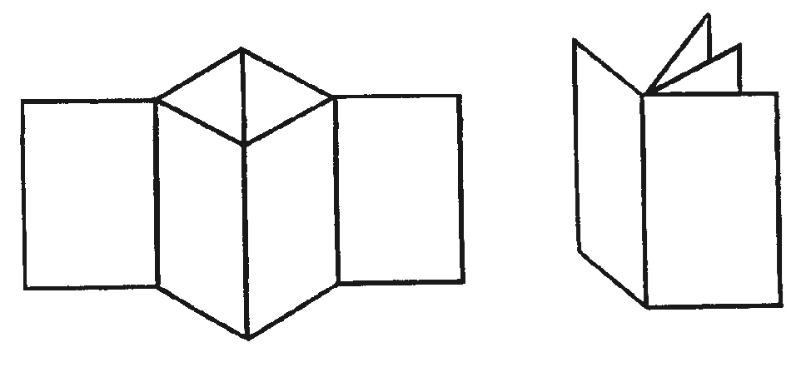
  - The four arms are the pages of the book. Fold all of the arms around to face the same direction and the book is complete.

Thursday 16th July 2020
Reading and book review – Year 1 & 2
The Boy who drew Cats by Anushka Ravishankar (click on the link below to listen to it)
https://stories.audible.com/pdp/B085GKQ9DZ?ref=adbl_ent_anon_ds_pdp_pc_pg-1-cntr-0-27
What did you like about the book?

What was your favorite part? (Describe)

Who was your favorite character and why?

Draw a picture of your favorite scene.

Yr 2 challenge: What rating would you give out of 10 for this book and why?

Week 17
Friday 10th July 2020
English spelling
Spelling
Write and learn the following words in your book.
Write the words 5 times.
Use each word in a sentence.
Do not forget to use a capital letter and full stop in your sentences.
Challenge- can you use a question mark in your sentences?
Example- Can you come over here please?
- come
- any
- break
- child
- has
- find
- because

