Summer 2
Reception Writing Tasks

Dear Parents/Carers,

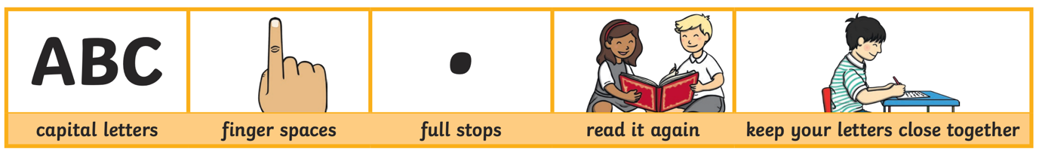
Your child will be expected to complete one writing tasks each day. Please ensure your child is writing in full sentences independently.

Encourage your child to use the above key when writing their sentences.

Success Criteria:
Has your child used capital letters?
Has your child used finger spaces after each word?
Has your child used a full stop at the end of their sentence?
Can your child read what they have written, and does it make sense?
Has your child made sure they have written their letters correctly in a way that can be understood and read by others?

Monday 13th July 2020

This week we will be learning about minibeasts. Watch the following video and see if you can name the minibeasts. https://www.youtube.com/watch?v=iJlfBNyBKQA

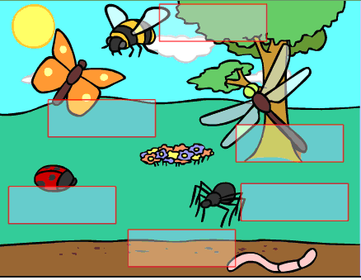

Tuesday 14th July 2020

Choose your favourite minibeasts and write a fact file for your chosen minibeasts.
Draw a picture of your minibeasts:

Minibeast Fact File

Minibeasts Name: _______________________________

Where does your minibeasts live?

______________________________________
Fast facts (Other facts):

What does your minibeasts eat?

______________________________________

Wednesday 15th July 2020

Can you think of adjectives (describing words) for this minibeasts?

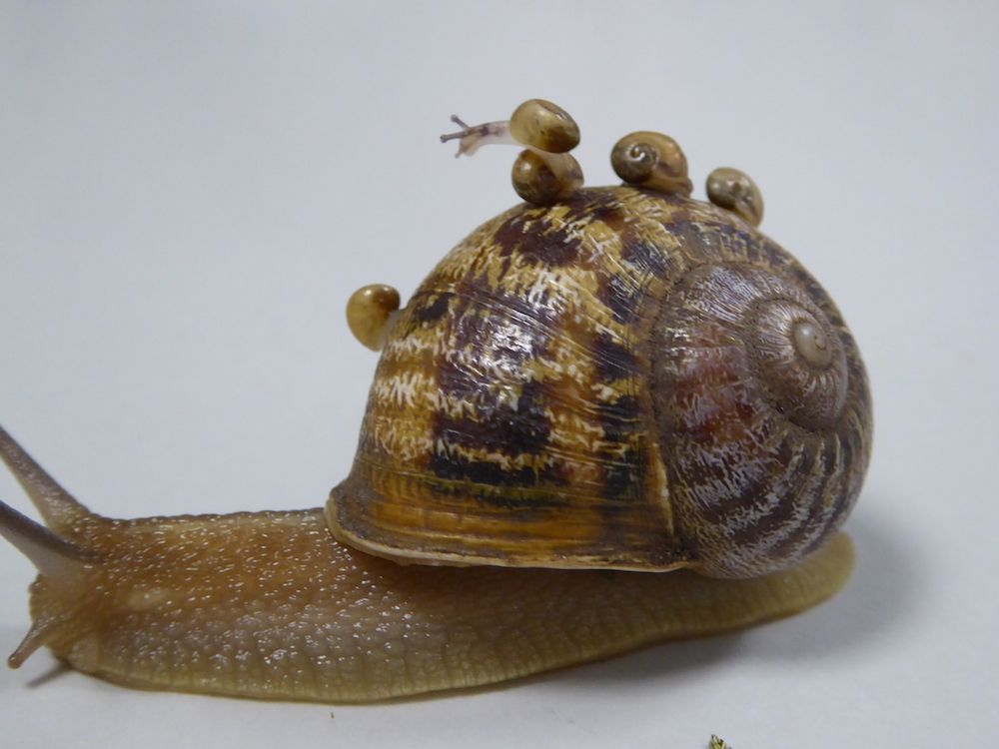

Thursday 16th July 2020

Watch the following video of ‘Life Cycle of a Buttterfly’ https://www.youtube.com/watch?v=O1S8WzwLPlM or read the story of ‘The very hungry Caterpillar’.

Your task is to create the Life Cycle of a Butterfly and to tell me the stages of how a butterfly is first a caterpillar and how it turns into a butterfly.

You can draw pictures and write sentences to design your diagram.

Friday 17th July 2020

Read the following text about ants and answer the questions:
There are more than a million kinds of insects. Most of them are solitary insects. Their survival depends on only one being— themselves. An ant is different; it is a social insect. It cannot survive by itself for long periods of time. Ants need other ants to help build a nest, gather food, and protect themselves from enemies. This need for other ants is not a weakness but a strength that enables the ant to overcome its small size. When an ant is threatened by a larger insect, it emits a scent called an alarm pheromone. Other ants smell the odor and rush to help.
How many kinds of insects are there?

_____________________________________________________________________________

Why can’t an ant survive by itself?

_______________________________________________________________________________________________________

