Summer 2
Rec Maths

Notes for parents
(Remember gold prizes from me for neat outstanding work)

If you do not have access to a printer, provide your child with an exercise book to do their work in.

- Write the short date (today's date)
- Write the L.O:
- Miss a line
- Question numbers in the margin and write answers on the line.

(I will be asking your parents if your work looks neat and to send me a picture of your amazing work. I myself will check your work once you come back to school in sha Allah)

Monday 13th July 2020

Can you get your child to count backwards from 20?

If they are struggling, you can ask them first to count backwards from 10 to begin with.

On a piece of paper, write numbers 20 to 0 to support your child counting backwards.

20 19 18 17
16 15 14 13
12 11 10 9
8 7 6 5
4 3 2
1 0

Well done if you were able to master this!

Tuesday 14th July 2020

Learn numbers words 1-10.
https://www.youtube.com/watch?v=WC_SBmoXrUw

Watch the following video with your child and see whether they are able to recall how to write each number in words.

Can you match the numbers to the correct words?

1 four
2 six
3 one
4 ten
5 eight
6 two
7 nine
8 seven
9 five
10 three

Wednesday 15th July 2020

Can you write the number names or numbers for the following?

4

Six

Ten

5

9

One

Thursday 16th July 2020

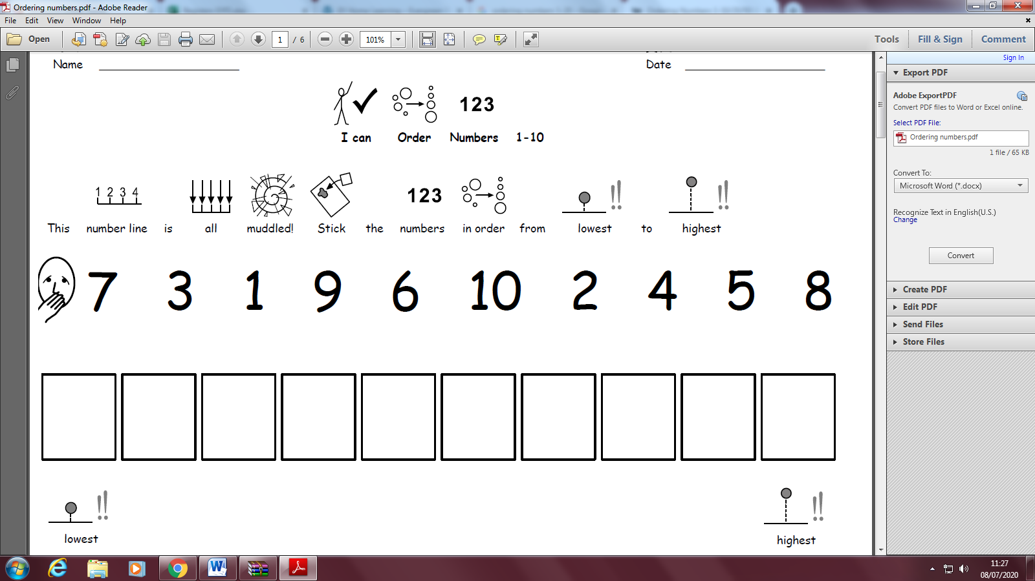

Friday 17th July 2020

Can you find different ways to make 10?

