Monday 13th July 2020

Read the following high frequency words and practise writing them in your neat handwriting.

Tuesday 14th July 2020
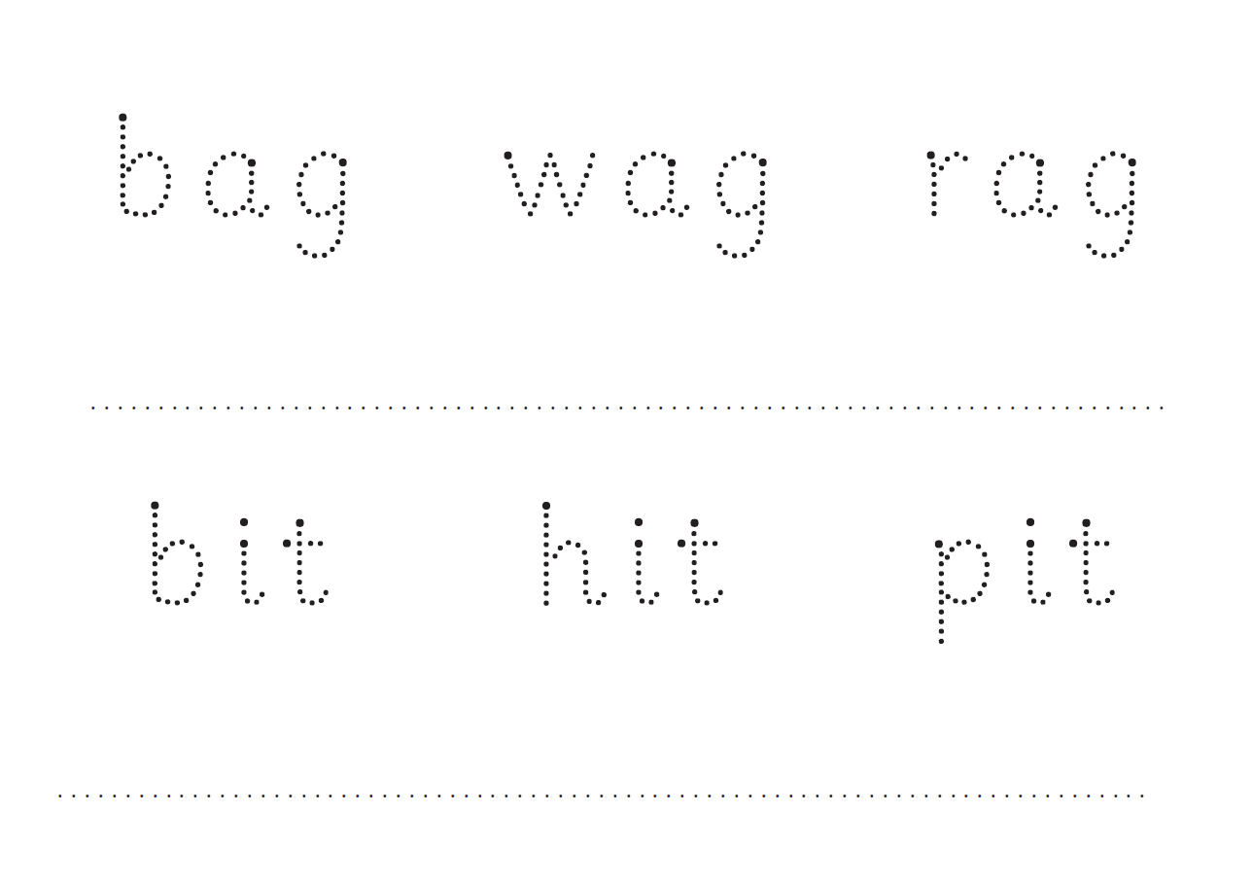

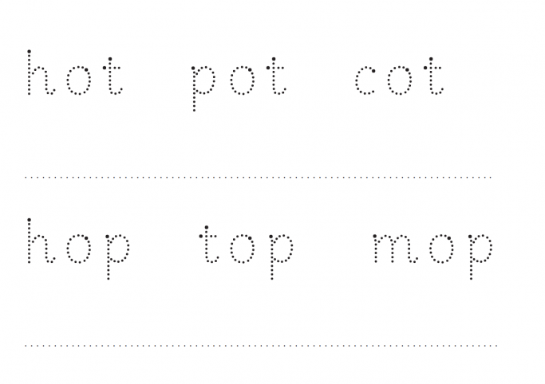

Wednesday 15th July 2020

Keyword | Practice 1 | Practice 2 | Practice 3 | Practice 4
a
am
I
at
in

Thursday 16th July 2020

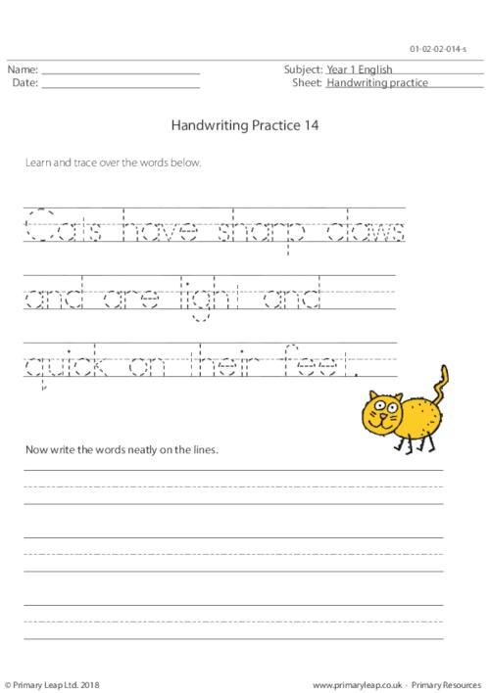

Friday 17th July 2020

