Week 16 Monday 06th July 2020 - English comprehension – Year 3 & 4 L.O: To answer reading comprehension questions by deducing and inferring information. Read the extract, then read the questions and find evidence from the reading to answer the questions.

Questions- Year 3 answer questions 1 to 5 (Children in school should attempt all)
Year 4 should attempt to answer all the questions.
- Please answer in full sentences e.g. There are 4 events that take place. Write them in order.
- Answer- The first event that takes place is…

- What does Alice do while she is falling?

- List the events to show the order that they happened.
- Alice hopes that someone has fed Dinah
- Alice looks inside a cupboard
- Alice chases the rabbit
- Alice starts to fall asleep
- Describe how Alice feels when she lands?
- Match each action to the character who completes it

- Why doesn’t Alice think that she will mind falling down the stairs anymore?
- Look at the paragraph beginning with Before Long…
Find and copy one word or phrase which shows that Alice was beginning to fall asleep.
- What is strange about Alice’s reaction to her long fall? Explain your answer.
- Describe Alice’s character. Explain your answer.

Tuesday 07th July 2020
LO: I can add Front Adverbials to sentences to describe locations.
Students MUST write the date and LO in their books.

Tuesday 07th July 2020
Spellings
Write and learn the following words in your book.
Write the words 5 times.
Write the definitions down using a dictionary or google search.
Use each word in a sentence.
Do not forget to use a capital letter and full stop in your sentences.
Challenge- can you use at least 2 of the words from the list in a sentence?
Example- It is possible to ignore the pressure from your friends.
- Awkwardly
- Frantically
- Curiously
- Obediently
- Carefully
- Rapidly
- Unexpectedly
- Deliberately
- Hurriedly
- Reluctantly

Week 16
Wednesday 08th July 2020
English writing – Year 3 & 4: Task: LO: To create a poster on ‘How to stay happy and Safe in School’

How to stay happy and Safe in School

Those who have not returned just yet – Please read the slides on the Powerpoint provided. After reading the slides please think of ways you can maintain safety when returning to school and also how to be happy and have fun while doing these things.

Students who have returned to school – You will be creating a poster for those students and members who will join us later on, informing them of how to maintain safety around the school.

Please keep in mind the new rules and timetable we have been given. Think about your class bubbles.

Your task: To create a poster on how to be happy and safe in school.  Remember to include:  Keep your distance, wash your hands rule, stay with your own bubble (Class Teacher and Members), do not share equipment’s and show you care.  Do not forget to:  - Use capital letters and full stops.  - Include lots of adjectives (describing words) and adverbs (to describe the verbs)  - Read each sentence to check if it makes sense.  - Use a wide range of punctuation including at least 3 of the following: full stop and capital, question mark, exclamation mark, apostrophe, and comma. | 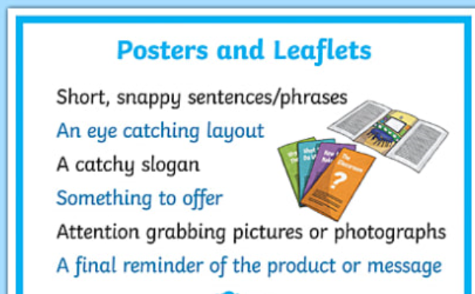

Week 15
Thursday 2nd July 2020
Reading and book review – Year 3 & 4
Click on the link and listen to the story of ‘Kid Normal’ Write A book review about the story.
https://stories.audible.com/pdp/B07533YSBN?ref=adbl_ent_anon_sc_pdp_pc_0
Book review by: ________________________________________________________
Title:_____________________________________________
Author: ___________________________________________
Non-fiction Fiction
What is the book about?
______________________________________________________________________________________
_____________________________________________________________________________________
Who would this book be suitable for? Age/interests

______________________________________________________________________________________
What was your favourite part? (Describe)
______________________________________________________________________________________
Year 4 challenge: Would you/would you not recommend the book to someone else? Why?

Week 15
Friday 3rd July 2020
Comprehension: Read the Fact File and answer the questions in your home learning book. Make sure you date your work and write the title. Remember answers should be written in full sentences.

- Name the worlds largest weed.
- Name something mentioned in this text, other than bees and other insects, that can move pollen around in the flower.
- What is another name for a dandelion ‘clock’?
- What is a good thing that nettles can be used for?
- What makes dandelion seeds good at floating in the air?
- Name another way mentioned in this text, apart from the wind, that seeds can be spread around to germinate in other places.
- How tall can the largest weed grow?
- What does ‘germinate’ mean in the final paragraph?
- In paragraph one, the author has written the contracted word it’s. Write the full words without the apostrophe.
- In the first paragraph, what does the word ‘reproduce’ mean? Use a dictionary or google.

