Week 16 Year 2 Monday 6th July 2020
L.O: To know my 2x, 3x, 5x and 10x
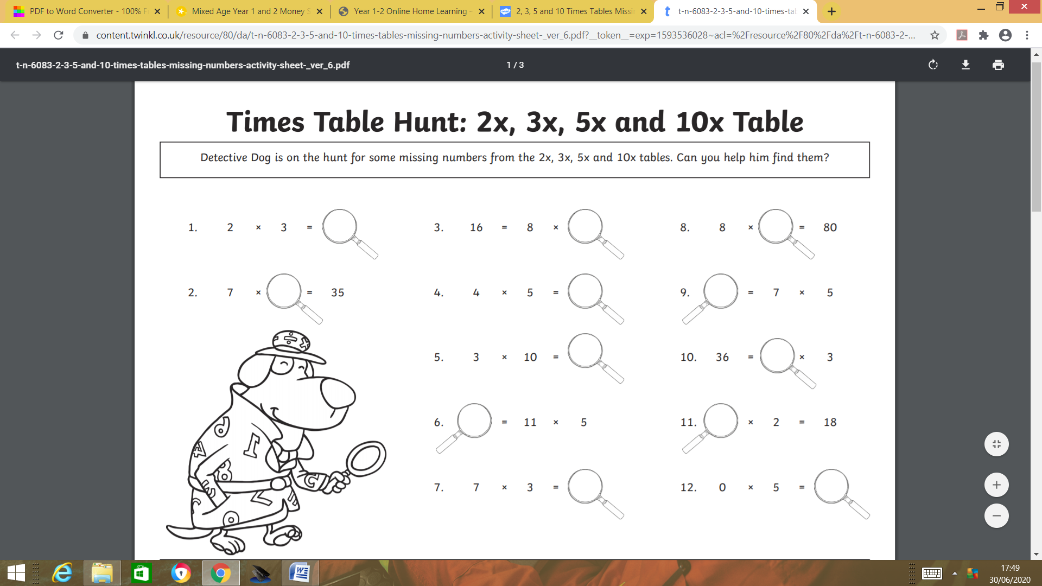

REMEMBER: Spend at least 10 minutes a day memorising your times table!

SPECIAL PRIZE:
If you memorise all of the times tables when you return to school

Week 16 Year 2 Tuesday 7th March 2020
L.O: To use addition and subtraction facts to 20 fluently
Challenge
Week 16 Year 2 Wednesday 8th July 2020
L.O: To understand the inverse relationship between addition and subtraction
Challenge

Make sure you explain your answer as best as you can.

Week 16 Year 2 Thursday 9th July 2020
L.O: To use addition and subtraction facts to 20 fluently
Challenge:
Week 16 Year 2 Friday 10th July 2020
L.O: To understand the inverse relationship between addition and subtraction

Challenge:

Make sure you explain your answer as best as you can.

